DISK OPERATING SYSTEM (DOS)

INTRODUCTION

DOS is an Operating System. It works as an interpreter between user and computer. We give English like commands and it converts it into machine language and after the computer has processed the information, returns the results to you in English. Ms. Dos consist of four essential programs and a set of additional utilities.

Components of MS-DOS

MS-DOS consists of four essentials programs and a set of additional utilities. Four main programs are

* Boot Record ❖ MSDOS.SYST
* IO.SYS ❖ COMMAND.COM

Booting: Process that starts up a computer is called booting. It checks for proper functioning of all the peripheral devices attached with the system. It searches for the operating system and, when located, loads it into the main memory. See fig.01.

Cold Booting is done by turning on the computer.

Warm Booting is performed by pressing Ctrl+Alt+Del keys simultaneously. There are two name in DOS and is divided into 2 parts.

* 1. Primary Name
  2. Secondary or extension.

Primary name is separated from the Secondary name extension with the help of a dot (.) look at the following example.

Example: ENVOICE. TXT

Primary name can be from 1 to 8 characters long and

Secondary name contains 3 or less than 3 characters and is optional. The extension tells DOS about what kind of file it is.

A valid Character for naming a file are: from A to Z and the digit 0 to 9 C :\> Is known as DOS/command prompt, where we give the commands. DOS command divided into 2 parts.

* + 1. Internal Commands or Memory-Resident Commands
    2. External Command or Disk-Residence Commands

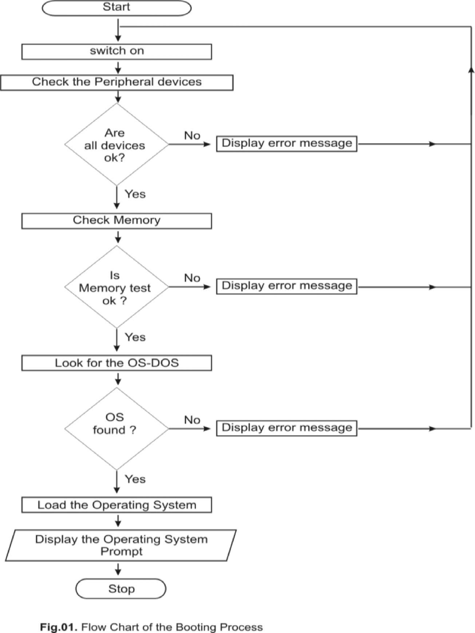

INTERNAL COMMAND

There are also called memory-resident commands. These commands are automatically loaded into the computer's memory during the booting process. They actually included in the Command.com file. So these commands are executable immediately after getting the dos prompt.

A few internal commands are

* + - 1. VER

2.VOL 3.date

TIME

CLS

DIR

MD

CD

1. PATH
2. RD
3. COPY CON
4. TYPE
5. COPY
6. DEL
7. REN
8. PROMpT

A command can be given in Capitals or Small letters also. The internal commands can execute immediately but External Commands require special files for their execution without which it is not possible to execute them.

* 1. VER: - All O/S has its own edition number or release or version number. The version number indicates which edition of O/S you are working on.

Syntax: VER <Enter>

Example: C:\> Ver <Enter>

Result will be: - Microsoft Windows XP [ Version 5.1.2600]

* + 1. VOL: - It is used to display volume label and serial number of the current drive Syntax: Vol [drive:]

Example: C:\> VOL

* + 1. DATE: - Used to display the current system date and prompt for entering new date. Syntax: Date <Enter>

Example: C:\> date <Enter>

* + 1. TIME: - Displays the current system Time and prompt for entering new time. Syntax: Time <Enter>

Example: C:\> Time <Enter>

* + 1. CLS: - Clears the cluster screen. Syntax: CLS <Enter>

Example: C:\> CLS <Enter>

* + 1. DIR: - This command displays the list of directories and files with details like date of creation whether it is directory or file etc.

Syntax: DIR <Enter>

Switches:

/p : To view one screen of files at a time.

/w : Displays only five column of filenames and directories.

/b : Display only file and directory.

/l : Display all the information in lower case letters.

/a — stands for attributes that are given below. /-h - Hidden (or not hidden) files s/-s - System (or not systems) files d/-d - Directory ( or not Directory) names r/-r - Read only( or not read only) files Example:

DIR *.txt : Display all the files with extension .txt

DIR D???. * : Display all the files starting with D and having less than or equal to

four characters in the file name and any extension.

Here "?" And "*" are called"wild card character".

"*" Stand for any number of the character

"?" Stands for nay one character.

* + - 1. MD OR MKDIR: -Used to create a new Directory or nested Directories. Syntax: MKDIR OR MD [DRIVE:] PATH DIRECTORY NAME Example: C:\> MD SAMS <Enter>
         1. CD OR CHDIR: - This command allows you to change present directory to another directory.

Syntax: CD [DRIVE:] PATH

Example: C:\> CD SAMS and press <Enter>

PATH: - This command defines a list of directories DOS Searches for external commands.

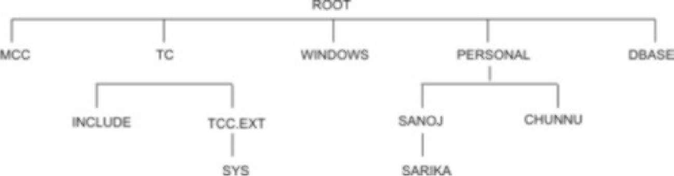

Syntax: PATH (Display the current Search Path)

PATH;: - (Clear the search path so DOS will search for external commands only in the current directory)

RD: - To delete the empty directory. Syntax: RD [DRIVE:] PATH

NOTE: -The directory must be empty when we use RD. Example: C:\> RD SAMS and press <Enter> Switches: - 1. /s - Remove with subdirectories and files. 2. /q - Don't ask to confirm.

COPY CON: -We use this command to create a new file. Syntax: COPY CON <FILENAME>

Example: C:\> Copy Con sams.txt <Enter>

Note: - Typing here and when you are done, press Ctr+Z or F6 key followed by Enter to save the current document.

TYPE: - This command allows you to see the contents of an existing file on the screen.

SYNTAX: TYPE <file name> Example: C:\> TYPE SAMS

COPY: - Using this command you can make duplicate files of an exiting file from one location to another or one directory to another with different name or exiting name.

SYNTAX: COPY < SOURCE FILE NAME> <TARGET FILENAME>

Example: C:\> COPYSAMS.TXTA:\TAJ

Example: C:\> COPY*. TXT +*.BAK TARGET FILENAME And Then Press Enter Example: C:\> COPY SAMS. TXT C:\SAMS_1\FO\RECEPTION And Then Press Enter You can also have the option to change the name of files as you copy it. Example: C:\> COPYold.TXT C:\dos\new.txt And Then Press Enter

DEL/ERASE: This command removes one or more files from the disk or current working directories.

SYNTAX: DEL filespec [/p] or ERASE filespec [/p] Example: C:\> DEL C:*.BAK/P And Then Press Enter Example: C:\> DEL abc And Then Press Enter Example: C:\> DEL ????.COM And Then Press Enter

Switches: - 1. /p -confirmation 2. /q - In quit mode

REN: Used to change the name of the file or directory. SYNTAX: REN <file name>

Example: REN sams sams1 <Enter> Example: REN *.dat *.mst And Then Press Enter

16 PROMPT: This command allows you to customize the dos prompt. SYNTAX: 1. PROMPT

^ SOME SPECIAL $ PARAMETERS ARE GIVEN BELOW.

|  |  |  |
| --- | --- | --- |
| CHARACTER | EXAMPLE | DESCRIPTION |
| $Q | = | Equal Sign |
| $$ | $ | Dollar Sign |
| $t | 12:30:06:92 | Display current time |
| $d | tue 09-07-2007 | Display current date |
| $v | msdos version 6.2 | show dos version number |
| $g | > | Greater than sign |
| $L | < | Less than sign |

Most people like to set their prompt to $p$g which display the current directory followed by > sign.

Example: PROMPT $P$G <Enter>

17. TREE: - It is used to display directory structure of a specified directory graphically.

Syntax : TREE [drive:] [path] [/f]

[/F] : displays the names of the files in each directory.

EXTERNAL COMMAND:

These are also called Disk-Resident Commands. These commands are meant for special purpose. These are found in separate files on Hard Disk or Floppy Disk, So that they don't typically consume valuable memory space. They are loaded into memory only when called.

Some External Command are:

Xcopy

Move

FC

Doskey

Mem

6. Attrib

7. Deltree

8.Edit

9.Tree

XCOPY: This command is faster than Copy Command and allows you to copy entire directories/disk including all the sub directories and files to destination.

Syntax: XCOPY Source [ Target][/Y][-Y] [/P][/E]

SWITCHES:

/-Y : Prompts before copying over existing files.

/y : Overwrites existing files without prompting.

/p : Ask before copying each file.

/e : Copying empty directory also.

/s : Copying subfolders.

EXAMPLE: XCOPY C:\SAMS D:\SAMS /S/E

MOVE : This command moves a file or group of files from one directory to another and also one disk to another disk. It can also be used to rename directories.

SYNTAX: Move [Path File Name] [Destination file name path]

SWICHES:

/-Y : Prompt before it overwrites while it copies file that already exists.

/Y : Overwrites existing files without prompting.

EXAMPLE: move c:\sams\fo.txt to d: EXAMPLE: move c:\sams\fo.txt to d:\ new_sams

. FC: Stands for File Compare. If you wish to compare two files or two sets of files then you may use this command. This command has the capability to differentiate between the files and display the difference

SYNTAX: FC <files spec 1> <files spec2> [/a][/b][/c][l][/n]

Switches

/a : This switch displays only the first and last line of each group. /b : Compare the files in library mode (byte-by-byte) /c : Ignore the case of letters.

/l : Compare the files in text mode.

/n : Displays the line number for lines that are different.

EXAMPLE: FC first.txt second.txt\n and then Press <enter>

. DOSKEY: Dos can remember only the last command you had entered. But in order to make DOS remember all the commands you enter you will have to load a DOSKEY utility. Also Used To Create Macros

Syntax: DOSKEY and Press <Enter>

Display message on the screen.

DOSKEY Installed.

NOTE: - To display all commands from the history list one the screen. Example: DOSKEY/History or/h < Enter>.

Now when DOSKEY is in memory, it can help store all the commands which you enter so that any of those commands need not be typed again to be executed. And this all are called HISTORY LIST. Now when you want the same command to be done you can use right arrow key or 'F1' or 'F3' Issuing following command.

Second feature of DOSKEY is Doskey Macro. Using this macro you can create own command and latter you can run it on the system prompt. For example

EXAMPLE: - DOSKEY C= CLS

Now if you type at the system prompt only C and press enter it will clear the screen.

Recalling Commands: Some key is provided to recall recent commands you have run since installing DOSKEY.

Key Strok Effect

Up Arrow Display the Preceding Command and further list.

Down Arrow Show the next command you executed after the one that's being displayed.

Page Up Display the oldest command that is still in Doskey.

Page Down Show the most recent command that you executed

F7 Display the entire list of command that you executedd.

F9 Selects a commands

Alt+F7 Erase the command history list.

Alt+F10

Esc

Ctrl-T

Erase all macros in memory

Clear the command line.

Command separator

**MEM**:

This command displays amount of total available memory ( low, Expanded and Extended) and all currently programs.

Syntax: MEM [/f][/p][/m]

Switches:

/f : Using this switch MEM display all the areas of memory that are fee. /p : Use this option to display the information one screen at a time. /m : Display information about how a specified program is using memory. Example: MEM/p and then press <Enter>

**. ATTRIB:**

Every File on the Disk has its own description like size, space occupied, the type, the date it was created, etc. Likewise, every file has few attributes. The attributes of a file indicates whether it is a

i) Read-Only File: r ii) Archive File a

iii) Hidden File: h iv) System File s

With the ATTRIB command you can check the attributes of a file.

SYNTAX: ATTRIB [+r][+a][+h][/+s][filename]

Switches:

+r, -r :

+a,-a :

+h,-h :

+s, -s :

Note:

While Creating a new file every file gets read only attribute and archive attribute by default.

EXAMPLE: C:\> ATTRIB my.txt +R and then press <Enter>

EXAMPLE: C:\> ATTRIB my.txt +H and then press <Enter>

**. DELTREE:**

This command used for deleting an entire directory whether in that directory contains files or subdirectories and also it will delete hidden files.

Syntax: DELTREE [drive:][path] directories [/y]

EXAMPLE: C:\> DELTREE my.txt and then press <Enter> 9. EDIT:

This is the DOS Editor, which you can use to edit the text file and also creating new file.

Syntax: Edit [drive:][path][filename]

EXAMPLE: C:\> EDIT c:\sams\FO. TXT and then press <Enter>

EXAMPLE: C:\> Edit NEW FILE and then press <Enter>