Chapter One

Introduction

1.1 General

The term Self-Compacting Concrete (SCC) refers to a “new” special type of concrete mixture, characterized by high resistance to segregation that can be cast without compaction or vibration. It flows like “honey”, deaerates, self-compacts, and has nearly a horizontal concrete level after placing. Products made with SCC have an excellent finish, and are virtually free of bug holes {Kaszynska (2004) [1]}.

The introduction of new admixtures and cementitious materials has allowed the production of SCC. These materials are used to prevent segregation, bleeding, and increase flowability. The superplasticizer and mineral admixture hold the aggregates in suspension, and the combination of powder materials is also used to control the hardened properties, such as strength [1].

SCC is an emerging technology to the construction industry, and has been described as the most revolutionary development in concrete construction for several decades. SCC originally developed to offset a growing shortage of skilled labor; but at the same time it has proved beneficial economically because of a number of factors, including [1]:

* Faster construction
* Reduction in site manpower
* Better surface finishes
* Easier placing
* Improved durability
* Greater freedom in design
* Thinner concrete sections
* Reduced noise levels, absence of vibration
* Safer working environment

**1.2 Development of SCC**

Self-compacting concrete, in principle, is not new. Special applications such as underwater concreting always require fresh concrete, which could be placed without the need to compaction; in such circumstances vibration has been simply impossible. Early self-compacting concretes relied on very high contents of cement paste and, once admixtures became established, superplasticisers were also added. The mixes required specialised and well controlled placing methods in order to avoid segregation, and the high contents of cement paste made them prone to shrinkage, high heat generation. The overall costs were very high and applications remained very limited.

The introduction of “modern” self-compacting concrete (SCC) is associated with the drive towards better quality of concrete pursued in Japan in late 1980’s, where the lack of uniform and complete compaction had been identified as the primary factor responsible for poor performance of concrete structures. There were no practical means by which full compaction of concrete on a site was ever to be fully guaranteed, instead, the focus; therefore, turned onto the elimination of the need to compact, by vibration or any other means. This led to the development of the first practicable SCC by researchers (Okamura, Ozawa et al.) at the University of Tokyo {Ouchi & Hibino (2000) [2]}.

The prototype of self-compacting concrete was first completed in 1988 using materials already on the market. The prototype performed satisfactorily with regard to drying and hardening shrinkage, heat of hydration, denseness (after hardening), and other properties. This concrete was named “High Performance Concrete” and was defined as follows at the three stages of concrete [2]:

* Fresh: self-compactable.
* Early age: avoidance of initial defects.
* After hardening: protection against external factors.

At almost the same time, Aitcin et al. [2] defined “High Performance Concrete” as a concrete with high durability due to low water-cement ratio. Since then, the term high performance concrete has been used around the world to refer to high durability concrete. Therefore, Okamura and Ozawa changed the proposed concrete to “Self-Compacting High Performance Concrete” [2].

The large Japanese contractors quickly took up the idea. The contractors used their large facilities to develop their own SCC technologies. Each company developed their own mix designs, trained their own staff to act as technicians for testing on sites, and tailor made their SCC mixes for large projects they tendered for. Importantly, each of the large contractors also developed their own testing devices and test methods.

In the early 1990’s there was only a limited public knowledge about the SCC, mainly in Japan, the fundamental and practical know-how was kept secret by the large corporations to maintain commercial advantage. The SCCs were used under trade names, such as the NVC (Non-Vibrated Concrete), SQC (Super Quality Concrete) or the Biocrete {Sika (2000) [3]}.

Simultaneously with the Japanese developments in the SCC area, researches and developments continued in mix-design and placing of underwater concrete where new admixtures were producing SCC mixes with performance matching that of the Japanese SCC (e.g. University of Paisley / Scotland, Univ. of Sherbrooke / Canada etc.). Since then, this technology created worldwide interest, but it was in Europe that SCC was extensively exploited and implemented {Naik & Kumar (2003) [4]}.

The accelerated application of SCC in Europe was made possible partly because of the huge potential benefits derived from its use and partly a result of collaborative research in 1996 between academic and industry partners with funding supported from the European Union. Research developed the necessary know-how and information for SCC production, thus generating confidence to the user. SCC has now been taken up with enthusiasm across Europe, for both site and precast concrete work. In the United States, SCC is still a relatively new technology that is well suited for precast applications. Currently, the use of self-compacting concrete is being rapidly adopted in many countries {Ho & Tim (2001) [5]}.

**1.3 Scopes and Study Significance**

This study aims at:

1. Evaluating the properties of SCC produced by using locally available materials with respect to the currently Japanese and European specifications.

2. Evaluating the influence of types, dosages, and fineness of locally available mineral admixtures and the ternary blend of powders on the properties of SCC in fresh and hardened phases.

In this study, an experimental work and statistical analysis have been carried out to achieve the above aims.

In chapter two, the definitions, rheology, workability, specifications, requirements, mix design methods and the constituents of SCC and their influence on its fresh and hardened properties are summarized.

Chapter three presents the experimental work and in chapter four, test results are analyzed and compared by which an appropriate discussion has been lined out.

Chapter five is concerned with the conclusions driven from this study and recommendations for further researches.

Chapter Two

Literature Review

**2.1 Definitions**

EFNARC (2002) [6] defined SCC as “Concrete that is able to flow under its own weight and completely fill the formwork, even in the presence of dense reinforcement, without the need of any vibration, whilst maintaining homogeneity”.

Shindoh and Matsuoka (2003) [7] defined SCC as “concrete that has excellent deformability, high resistance to segregation, and can be filled into heavily reinforced areas without applying vibration”.

From many other researches and the experimental work of this study, this definition can be suggested for SCC:

HPC that is able to flow under its own weight up to leveling, completely fill the formwork even in the presence of dense reinforcement, airs out, compacts and consolidates without the need of any vibration, whilst maintaining homogeneity due to high resistance to segregation.

**2.2 Properties of Fresh SCC**

**2.2.1 Rheology**

Banfill (2003) [8] defined rheology as the science of the deformation and flow of matter, and the emphasis on flow means that it is concerned with the relationships between stress, strain, rate of strain, and time.

Concrete and mortar are composite materials, with aggregates, cement and water as the main components. Ferraris (1999) [9] described the concrete as really a concentrated suspension of solid particles (aggregates) in a viscous liquid (cement paste). Cement paste is not a homogeneous fluid and is itself composed of particles (cement grains) in a liquid (water). Because concrete, on a macroscopic scale, flows as a liquid, equation (1) is applicable. If a shear force is applied to

a liquid, as shown in Fig. (2.1), a velocity gradient is induced in the liquid. The proportionality factor between the force and the gradient is called the viscosity. The velocity gradient is equal to the shear rate γ•. A liquid that obeys this equation is called Newtonian.

F/A = τ = η γ• (1)

where η = viscosity

γ• = shear rate = dν / dy {see Fig. (2.1)}

τ = shear stress = F/A

F = shear force

A = area of plane parallel to force.

Ferraris [9] also explained that most of the equations used for concentrated suspensions, such as concrete, try to relate the suspension concentration to the viscosity or the shear stress to the shear rate, thus assuming that there is only one value for the viscosity of the whole system.

Tables (2.1) and (2.2) give the most commonly used equations in two approaches. Equations from Table (2.1) are used to describe the flow of cement paste, but they are not applicable to concrete due to the complexity of the suspension (aggregates in a suspension (cement paste)). Table (2.2) gives equations commonly used for concrete. It should be noted that quite few of the equations described in Table (2.2) incorporates a second factor, the yield stress. The physical interpretation of this factor is that the yield stress is the stress needed to be applied to a material to initiate flow. For a liquid, the yield stress is equal to the intersection point on the stress axis and the plastic viscosity is the slope of the shear stress - shear rate plot {see Fig. (2.2)}. A liquid that follows this linear curve is called a Bingham liquid [9].

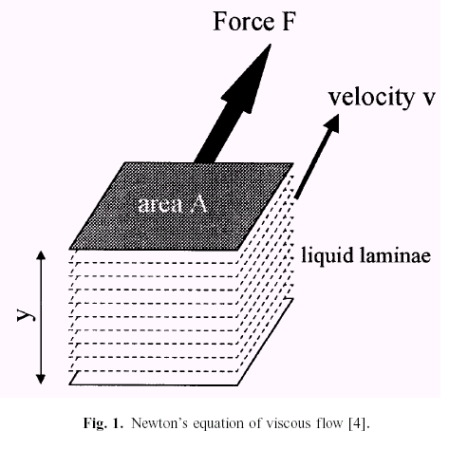

Fig. 2.1– Newton’s equation of viscous flow [9].

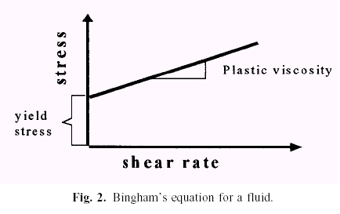

Fig. 2.2– Bingham’s equation for a fluid [9].

Table 2.1– Equations relating viscosity to concentration of suspension (cement paste) [9]

|  |  |  |  |
| --- | --- | --- | --- |
| Equation name | Equation | | Hypothesis |
| Einstein | η = η0 (1+ [η] φ) | | No particle interaction, dilute suspension |
| Roscoe | η = η0 (1- 1.35 φ)k | | Considers particle interaction |
| Krieger-Dougherty | η / η0 = (1- φ / φmax ) –[η] φmax | | Relation between viscosity and particle packing. Takes into account the maximum packing factor |
| Mooney | η= η0 exp [([η]φ) / (1-φ/φmax)] | | Takes into account the maximum packing factor |
| Variable definitions: | | | |
| η = viscosity of the suspension  φ = volume fraction of solid  φmax = maximum packing factor | | k = constant  η0  = viscosity of the liquid / media  [η] = intrinsic viscosity of the suspension | |

Table 2.2– Equations relating shear stress and shear rate (concrete) [9]

|  |  |  |
| --- | --- | --- |
| Equation Name | Equation | |
| Newtonian | τ = η γ• | |
| Bingham | τ = τo + η γ• | |
| Herschel and Bulkley | τ = τo + K γ• n | |
| Power equation | τ = A γ• n  n = 1 Newtonian flow  n > 1 shear thickening  n < 1 shear thinning | |
| Vom Berg  Ostwald-deWaele | τ = τo + B sinh -1 (γ•/C) | |
| Eyring | τ = a γ• + B sinh -1 (γ•/C) | |
| Robertson-Stiff | τ = a (γ• + C)b | |
| Atezeni el al. | τ = α τ2 + β τ + δ | |
| Variable definition: | | |
| τ = shear stress  τo = yield stress | | A, a, B, b, C, K, α, β, δ = constants  η = viscosity  γ• = shear rate |

Figure (2.3) shows some of the idealized types of curves that can be obtained when shear stress is plotted against shear rate. All the depicted curves can be described by one of the equations of Table (2.2). Liquids following the power law are also called pseudo-plastic fluids.

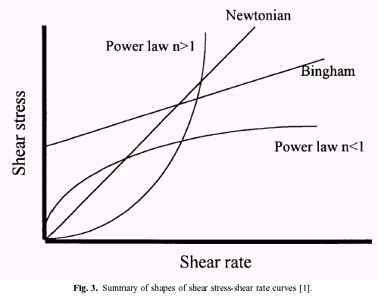

Fig. 2.3– Summary of shapes of shear stress-shear rate curves [9].

Ferraris [9] considered that the main conclusion that can be deduced from studying the proposed equations is that all (with the exclusion of the Newtonian liquid) use at least two parameters to describe the flow. In the case of a concentrated suspension such as concrete, it has been shown that a yield stress exists. The equations that have a physical basis which include at least two parameters, with one being the yield stress, are the Herschel-Bulkley and Bingham equations. The Herschel-Bulkley equation contains three parameters, one of which, n, does not represent a physical entity. It has been shown that in certain concretes, such as SCC, this equation is the best that describes their behavior. Ferraris at al. (2000) [10] stated that if the rheological properties that characterize SCC are examined, the yield stress must be zero or very low and the viscosity must be controlled.

The range of viscosities needed to obtain good consolidation without vibration and without segregation has been the topic of various papers. Most of them used semi-empirical tests such as filling ability tests to characterize concrete flow behavior.

The properties of cement paste or the mortar of SCC were found to be very important to avoid segregation. If the viscosity of the mortar is high enough, the coarse aggregate will be supported by the mortar, thus avoiding segregation. While superplasticizer lowers the yield stress, viscosities such as Viscosity Modifying Agent (VMA) or mineral admixtures are added to increase the viscosity of the paste, without significantly increasing the yield stress.

Sedran (2000) [11] concluded that the rheology of paste or grout could be a useful tool to select a set of cement, mineral addition and superplasticizer to be included in SCC concrete. With rheological measurements, it is possible to separate the effect of the components on the shear yield stress and the plastic viscosity. The aim, today, is to obtain a combination with a low shear yield stress and a sufficient viscosity which allows to roughly compare the components. But the acceptable limits are not well defined simply because the question remains how to relate these properties to the concrete behavior at fresh state. More research is needed on this subject.

The rheological properties of the concrete mixtures are measured by using two rheometers, The IBB rheometer is developed in Canada and consists of a cylindrical container holding the concrete, with an H-shaped impeller driven through the concrete in a planetary motion. The speed of the impeller rotation is first increased to a maximum rotation rate and then the rotation rate is decreased in six stages with each stage having at least two complete center shaft revolutions. The torque (N·m) that generated by the resistance of the concrete specimen to the impeller rotation is recorded at each stage as well as the impeller rotation rate (revolutions per second) is measured by the shaft tachometer.

**2.2.2 Workability**

**2.2.2.1 Introduction**

The ACI 116-00 [12] defined workability as the property of freshly mixed concrete or mortar which determines the ease and homogeneity with which it can be mixed, placed, consolidated and finished.

The ASTM C 125-93 [13] defined workability as the property that determines the effort required to manipulate a freshly mixed quantity of concrete with minimum loss of homogeneity.

Ferraris et al. (2000) [14] illustrated that the workability is defined either qualitatively as the ease of placement or quantitatively by rheological parameters. They stated that the most common rheological parameters, used to qualify workability, are the yield stress and plastic viscosity, as defined by the Bingham or (in some cases like SCC) Herschel-Bulkley equations.

The workability of SCC is higher than the highest classes of consistence described within international standards, but a highly flowable concrete is not necessary SCC, because SCC should not only flow under its own weight but should also fill the entire form and achieve uniform consolidation without segregation.

**2.2.2.2 Key Properties**

SCC differs from conventional concrete in that its fresh properties are critical to its ability to be placed satisfactorily. There are three key properties of workability which need to be carefully controlled to ensure satisfactorily performance during its wet phase and for successful classification as SCC.

EFNARC [6], Tviksta (2000) [15], Vachon (2002) [16], Wüstholz (2003) [17], JSCE (1999) [18], and all other researchers agreed with the following statements.

“A concrete mix can only be classified as Self-compacting Concrete if the requirements for all three characteristics below are fulfilled:

**A-Filling ability:** which is the ability of concrete to flow, maintaining homogeneity whilst undergoing the deformation necessary to completely fill the formwork, encasing the reinforcement and achieving compaction through its own weight. The level of fluidity of the SCC is governed chiefly by the dosing of the Superplasticizer. However, overdosing may lead to the risk of segregation and blockage.

**B-Segregation resistance:** which is the facility of the particle suspension to maintain a cohesive state throughout the mixing, transportation and casting process. Due to the high fluidity of SCC, the risk of segregation and blocking is very high. Preventing segregation is; therefore, an important feature of the control regime. The tendency to segregation can be reduced by the use of a sufficient amount of fines (< 0,125 mm), or using a VMA.

**C-Passing ability:** which is the ability to pass through closely spaced rebars or enter narrow sections in formwork, and to flow around other obstacles without blocking due to aggregate lock.

The clearance between reinforcing bars, the volume of coarse aggregate and the rheological properties of matrix play an important role in the passing ability of SCC in congested areas.

**2.2.2.3 Test methods**

Many different test methods have been developed in attempts to characterize the properties of SCC. However, due to the newness of SCC and its simultaneous development under multiple agencies, few to no testing procedures have been standardized. This has lead to the attempt of different standardization organizations to develop their own testing equipment having different dimensions and varying procedures. This becomes a problem, but is currently being addressed by organizations such as ASTM. ASTM Committee [C09](http://www.astm.org/COMMIT/COMMITTEE/C09.htm) on Concrete and Concrete Aggregates has begun work toward developing standards for SCC.

So far no single method or combination of methods has achieved universal approval and most of them have their adherents. Similarly no single method has been found which characterizes all the relevant workability aspects so each mix design should be tested by more than one test method for the different workability parameters.

For the initial mix design of SCC, all three workability parameters need to be assessed to ensure that all aspects are fulfilled. For site quality control, two test methods are generally sufficient to monitor production quality. With consistent raw material quality, a single test method operated by a trained and experienced technician may be sufficient.

Workability tests for SCC can be broadly split into three categories: filling ability tests, passing ability tests and segregation resistance tests. Each test fits into one or more of these categories. Test methods for the three parameters are listed in Table (2.3).

Table 2.3– List of test methods for workability properties of SCC

|  |  |
| --- | --- |
| Property | Method |
| Filling ability | Slump-flow by Abrams cone |
| Filling ability | T50cm slump-flow |
| Filling ability + Segregation resistance | V-funnel |
| Filling ability | Ormit |
| Passing ability | J-ring |
| Passing ability | L-box |
| Passing ability | U-box |
| Passing ability | Fill-box |
| Segregation resistance | GTM screen stability test |
| Segregation resistance | V-funnel at T5minutes |

**2.2.2.4 Acceptance Criteria**

Typical acceptance criteria for SCC (EFNARC [6], Tviksta [15], VACHON [16] and JSCE [18]) with a maximum aggregate size up to 20 mm are shown in Table (2.4). These typical requirements shown against each test method are based on current knowledge and practice. Values outside these ranges may be acceptable if the producer can demonstrate satisfactory performance in the specific conditions, e.g, large spaces between reinforcement, layer thickness less than 500 mm, short distance of flow from point of discharge, very few obstructions to pass in the formwork, very simple design of formwork, etc.

Special care should always be taken to ensure no segregation of the mix occurs. At present, there is not a simple and reliable test that gives information about segregation resistance of SCC in all practical situations.

Table 2.4– Acceptance criteria for Self-compacting Concrete

|  |  |  |  |  |  |  |  |
| --- | --- | --- | --- | --- | --- | --- | --- |
| **Typical range of values** | | | | | | | **Method** |
| **Unit** | **Symbol** | **Minimum** | | | **Maximum** | |
| mm | D | 600** | 500* | | 750 | | Slumpflow by Abrams cone |
| sec | T50 | 3** | 2* | | 25** | 5* | T50cm slumpflow |
| sec | T | 6 | | | 12 | | V-funnel |
| sec | T5 | 0 | | | +3 | | Time increase, V-funnel at T5minutes |
| - | Blocking Ratio  (h2/h1) | 0.8 | | | 1.0 | | L-box |
| mm | ΔH | 50** | | 30* | 0 | | U-box |
| * EFNARC  ** JSCE | | | | | | | |

**2.3 Mix Design Methods**

**2.3.1 Introduction**

The basic components of the mix composition of SCC are the same as those used in conventional concrete. However, to obtain the requested properties of fresh concrete in SCC, a higher proportion of ultrafine materials and the incorporation of chemical admixtures, in particularly an effective superplasticizer, are necessary. Because of this, self-compactability can be largely affected by the characteristics of materials and mix proportion.

No standard or all-encapsulating method for determining mixture proportions currently exists for SCC. However, many different proportion limits have been listed in various publications. Therefore, a rational mix-design method for SCC using variety of materials is necessary. Mix designs of SCC must satisfy the criteria on filling ability, passability and segregation resistance. Multiple guidelines about mixture proportions for SCC are found, summarized in Table (2.5) and discussed in the following sections.

Table 2.5– Limits on SCC material proportions [1]

|  |  |  |  |
| --- | --- | --- | --- |
|  | High Fines | VMA | Combination |
| Cementitous (kg/m3) | (450-600) | (385-450) | (385-450) |
| Water/Cementitous Material | 0.28-0.45 | 0.28-0.45 | 0.28-0.45 |
| Fine Aggregate/Mortar (%) | 35-45 | ~40 | ~40 |
| Fine Aggregate/Total Aggregate (%) | 50-58 | - | - |
| Coarse Aggregate/Total Mixture (%) | 28-48 | 45-48 | 28-48 |

**2.3.2 Mechanism for achieving self-compactability**

According to the previous illustration, the method for achieving self-compactability involves not only high deformability of paste or mortar, but also resistance to segregation between coarse aggregate and mortar when concrete flows through the confined zone of reinforcing bars.

Okamura and Ozawa [19] employed the following methods for achieving self-compactability {Fig. (2.4)}:

* Limited aggregate content
* Low water-powder ratio
* Use of superplasticizer

They stated that the collision and contact between aggregate particles can increase as the relative distance between particles decreases and then internal stress can increase when concrete is deformed, particularly near obstacles. They also found that the energy required for flowing is consumed by the increased internal stress, resulting in blockage of aggregate particles. Limiting the coarse aggregate content, whose energy consumption is particularly intense, to a level lower than normal is effective in avoiding this kind of blockage.

Limited Gravel Content

Appropriate Mortar

Limited Sand Content

Higher Deformability

Moderate Viscosity

50% of solid volume

40% of mortar volume

Higher dosage of SP

Lower W\C

Fig. 2.4– Methods for achieving self-compactability [19]

On the other hand, highly viscous paste is also required to avoid the blockage of coarse aggregate when concrete flows through obstacles {Fig.(2.5)}. When concrete is deformed, paste with a high viscosity also prevents localized increases in internal stress due to the approach of coarse aggregate particles. High deformability can be achieved only by employment of a superplasticizer and keeping the water-powder ratio to a very low value.

Coarse

Aggregate

Limited content

Mortar

1. Compatible of deformability & viscosity.

Low water-powder ratio

High superplasticizer dosage

2. Low pressure transfer

Limited fine aggregate content

Rebars

Fig. 2.5– Mechanism for achieving self-compactability [19]

**2.3.3 Okamura and Ozawa Method**

Okamura and Ozawa [19] proposed a simple proportioning system. The coarse and fine aggregate contents are fixed so that self-compactability can be achieved easily by adjusting the water-powder ratio and superplasticizer dosage only.

* The coarse aggregate content in concrete is fixed at 50% of the solid volume.
* The fine aggregate content is fixed at 40% of the mortar volume.
* The water-powder ratio by volume is assumed as 0.9 to 1.0, depending on the properties of the powder.
* The superplasticizer dosage and the final water-powder ratio are determined so as to ensure self-compactability.

In the mix proportioning of conventional concrete, the water-cement ratio is selected to obtain the required strength. Okamura and Ozawa stated that with SCC the water-powder ratio has to be decided taking into account self-compactability because self-compactability is very sensitive to this ratio. They stated also, in most cases, the required strength does not govern the water-cement ratio because the water-powder ratio is small enough for obtaining the required strength for ordinary structures unless most of the powder in use is not reactive.

The characteristics of the powder and superplasticizer largely affect the mortar property, and so the proper water-powder ratio and superplasticizer dosage cannot be fixed without trial mixing at this stage.

**2.3.4 EFNARC Approaches**

EFNARC [6] stated that in designing the mix, it is most useful to consider the relative proportions of the key components by volume rather than by mass. This institute adopted two approaches for designing SCC.

**EFNARC’s Requirements**

**First Approach :**

* Absolute volume of coarse aggregate (VG) = (28-35)% by volume of concrete.
* Total absolute volume of powder (VC+VL) = (0.16-0.24) by volume of concrete.



(VcV+wVL) ratio = (0.80 -1.10).

( 400 ≤ WC+WL ≤ 600 ) kg/m3.

Vw ≤ 200 lit./m3, i.e. W ≤ 200 kg/m3.

**Second approach**

This approach is based on a method developed by Okamura. The sequence is determined as:

A) Definition of the desired air content ( mostly 2 % ) : air content may generally be set at 2 per cent, or a higher value specified when freeze thaw resistant concrete is to be designed.

B) Determination of coarse aggregate volume : coarse aggregate volume is defined by bulk density. Generally coarse aggregate content (D> 4 mm) should be between 50 per cent and 60 per cent. When the volume of coarse aggregate in concrete exceeds a certain limit, the opportunity for collision or contact between coarse aggregate particles increases rapidly and there is an increased risk of blockage when concrete passes through spaces between steel bars. The optimum coarse aggregate content depends on the following parameters :

* Maximum aggregate size. The lower the maximum aggregate size, the higher the proportion of coarse aggregate.
* Crushed or rounded aggregates. For rounded aggregates, content higher than for crushed aggregates can be used.

C) Determination of sand content: sand, in the context of this mix composition procedure is defined as all particles larger than 0,125 mm and smaller than 4 mm. Sand content is defined by bulk density. The optimal volume content of sand in the mortar varies between 40 – 50 % depending on paste properties.

D) Design of paste composition : initiallythe water:powder ratio for zero flow (βp ) is determined in the paste, with the chosen proportion of cement and additions. Flow cone tests with water/powder ratios by volume of e.g. 1.1, 1.2, 1.3 and 1.4 are performed with the selected powder composition, see Fig.(2.6). The point of intersection with the y - axis is designated the βp value. This βp value is the water adsorbed on the powder surface together with that required to fill the voids in the powder system and provide sufficient dispersal of powder and is used mainly for quality control of water demand for new batches of cement and fillers.

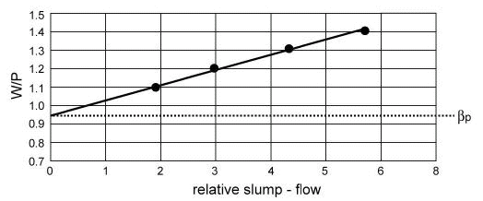

Fig. 2.6– Determination of water/powder ratio βp [6]

E) Determination of optimum volumetric water/powder ratio and superplasticizer dosage in mortar : tests with flow cone and V-Funnel for mortar are performed at varying water/powder ratios in the range of [ 0.8 – 0.9 ] βp and dosages of superplasticizer. The superplasticizer is used to balance the rheology of the paste. The volume content of sand in the mortar remains the same as determined above.

**2.4 Influences of SCC Constituents**

**2.4.1 Introduction**

The materials used for SCC are selected from those used by the conventional concrete industry. Typical materials used for SCC are as follows: coarse aggregate, fine aggregate, cement, mineral admixtures and chemical admixtures (superplasticizer, viscosity-modifying agents).

Gibbs [20] stated that SCC can be designed and constructed using a broad range of normal concreting materials, and that this is essential for SCC to gain popularity.

The constituent materials, used for the production of SCC should generally comply with the requirements of international standards. The materials should be suitable for the intended use in concrete and do not contain harmful ingredients in such quantities that may be detrimental to the quality or the durability of the concrete, or cause corrosion of the reinforcement.

The works of many researchers assigned that the properties and amounts of concrete constituents have important effects on rheological behavior, stability, blocking, strength etc of a certain SCC.

**2.4.2 Cement**

EFNARC [6] stated that the general suitability (for producing SCC) is established for cement conforming to EN 197-1[2]. According to Rawa’a (2003) [26] there are no significant differences between Iraqi and European cement standards with respect to the most physical and chemical properties and tests results. So, it can be said that the General suitability (for producing SCC) is established for cement conforming to IOS No. 5:1984 [27] also.

Emborg (2000) [28] stated that the influence of variation of cement on SCC is, so far, not clearly documented but some observations have been made during the production of this new concrete. Emborg assigned an example, in Sweden serious problems of achieving target consistency during 90 minutes have arisen during winter/spring 2000. The main reasons have been the variations of gypsum addition at the cement manufacturing and the variations of other production moments that lead to the well known problem of false set and rapid set to which the SCC is more sensitive.

**2.4.3 Mixing Water**

EFNARC [6] stated that the suitability of mixing water is the same as in conventional concrete.

It is well known that the amount of water in normal concrete is of particular importance for the properties at the fresh stage, i.e. the workability, and of course for the properties of hardened concrete by affecting the water cement ratio. For SCC, the amount of water is even more important and in mix design methods of this family of concrete, water is addressed in several relations such as: water/total fines (powder + fine aggregate) and water to powder ratio.

Figure (2.7) shows some data from literature where it is seen that, for a certain SCC without viscosity agent, the amount of water (here: ratio of water to total fines) is quite limited.

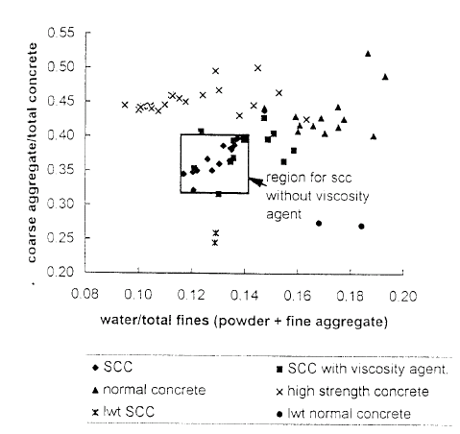

Fig. 2.7– Influence of water/total fines on concrete mix optimization [28]

Concerning the amount of water, experiments by Sakai et al (1994) [29] showed a strong influence on slump flow when the amount of water is changed by ± 5 kg/m³ (equaling a change in moisture content by 0.7 % of sand), see Fig. (2.8). By adding a viscosity agent, these variations were limited.

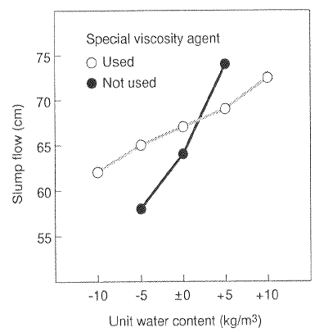

Fig. 2.8– Slump flow with and without viscosity agent

when water content is varied (w\c ratio: 0.53). [29]

**2.4.4 Aggregates**

The coarse aggregate chosen for SCC is typically round in shape, well graded and smaller in maximum size than that used for conventional concrete; typical conventional concrete could have a maximum aggregate size of 37.5mm or more. In general, a rounded aggregate and smaller aggregate particles aid in the flowability and deformability of concrete as well as in the prevention of segregation.

Crushed stone or angular aggregates can be successfully used in SCC; however, adjustments to the mixture proportions must be made in order to increase the amount of flowability (as compared to an SCC created with round gravel). Petersson (1999) [30] stated that both natural and crushed aggregates can be successfully used in SCC as long as attention is given to the amount of paste necessary to avoid blocking of the aggregates (crushed coarse and fine aggregates require more paste, while uncrushed aggregates and smaller maximum size require less paste).

Gradation is an important factor in choosing a coarse aggregate, especially in typical uses of SCC where reinforcement may be highly congested or the formwork has small dimensions. Gap-graded coarse aggregate promotes segregation to a greater degree than does well-graded coarse aggregate.

As with conventional concrete construction, the maximum size of the coarse aggregate for SCC depends upon the type of construction. Typically, the maximum size of coarse aggregate used in SCC ranges from approximately 10 mm to 20 mm.

Petersson also stated that the most common maximum aggregate size is in the range of 16 to 20 mm. When these smaller coarse aggregate sizes are considering, it should be noted that for mixtures with aggregate having a maximum size of 10 mm, no suitable methods are found to check segregation.

Gibbs [20] explained that SCC requires restrictions on aggregate size, but only as it would for conventional concrete. This is supported by the statement that work on the Brite-EuRam project at Paisley University [31] successfully used 20 mm aggregate, even with moderately heavy reinforcement, and the SCC poured into the Honshu-Shikoku bridge anchorage actually included 40 mm aggregate as its main volume fraction [20].

Bartos (2000) [32] stated that the need for cohesion and resistance to segregation affects the choice of materials to a greater extent than conventional concrete; coarse sands may be unsuitable for SCC because of the extent to which they promote bleeding.

It is usually regarded that the smaller the aggregate, the more drying shrinkage will occur; but the larger the aggregate, the more difficult it will be to attain the necessary flowability, deformability and segregation resistance for the mixture. However, Neville (2000) [33] stated that the factor that most affects shrinkage in concrete is the total amount of aggregate.

Su et al. (2002) [34] stated that the sand/total aggregate (S/A) ratio is an important material parameter of SCC and the rheological properties increase with an increase in the S/A ratio. On the other hand, this ratio affects the hardened properties of SCC, especially elastic modulus. They found that, the proper S/A ratio for SCC is suggested to be 47.5%.

**2.4.5 Chemical Admixtures**

Two types of chemical admixtures are commonly used in the production of SCC: superplasticizers and viscosity modifying agents VMA. Recently, shrinkage reducing admixture (SRA) has been used as new type {Collepardi (2003) [35]}.

Superplasticizer is essential for the creation of SCC. In recent times, the evolution of superplasticizers has become rapid and results in ever-improving synthetic chemical admixtures. These newer products will continue to evolve and improve; at the current time, the superplasticizer best suited for SCC is of the newer polycarboxylate type.

Conventional Superplasticizers, such as those based on sulphonated melamine and naphthalene formaldehyde condensates, at the time of mixing, are absorbed onto the surface of the cement particles. This absorption takes place at a very early stage in the hydration process. The sulphonic groups of the polymer chains increase the negative charge on the surface of the cement particle and dispersion of the cement occurs by electrostatic repulsion.

Polycarboxylate Superplasticizer is differentiated from the conventional Superplasticizer in that it is based on a unique carboxylic ether polymer with long lateral chains. This greatly improves cement dispersion. At the start of the mixing process, the same electrostatic dispersion occurs, as described previously, but the presence of the lateral chains, linked to the polymer backbone, generates a steric hindrance which stabilizes the cement particles capacity to separate and disperse. This mechanism provides flowable concrete with greatly reduced water demand {Degussa; Glenium 51 (2002) [36]}.

Okamura and Masahiro (2003) [37] summarized the requirements for superplasticizer in SCC as:

* High dispersing effect for low water/powder ratio: less than approx. 100% by volume.
* Maintenance of the dispersing effect for at least two hours after mixing.
* Less sensitivity to temperature changes.

The job of superplasticizer is to impart a high degree of flowability and deformability; however, the higher dosages (when compared to conventional concrete) generally associated with SCC can lead to a high degree of segregation. When a superplasticizer is only used, concrete tends to segregate due to the loss in yield stress of the concrete coupled with the fact that materials with different specific gravities reside within the mixture. One of the main characteristics of SCC is segregation avoidance, also referred to as “stability” of SCC.

Three methods exist for increasing the viscosity of concrete, and these will be referred to as in the following approaches:

* VMA Approach
* High Fines Approach
* Combination Approach

All methods use a superplasticizer to increase the fluidity of the mixture. The difference between the three approaches lies in the method used to combat the segregation that will occur when superplasticizers are used. The desired mixture should result in a fluid mixture that is viscous enough to avoid segregation.

The VMA Approach uses a chemical admixture to increase the viscosity of the mixture. Addition of another chemical admixture (besides the superplasticizer) further increases the complexity of the mixture chemistry.

According to Petersson [30], up to 10 % of filler can be replaced by using a viscosity modifying agent; but this cannot replace the filler. His findings also showed that when VMA is used, the workability over time decreases compared with mixtures with only fillers, and that this is a difficulty when VMA is used for SCC. The recommendations of the project also showed that with modern superplasticizers and filler, no VMA is normally necessary; and only for special applications a VMA should be used. He also stated that when a VMA is used the early-age strength considerably decreases.

Hodgson (2003) [38] stated that the use of increased amounts of fine material (the High Fines Approach) appears to be the most suitable.

**2.4.6 Mineral admixtures**

**2.4.6.1 Background**

Mineral admixtures, additions, or supplementary cementitious materials have long provided the means to improve the fresh and hardened properties of concrete and at the same time reduce the cost of concrete materials.

Mindess and Young (1981) [39] defined mineral admixtures as "finely ground solid materials added to improve the workability of fresh concrete and the durability of hardened concrete. They subdivided this class of admixtures into:

* Materials of low reactivity.

* Cementitious materials.

* Pozzolanic materials.

Mehta (1986) [40] defined mineral admixtures as "finely divided siliceous materials added to concrete in relatively large amounts, generally in the range 20 to 100 percent by weight of Portland cement, and classified them as:

* Cementitious like ground granulated blast-furnace slag.

* Cementitious and pozzolanic like high-calcium fly ash.

* Highly active pozzolanas like condensed silica fume & rice husk ash.

* Normal pozzolanas like low-calcium fly ash & natural materials.

* Weak pozzolanas are like slowly cooled blast-furnace slag & field burnt rice husk ash.

Neville [33] used the term “cementitious materials” for all the powdered materials, and defined pozzolanas as a natural or artificial materials containing silica in a reactive form. He also defined the fillers as very finely-ground materials of about the same fineness as Portland cement, owing to their physical properties, which have a beneficial effect on some properties of cement, such as workability, density, permeability, capillarity, bleeding or cracking tendency.

EFNARC [6] and the British Cement Association (2002) [41] defined additions as “Finely-divided inorganic materials used in concrete in order to improve certain properties or to achieve special properties”, and classified them into two categories:

* Type I (semi-inert) additions like finely crushed (lime stone, dolomite or granite), filler aggregate, pigments …etc.

* Type II (pozzolanic or latent hydraulic) like silica fume, metakaolin, rice husk ash, fly ash, ground granulated blast-furnace slag …etc.

BS EN 206–1 [42] places little restriction on the use of additions, simply stating that additions of Type I and Type II may be used in concrete in quantities as used in the ‘initial tests’. Initial tests are defined in BS EN 206–1 Annex A, as those required to demonstrate that all the specified requirements for the fresh and hardened concrete are satisfied. These initial tests may consist of laboratory work or long-term experience.

Aitcin (1998) [43], and Bentur (2002) [44] stated that the overall composition of mineral admixtures is defined within the ternary diagram CaO-SiO2-Al2O3 shown in Fig. (2.9).

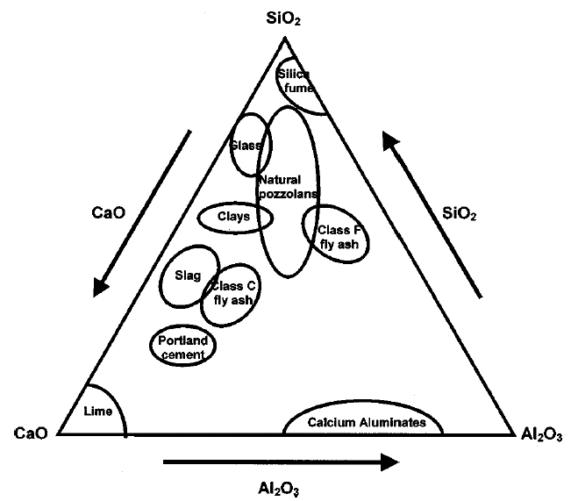

Fig. 2.9– Ternary diagram representing overall composition

of cementitious materials [44]

**2.4.6.2 Mineral Admixtures in SCC**

Collepardi (2002) [45] stated that the most important basic principle for flowing and cohesive concretes including SCCs is the use of superplasticizer combined with a relatively high content of powder materials in terms of Portland cement, mineral additions, ground filler and/or very fine sand.

Ramsburg and Neal (2003) [46] stated that the successful production of SCC is dependant on arriving at an appropriate balance between the yield stress and the viscosity of the paste. Specially formulated high range water reducers are used to reduce the yield stress to a point to allow the desired free flowing characteristics of the concrete. However, this alone may result in segregation if the viscosity of the paste is not sufficient to support the aggregate particles in suspension. To achieve the desired viscosity, it is customary to use either high cement content, VMA, or both. An alternate methodology is to employ a supplementary cementitious material that can increase the cohesion or viscosity of the paste as well as provide the desired early strength.

2.4.6.3 Influence on the Fresh State

It is usually reported that, if the volume concentration of a solid is held constant, the addition of mineral admixtures improves concrete performance but reduces workability. The most common reason for poor workability is that the addition of a fine powder will increase the water demand due to the increase in surface area. However, in certain cases, it is reported in the literature that the use of fine mineral admixtures can reduce the water demand or increase the slump. Lange et al. (1997) [47] measured the water demand of mortars with increasing additions of a very fine blast furnace slag. He found that, for a specific flow, an optimum amount of blast furnace slag reduces the water demand of the mortar. Ferraris et al. (2001) [48] explained that the workability enhancement is due to the reduction in inter-particle friction by the easily roll of spherical particles (of certain fine mineral admixtures) over one another. The spherical shape also minimizes the particle's surface to volume ratio, resulting in low fluid demands. Sakai et al. (1997) [49] reported that a higher packing density is obtained with spherical particles as compared to crushed particles in a wet state, and this results in lower water retention in the spherical case and subsequently low water demand for a specific workability.

Sakai et al., also, reported that there is a strong dependence of fluidity on the average particle size of mineral admixture. It was explained that, at an optimal particle size, the packing density is maximum, which helps to achieve fluidity. Collins and Sanjayan (1999) [50] reported that in concrete containing alkali-activated ground granulated slag as the binder, the workability is improved by replacing part of the binder with ultrafine materials. It was also reported that some similar materials (in particle size) are not effective in improving the workability (Ferraris et al. [48]).

Domone and Jin (1999) [51] found that the workability retention of mortars for SCC is dependent on a combination of factors including the powder composition and the type and dosage of superplasticizer. They also found that mixes with ternary blends of powders may provide a beneficial combination of properties. They stated that there is scope for work to define optimum blends for the combination of fresh, early age and hardened properties required.

Petersson [30] mentioned recommendations for the gradation of mineral admixtures (he referred to these materials used to increase the viscosity of the mixture as “filler”) in SCC to, if possible, avoid a grading curve that coincides with the cement’s grading curve. Petersson went on to state that a relative flat grading curve, compared with the cement, gives good workability with a reasonable amount of admixture.

Holt and Schodet (2002) [52] concluded from their work on the early age shrinkage of SCC that the high amount of limestone powder added to SCC compared with reference concrete resulted in lower shrinkage because of the restraint provided by stiffening paste before setting time.

**2.4.6.4 Influence on the Hardened State**

Neville [33] and Aitcin [43] stated that most of supplementary cementitious materials have one feature in common, which is they contain some form of vitreous reactive silica which, in the presence of water, can combine with lime, at room temperature, to form calcium silicate hydrate of the same type as that formed during the hydration of Portland cement. They stated also that the silica has to be amorphous, that is, glassy, because crystalline silica has very low reactivity.

Neville [33] illustrated that other researchers found that CaCO3, which is common filler, reacts with C3A and C4AF to produce 3CaO.Al2O3.CaCO3.11H2O, and becomes partly incorporated into the C-S-H phase. Neville stated that this effect on the structure of the hydrated cement paste is beneficial.

British Cement Association [41] stated that the additions can influence many concrete properties, including:

* + sulfate resistance;
  + chloride resistance;
  + protection against reinforcement corrosion;
  + freeze/thaw resistance; - chemical resistance;
  + strength;
  + permeability;
  + abrasion resistance;
  + heat generation;
  + aesthetic properties such as color.

The previous reference also stated that in some circumstances, specific additions at specific proportions may be specified to enhance selected properties of the concrete.

Ramsburg and Neal [46] also stated that in the pre-cast industry early age strength is a critical factor, and to maintain an efficient production schedule, the concrete strength has to be sufficient for stripping and handling by an age of about 14 to 18 hours. Therefore, the additions to be used would not only have to complement the SCC technology, but also to be capable of achieving early-age strength similar to the standard production mix.

Many researchers[3] evaluated the hardened properties of SCC, and made a comparison with the same properties of the conventional concrete. All of them found that there is a significant improvement in hardened SCC properties.

Based on their experimental investigations and a large number of test results taken from the literature, Holschemacher and Klug (2002) [53] created a database with regard to the hardened properties of SCC. They stated the following:

1. The reasons for the possible differences between the hardened properties of SCC and the conventional concrete are mentioned in the following facts:

* Better microstructure and homogeneity of SCC: Many investigations, carried out by means of efficient microscopes, show an improved microstructure of SCC opposite to normal vibrated concrete. So, the void ratio of SCC in the interfacial transition zone between cement paste and aggregate is essentially lower and the pores are distributed much more evenly.
* Higher content of ultrafine materials & addition of additives: High content of ultrafine materials, usage of effective superplasticizer, and if necessary, stabilizer characterize the special composition of SCC. The addition of concrete additives and admixtures, necessary for SCC, with the production of conventional concrete is an exception, or at least their percentage at SCC is considerably higher.

1. Some of the published test results show that an increase of the cement content and a reduction of filler content at the same time increase the initial concrete strength and the ultimate concrete strength.
2. If limestone powder is used, higher compressive strengths are noticeable at the beginning of the hardening process.
3. There is a tendency of a higher splitting tensile strength of SCC. Likely as not, the reason for this fact is given by the better microstructure, especially the smaller total porosity and the more even pore size distribution within the interfacial transition zone of SCC. Further, on denser cement, matrix is present due to the higher content of ultrafines.
4. A relative lower modulus of elasticity can be expected, because of the high content of ultrafines and additives as dominating factors and, accordingly, minor occurrence of coarse and stiff aggregates at SCC.
5. The denser microstructure of the cement paste can be achieved by the addition of fillers with fineness larger than that of cement, whereby the shrinkage dimension is positively affected.

The bond between reinforcement and concrete is influenced by various parameters, both from the reinforcing bar and from the surrounding matrix. Within SCC, the main interesting factors are the grading of the aggregates and the ultrafine material content, the consistency and application of superplasticizer and stabilizer. Depending on the mix design and the modified test specimens it was found out, that the bond behavior in SCC is better than normal vibrated concrete.

**2.4.6.5 Concluding Remarks**

From the work of prior researchers and many others, {Ramsburg et al. (20003) [54], Ozylidirim & Lane (2003) [55], Naike et al. (2003) [56], Kim et al. (1998) [57], Dietz & Ma (2000) [58], Kumar & Kaushik (2002) [59], Ma & Dietz (2002) [60], Folarin et al. (1998) [61], Poon et al. (2003) [62], Persson (2003) [63], Dehn et al. (2000) [64], Daczko (2003) [65], and Johansen & Hammer (2002) [66]}, it can be concluded that the use of additional cement size materials is necessary for the production of SCC, and the type, amount, fineness, particle distribution size and the number of these materials have a significant influence on fresh and hardened properties of SCC.

Ferraris et al. [48] stated that at present, this selection cannot be predicated from physical or chemical characteristics of the mixture, and can be only determined using properly designed test.

**2.4.6.6 A Brief Description about Mineral Admixtures**

**Limestone Powder**

BS 7979, Specification for limestone fines for use with Portland cement [67] defined limestone fines as a fine powder obtained from the processing of limestone, and stated that there is uncertainty over whether limestone fines should be classified as a Type II or Type I addition. It is less reactive than Type II addition, but research shows that it may have slight reactivity as well as any physical effects conferred by virtue of its fine particle size. It can be concluded from the results of many researches that limestone powder has a good performance in both fresh and hardened SCC.

Chapter Three

Materials and Experimental Work

**3.1 Introduction**

The original objective of this study is to determine the relative behavior of SCC when the:

1. Type, dosages, fineness and number of mineral admixtures constant.
2. Five different ratio of Superplasticizer are added.

The tests are conducted in order to view the differences in behavior made during the fresh state as well as the hardened state. The Slump flow, L-box and V-funnel are performed during the fresh state. After concrete has cured; compressive strength, measurements and non- destructive tests are performed.

**3.2 Materials**

Effective production of SCC is achieved by more stringent requirements on materials selecting, controlling and proportioning all of the ingredients. Optimum proportions must be selected according to the mix design methods, considering the characteristics of all materials used.

**3.2.1 Cement: -**

Ordinary portland cement produced at northern cement factory (Tasluja-Bazian) was used throughout this investigation. The cement was stored in air-tight plastic containers to avoid the harmful effects of humidity. Analysis of chemical composition and physical properties of this cement were made at the Engineering consultancy bureauat College of Engineering /Al-Mustansiriya University. The results are shown in **Tables (3.1) and (3.2)** respectively. Results showed that the cement is conformed to the Iraqi specification No. 5/1984(66 ).

Table (3.1): Percentage of Oxide Composition and Main Compounds of Cement Used Throughout this Work.

|  |  |  |  |
| --- | --- | --- | --- |
| Oxide composition | **Abbreviation** | **Content (percent)** | **Limit of Iraqi specification No.5/1984** |
| Lime | CaO | 63.19 | --- |
| Silica | SiO2 | 20.60 | --- |
| Alumina | AL2O3 | 4.10 | --- |
| Iron Oxide | Fe2O3 | 4.48 | --- |
| Sulphate | SO3 | 1.98 | < 2.8% |
| Magnesia | MgO | 2.28 | ≤ 5% |
| Loss on Ignition | L.O.I | 2.45 | ≤ 4% |
| Insoluble residue | I.R | 0.47 | ≤1.5% |
| Lime saturation factor | L.S.F | 0.94 | 0.66-1.02 |
| Main compounds (Bogue’s equations) |  |  |  |
| Tricalcium Silicate | C3S | 57.11 |  |
| Di Calcium Silicate | C2S | 16.23 |  |
| Tri Calcium Aluminate | C3A | 8.39 | > 5% |
| Tetra Calcium Alumina Ferrite | C4AF | 13.62 |  |

Table (3.2): Physical Properties of the Cement Used in this Work.

|  |  |  |
| --- | --- | --- |
| Physical properties | **Test Results** | **Limit of Iraqi specification No. 5/1984** |
| Specific Surface area (Blaine Method , cm2/gm) | 3329.0 | ≥ 2300.0 |
| Setting time (Vicats Method)  Initial Setting time, hrs. : min  Final Setting time, hrs. : min | 2:10  3:45 | ≥ 1:00  ≤ 10:00 |
| Compressive strength of mortar  3- days, N / mm2  7- days, N / mm2 | 32.4  40.5 | ≥ 15  ≥ 23 |

**3.2.2 Fine Aggregate: -**

As illustrated previously, the grading and particle shapes of fine aggregate are significant factors in the production of SCC. Fine aggregate with rounded particle shape and smooth textures requires less mixing water in concrete and for this reason is preferable in SCC.

Natural sand from is used in this work. Table (3.3) and Fig. (3.1) show the grading of the fine aggregate and the limits of the Iraqi specification No.45/1984 [68]. Table (3.4) shows the physical properties of the fine aggregate that are performed by the National Center for Construction Laboratories (NCCL).

Table 3.3 – Grading of Fine Aggregate

|  |  |  |
| --- | --- | --- |
| Sieve size  (mm) | % Passing by  weight | Limits of the Iraqi specification No.45/1984 (zone 2) |
| 4.75 | 100 | 90-100 |
| 2.36 | 93.3 | 75-100 |
| 1.18 | 84.0 | 55-90 |
| 0.60 | 57.2 | 35-59 |
| 0.30 | 27.5 | 8-30 |
| 0.15 | 8 | 0-10 |
| Fineness Modulus = 2.33 | | |

Table 3.4 – Physical Properties of Fine Aggregate

|  |  |  |
| --- | --- | --- |
| Physical Properties | Test Results | Limits of the Iraqi specification No.45/1984 |
| Specific gravity | 2.60 | - |
| Sulfate content | 0.08 % | ≤ 0.50 % |
| Absorption | 0.75 % | - |

Fig. 3.1 – Grading Curve for Fine Aggregate with grading limits in zone 2

**3.2.3 Coarse Aggregate: -**

Crushed gravel of maximum size( 12.5) mm is used. Table (3.5) and Fig. (3.2) show the grading of this aggregate, which conforms to the Iraqi specification No.45/1984 [68]. The specific gravity, sulfate content and absorption of coarse aggregate are illustrated in Table (3.6).

Table 3.5 – Grading of Coarse Aggregate

|  |  |  |
| --- | --- | --- |
| Sieve size  (mm) | % Passing by  weight | Limits of the Iraqi specification No.45/1984 |
| 12.5 | 100 | 100 |
| 10 | 88.6 | 85-100 |
| 5 | 10.8 | 0-25 |
| 2.36 | 0 | 0-5 |

Table 3.6 – Physical Properties of Coarse Aggregate

|  |  |  |
| --- | --- | --- |
| Physical Properties | Test Results | Limits of the Iraqi specification No.45/1984 |
| Specific gravity | 2.63 | - |
| Sulfate content | 0.06 % | ≤ 0.1 % |
| Absorption | 0.63 % | - |

Fig. 3.2 – Grading Curve for Coarse Aggregate

**3.2.4 Water: -**

Tap water is used for both mixing and curing of concrete.

**3.2.5 Superplasticizer: -**

One of the new generations of copolymer-based superplasticizer, designed for the production of High Performance Concrete is used (Glenium 51). Appendix A contains the properties of this product.

**3.2.6 Mineral Admixtures: -**

one locally available type of mineral admixtures is used for the purpose of this study. Limestone powder is produced locally, while the fumed silica is imported from special companies.

**3.2.6.1 Limestone Powder (LSP)**

This material is locally named as “Al-Gubra”. It is a white grinding material from lime-stones excavated from different regions in Iraq, and usually used in the construction processes. In this work, a fine limestone powder, grinded by blowing technique, has been used. The cost of grinding is very low, and the fineness of the gained material is very high. The chemical composition of LSP is listed in Table (3.7).

Table 3.7 – Chemical Composition and Physical Properties of LSP

|  |  |
| --- | --- |
| Chemical Properties | |
| Oxides | Content % |
| SiO2 | 1.38 |
| Fe2O3 | 0.12 |
| Al2O3 | 0.72 |
| CaO | 56.1 |
| MgO | 0.13 |
| SO3 | 0.21 |
| L.O.I | 4.56 |
| Physical Properties | |
| Fineness (Blain) | 3100 |

**3.3 Preliminary Investigations**

**3.3.1 Introduction: -**

The preliminary investigations of this study include evaluation of the equipment and test procedures, evaluation of the mixture proportioning method chosen, mixing procedure and preliminary dosage of superplasticizer. Testing for these initial investigations is limited to fresh concrete properties. In this phase of work, no changes are made to all materials except the dosages of superplasticizer. Mineral admixture is used at this phase. Figure (3.3) is a summary of the experimental design for the initial investigations.

Fig. 3.3 Summary of the Experimental Design for the Initial Investigations

**3.3.2 Determining of Mix Design Method**

Initially EFNARC first approach for mix design method (section 2.3.4) is used, and then the proportions of materials modified after the evaluation by fresh tests have been done. The modifications are made according to EFNARC [6] and sections 2.3 and 2.4 of this study.

**3.3.3 Evaluation of the Equipments and Test Procedures of Fresh Concrete**

After determining a suitable mixture proportioning method and the materials for this study, the experimental process begins. Because of this study is one of the earlier studies that investigates SCC in Iraq, the various pieces of experimental equipment used to evaluate the fresh concrete (such as the Slump flow, L-box and V-funnel) are fabricated according to the specifications and requirements stated in section (2.2.2.3). The first priority is to determine if the equipment works as expected. Table (3.8) contains the first data set created during this study. The data represent concrete mixes designed to be SCC with the single variable of superplasticizer dosage. The dosages range from 0.50 to 2.5 liters per 100 kg of cement

( mineral admixture has been used in this stage). The data are taken from the results of Slump flow, L-box and V-funnel tests.

Table (3.8) shows that as the dosage of superplasticizer increases, the slump flow increases. This is expected because as the superplasticizer dosage increases the fluidity of the concrete also increases. The L-box values increase as superplasticizer dosage increases; this translates that as the dosage increases, concrete is more able to flow through reinforcement. The V-funnel values are the most variables of the tests. These values display a trend of decrease in time to flow through the orifice with the increases in superplasticizer dosage, but due to the lack of a viscosity modifying admixture, the values increase after optimal dosage because of blocking behavior of coarse aggregate. From these data sets, it is decided that a high degree of confidence could be associated with these apparatus, and it is decided that this study could progress with confidence that meaningful data could be gathered.

Table 3.8 – Data of Initial Investigations

|  |  |  |  |  |  |  |  |  |
| --- | --- | --- | --- | --- | --- | --- | --- | --- |
| Indication of segregation | L –box  Ratio  (H2/H1) | V-funnel  T5min  (sec) | V-funnel  Tf (sec) | T50cm  ((sec)) | Slump flow (mm) | Dosage  Of  S.P | Mix | SR .NO |
| NO | 0.095 | 7. 38 | 9.58 |  | 470 | 0.5 | Tr1 | 1 |
| NO | .803 | 9.1 | 7.51 | 4.27 | 631 | 1.0 | Tr2 | 2 |
| NO | .821 | 8.66 | 6.60 | 3.20 | 674 | 1.5 | Tr3 | 3 |
| NO | 0.88 | 8.41 | 6.23 | 2.11 | 680 | 2.5 | Tr4 | 4 |
| yes | 0.921 | 3.32 | 5 | 1.94 | 814 | 3 | Tr5 | 5 |

**3.3.4 Procedure of Mix design for SCC**

Below is listed the required modification on the ACI 211.1 method to be used to procedure self-compact concrete :

1. From table below weight of water content is obtained (WW) and air content according to maximum aggregate size of water (MAS) is used and the calculated volume of water (VW) by dividing it on its density which is (1000 kg/m3)

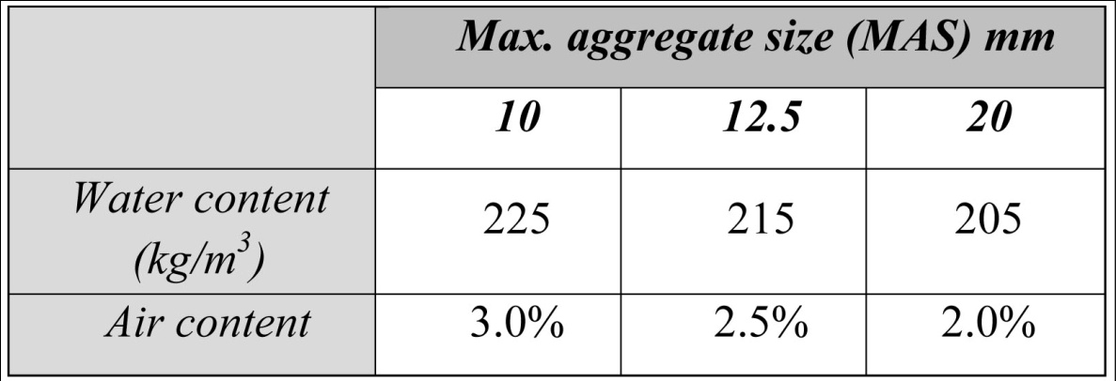

1. 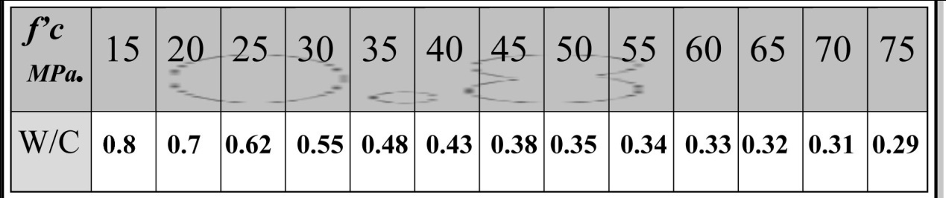 From table below (w/c)ratio is obtained according to the required compressive strength of concrete .
2. Calculate cement content (WC) and calculate valume of cement

(VC).

Where : Wc = , vc = ,(SGC =specific gravity of cement =3.15).

1. From table below dry-rodded volume of gravel (VG) can be obtained.

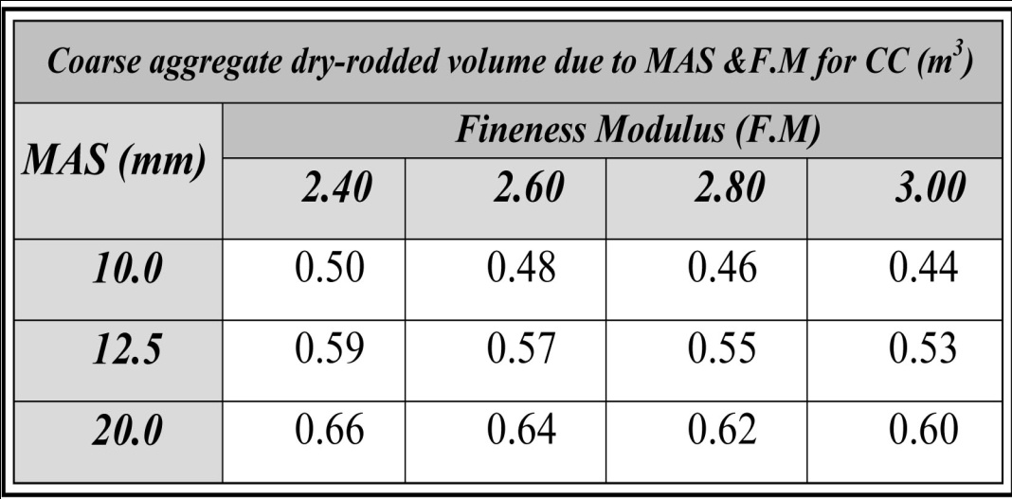

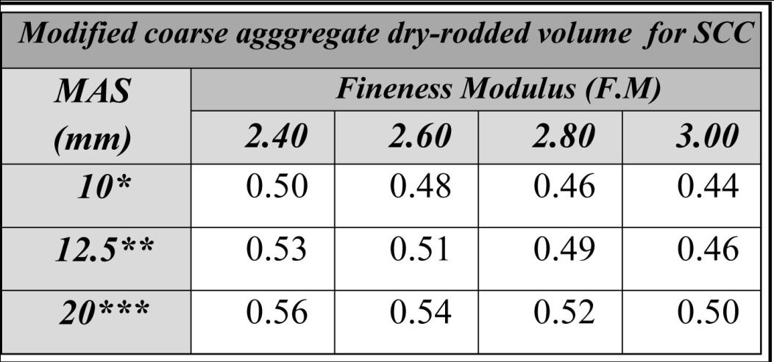

* no reduction factor.

** Reduction factor (10-11)%.

*** reduction factor (15-16)%.

1. Calculate dry-weight of gravel by multiplying (VG) by dry-rodded

unit weight of gravel(WGD).

1. Calculate saturated surface dry (SSD) weight of gravel.

WGSSD=WGD×(1+ $\frac{A}{100}$) (A= absorption of gravel)

1. From table below determine ($\frac{VW}{VC+VL}$)ratio for a known (ƒˊc) to

calculate volume of limestone powder.(VL).

1. Calculate the limestone powder weight(WL).

WL=( VL × SGL )

Where :WL =limestone powder weight .

VC =limestone powder volume.

SGL =specific gravity of limestone powder.

1. Calculate the weight of total powder content (Wc +WL ) and

total powder volume (WC +WL ).

1. Calculate the fine aggregate content (sand) by absolute

volume method.

**1m3=++++Air %**

1. Calculate the volume of sand (vs) by dividing the sand content by its density.
2. Check the volume of gravel (Vg=).
3. Check the sand to paste ($\frac{Vs}{V-Vg}$).

**3.3.5The application of the Procedure of Mix design for SCC**

We assume the following term:

* Compressive strength(Fˊc)=30 mpa
* max aggregate size(MAS) =12.5 mm
* fine modulus(F.M) =2.4

**Step (1)** From table **(3.2)**and **(3.1)**

Ww =190 kg/m3 A%=2.5%

Vw == 0.19m3

**Step(2)** From table

Fˊc=30Mea $\frac{w}{c}$ =0.55

**Step(3)**

Wc= $\frac{Ww}{w/c}$ = $\frac{190}{0.55}$ =345.45 kg/m3

**Vc**= =0.11m

**Step (4)** From table **(3.5)**

Dry. Rodded volume of graval =0.53

**Step( 5)**

Dry weight of graval =0.53× 1650

=874.5 kg/m3

**Step(6)**

Weight of graval=874.5×1.011 =883.25 kg/m3

**Step (7)** table **(3.6)**

For Fˊc =30 mpa $\frac{Vw}{Vc+Vt}$ =1.025

VL =0.0754 m3

**Step (8)**

WL=0.0754×2.7×1000 =203.58 kg/m3

**Step (9)**

WL+Wc =203.58 + 345.45 =549 kg/m3

(400 ≤ 549 ≤ 600) kg/m3

Vc+VL =0.11 + 0.0754 =0.1854 m3

(0.16 ≤ 0.1854 ≤ 0.24 ) m3

**Step (10)**

Im3 = + + + + V5 +0.03

V5 = 0.262 m3

**Step (11)**

Ws =693.3 kg/m3

**Step (12)**

VG = = 0.33m3

(0.28 ≤ 0.33 ≤ 0.35 ) m3

**3.4 Preliminary Dosage of Superplasticizer**

The supplier of the superplasticizer recommended a dosage in the range of 0.5 to 2.5 liters per 100 kg of cement (cementitious material). A dosage of 0.50 liters per 100 kg of cement is used for the first trial mixtures ( mineral admixture had been used in this stage). The resulted mix does not satisfy the SCC requirements, so the dosage is increased steps by 0.5 liters per 100 kg of cement for each step until the optimal dosage is obtained.

**3.5 Tests of Fresh SCC**

Testing of concrete in its fresh state is a major focus of this study. SCC is defined by its behavior when it is in the fresh state, and it is determined whether concrete meets certain requirements, as stated in chapter 2, while fluid is paramount in qualifying concrete as SCC or not. The slump flow, L-box and V-funnel are all used for all mixes of this study.

As illustrated previously, the apparatus are made according to the specifications and requirements mentioned in section (2.2.2.3).

These apparatus are made from galvanized steel in the local market. The procedures of tests are illustrated below, and the results are recorded.

**3.5.1 Slump Flow Tests**

**1. Introduction & Scope**

The simplest and most widely used test method for SCC is the slump flow test {Fig. (3.4)}. The test, which was developed in Japan, was originally used to measure underwater concrete and has also been used to measure highly flowable concretes.

The slump flow test is used to determine filling ability and can indicate segregation resistance of SCC to an experienced user.

**2. Principle**

The fresh concrete is poured into a mould in the shape of a frustum of a cone. When the cone is withdrawn upwards, the distance the concrete has spread provides a measure of the consistency of the concrete.

**3. Apparatus**

* Standard Slump Cone

*Base plate [with surface, non-absorbent, rigid, flat plate, with a concentric diameter of 50 cm marked on it, on which to place the mould].

* Moist cloth

*Scoop

* measuring tape

* clock.

**4. Procedure**

1. The base plate is surely made horizontal and a circle with 50 cm diameter is marked on it.

2. The surfaces of the cone and the table are cleaned with water then dried with a cloth so that they are moist, but without free water.

3. The slump cone is placed centrally on the plate.

4. The slump cone is filled with concrete while pressing the slump cone to the plate.

5. Then the slump cone is lifted vertically.

6. The timing is started when lifting of the slump cone starts and stopped when the concrete reach the 50 cm diameter circle on the plate.

**5. Test results**

1. The required time for the concrete flow to reach 50 cm diameter circle (T50) is recorded.

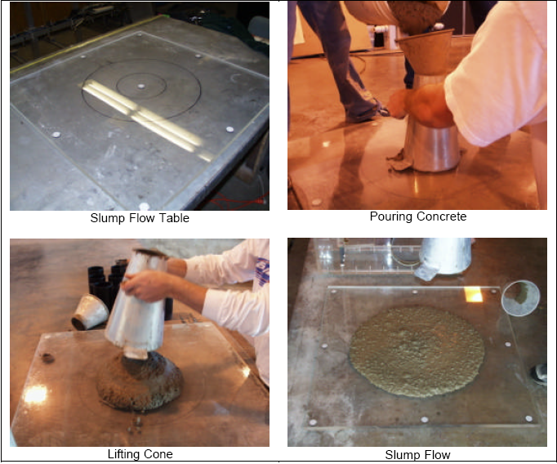2. When the concrete has stopped flowing, the final diameter (D) of the concrete is measured by measuring two perpendicular diameters. The coarse aggregates is noted whether have been transported to the periphery (no halo) or not. The presence of a border of mortar (halo) can indicate segregation; see Fig. (3.4).

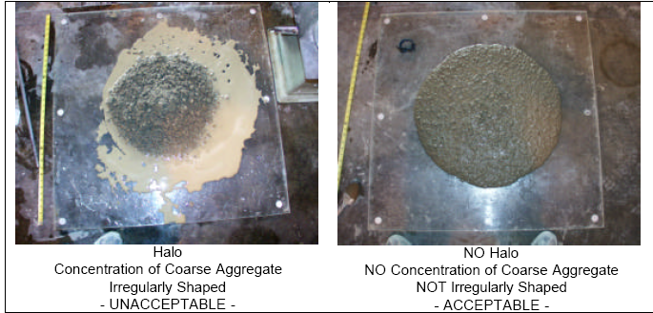



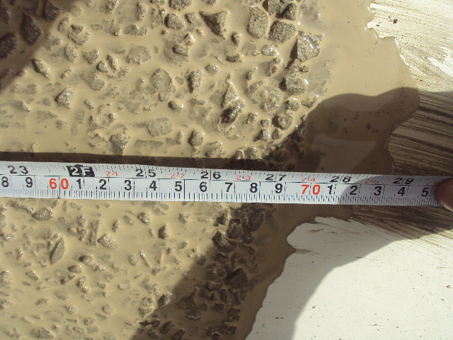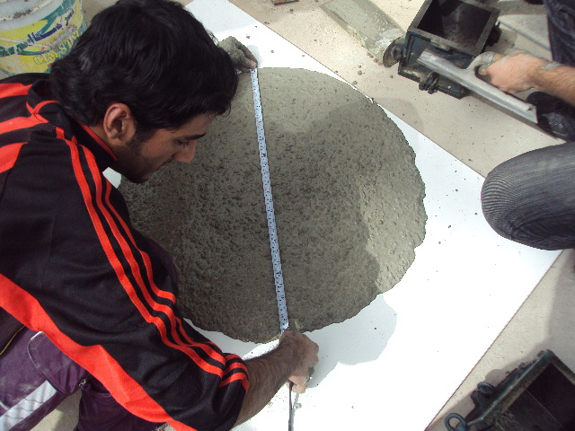

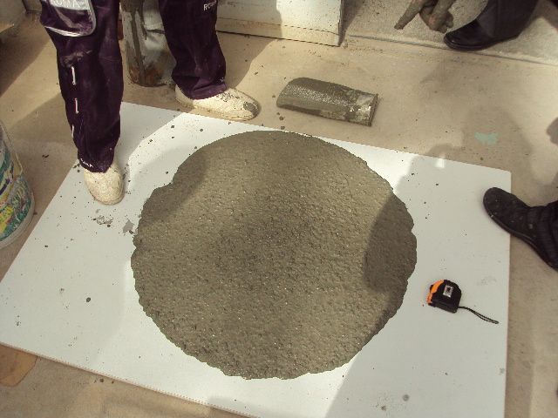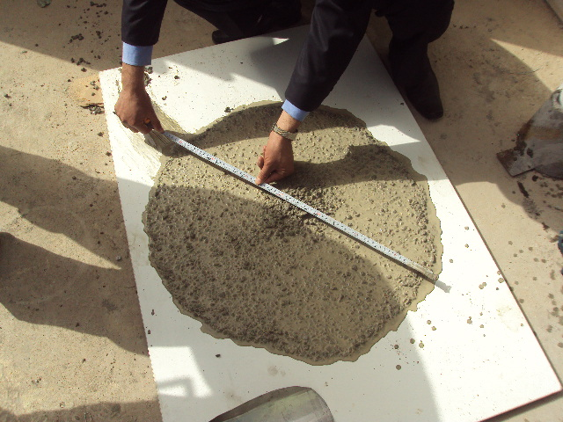

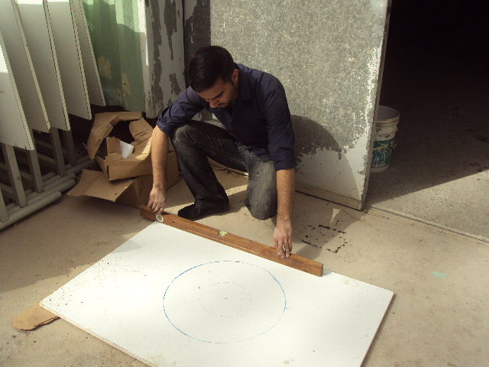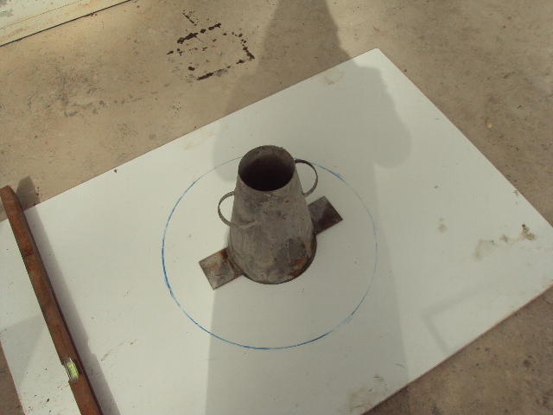

Fig. 3.4 Slump flow Test

**3.5.2 L-Box Test**

**1. Introduction & Scope**

The L-box test measures the filling and passing ability of SCC. Originally developed in Japan for underwater concrete, the test is also applicable to highly flowable concrete. With the L- box test, it is possible to measure the filling ability and the passing ability of SCC.

**2. Principle**

The fresh concrete is poured in the vertical part of the L-box. When the sliding gate is lifted, the concrete spread provides a measure of the filling ability and the passing ability of the concrete.

**3. Apparatus**

* L-box {Fig (3.5)}: As the test name implies, the apparatus consists of an L-shaped box, which measures 600 mm in height and 100 mm by 200 mm in section. A door between the vertical or horizontal portions of the box is opened and the concrete is allowed to flow through a line of vertical reinforcing bars and into the 800 mm long, 200 mm wide and 150 mm tall horizontal portion of the box. In the most common arrangement of reinforcing bars, three 12 mm bars are spaced with a clear spacing of 35 mm. Generally, the spacing of the reinforcing bars should be three times the maximum aggregate size.

* Moist cloth

* Scoop

* Rule.

**4. Procedure**

1. The vertical part of the box is filled with concrete.

2. The concrete is left to rest in the vertical part for one minute.

3. Then the sliding gate is lifted. The concrete flows out of the vertical part into the horizontal part of the L-box. On its way it has to pass between the vertical reinforcement bars.

**5. Test results**

After the sliding gate is lifted, the following parameters are measured:

1.When the concrete has stopped, the heights H1 and H2 are measured.

2. The blocking ratio (BR) H2/H1 is calculated.

3.Both passing ability and segregation resistance are detected visually.

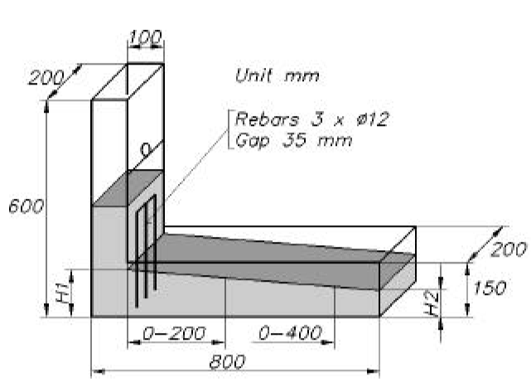If the concrete builds a plateau in front of the reinforcement layer, the concrete is either blocked or segregated. Passing ability usually displays itself by coarse aggregates gathered between the reinforcement bars. If coarser aggregates are distributed on the concrete surface, all the way to the end of the horizontal part, the concrete is regarded as homogeneous.

Fig. 3.5 L-box Test

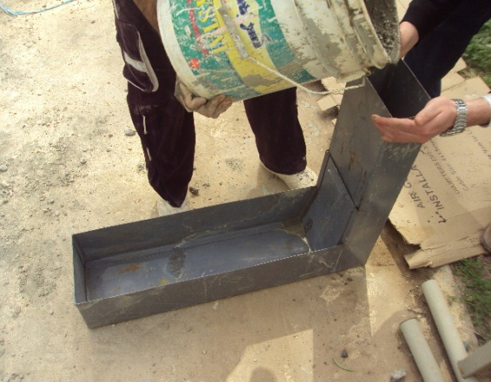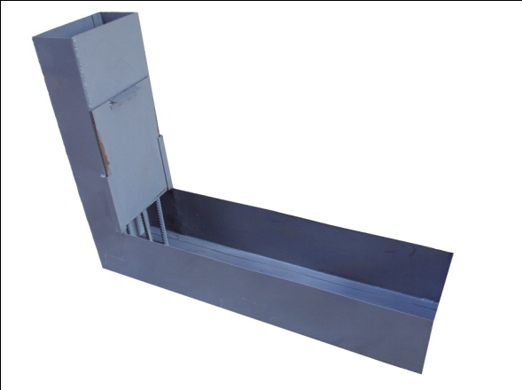

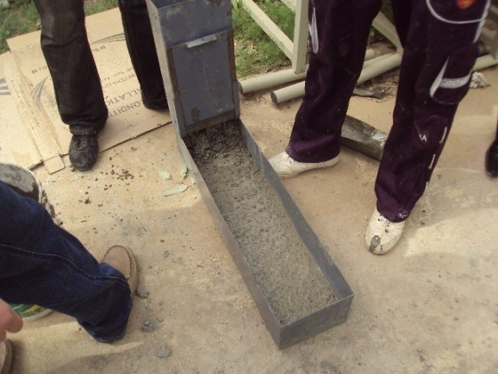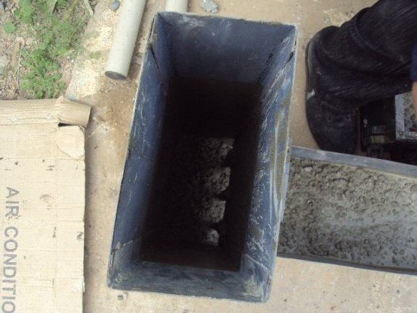

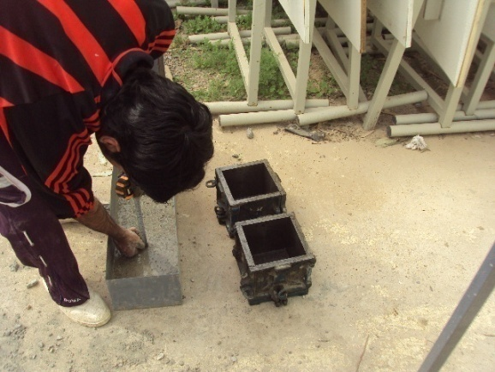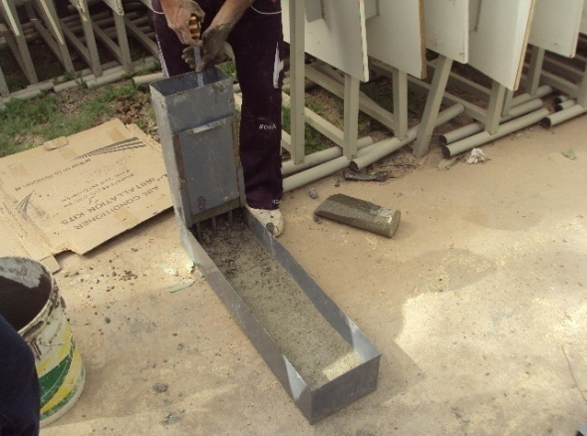

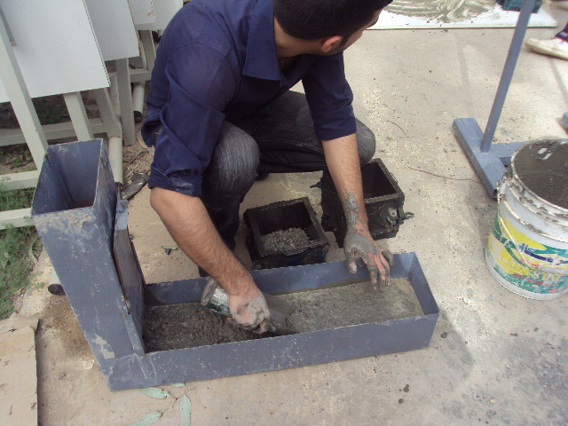

**3.5.3 V-Funnel Test**

**1. Introduction & Scope**

This test was developed in Japan and used by Ozawa et al. The V-funnel test is used to measure the filling ability of SCC and can also be used to judge segregation resistance.

**2. Principle**

Though the test is designed to measure flowability, the result is affected by concrete properties other than flow. The inverted cone shape will cause any liability of the concrete to block to be reflected in the result – if, for example there is too much coarse aggregate. High flow time can also be associated with low deformability due to a high paste viscosity, and with high inter-particle friction.

**3. Apparatus**

* V-Funnel {Fig (3.7)}: The test apparatus consists of a V-shaped funnel with a height of 425 mm, a top width of 490 mm, a bottom width of 65 mm, and a thickness of 75 mm. At the bottom of the V-shape, a rectangular section extends downward 150 mm.

* Moist cloth

* Scoop

* clock

**4. Procedure (flow time)**

1. About 12 liters of concrete are needed to perform the test, sampled normally.

2. The V-funnel is sited on firm ground.

3. The inside surfaces of the funnel are moistened.

4. The trap door is kept open to allow any surplus water to drain.

5. Then the trap door is closed and a bucket underneath is placed.

6. The apparatus is completely filled with concrete without compacting or tamping.

7. Within 10 sec after filling, the trap door is opened to allow the concrete to flow out under gravity.

8. The stopwatch is started when the trap door is opened, and the time required to complete discharge of concrete Tv (the flow time) is recorded. This is taken to be when light is seen from above through the funnel.

**5. Procedure (flow time at Tv5 minutes)**

1. Without cleaning or moistening the inside surfaces of the funnel, the V-funnel immediately is refilled with the same sample of concrete.

2. The trap door is opened after 5 minutes from refilling the funnel and the concrete is allowed to flow out under gravity.

3. Simultaneously the stopwatch is started when the trap door is opened, and the time for the discharge completion (the flow time at Tv5 minutes) is measured.

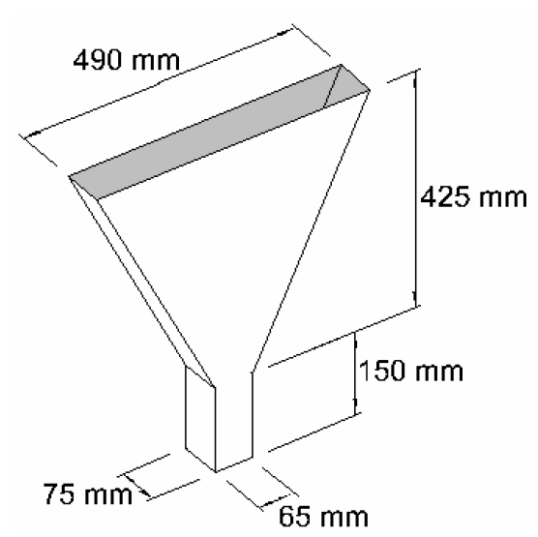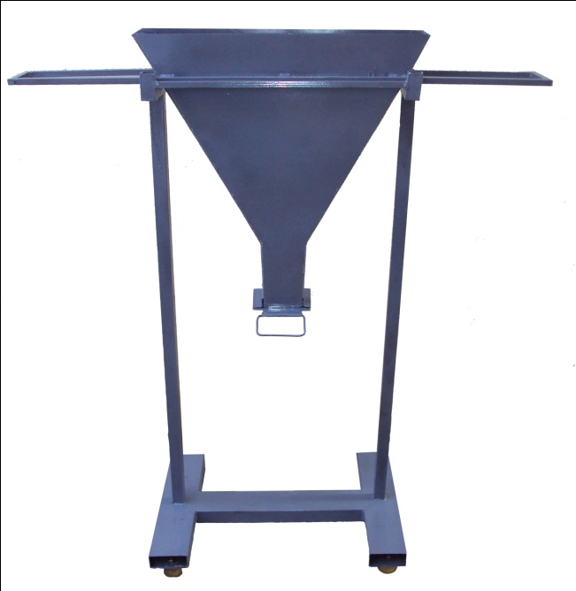

Fig. 3.7 V-funnel Apparatus

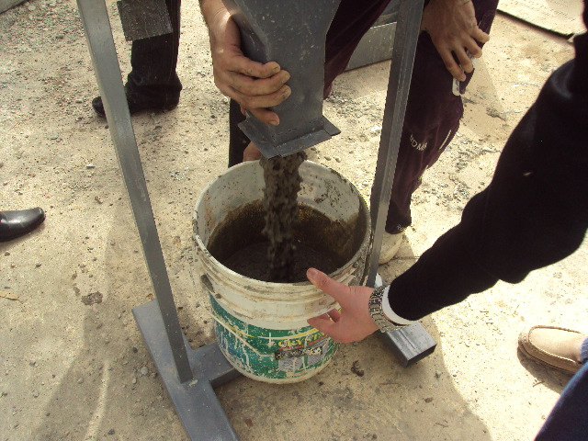 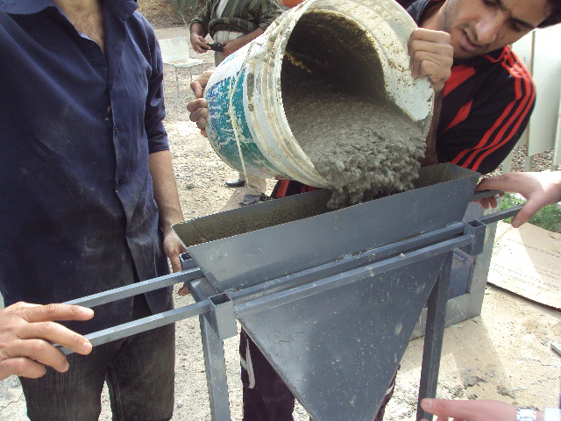

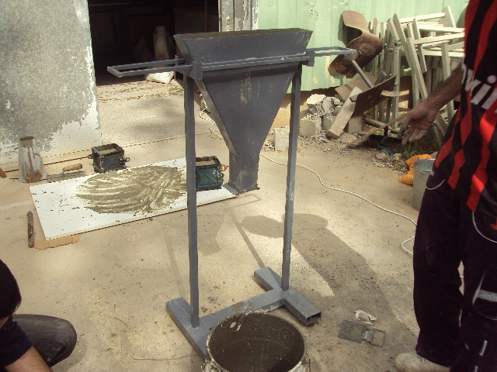

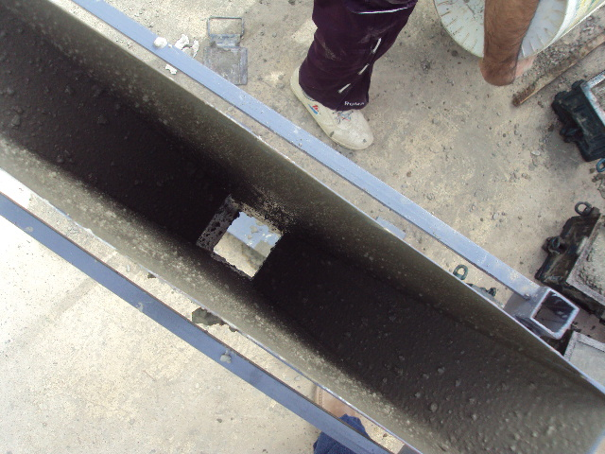

Fig. 3.8 V-funnel Test

**3.6 Tests of Hardened SCC**

In the hardened phase, the tests that have done are destructive and non-destructive. The destructive tests are compressive strength. The non-destructive tests are ultrasonic pulse velocity (UPV) and unit weight.

**3.6.1 Destructive Tests**

**3.6.1.1 Compressive Strength**

According to BS 1881: Part 116 [69] and ASTM C 39-86 standard cubes measuring 150 mm is demoulded 7 day after casting. Testing is carried out at 7 d, 14 d and 28 d. The tests are carried out by 3000 KN capacity machine. The average value of the two specimens for each dosage and age is determined and recorded.

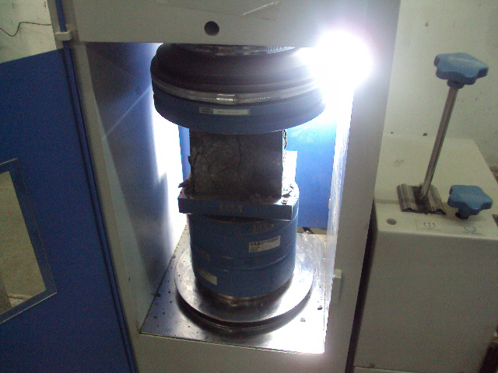 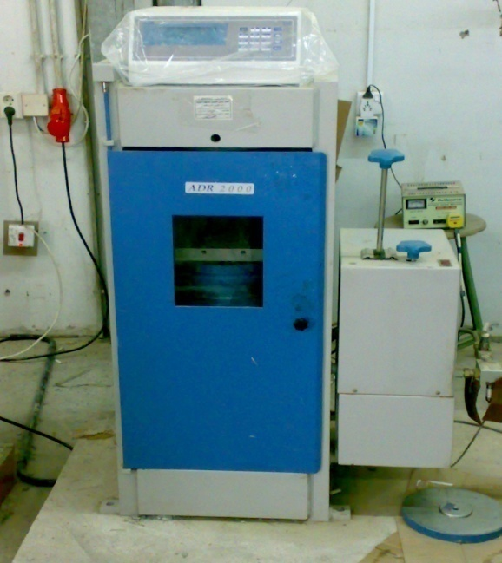

***3.6.2 Non-Destructive Tests***

**3.6.2.1 Ultra Pulse Velocity Test**

This test is carried out according to B.S. 4408:Part5 [70] using the Portable Ultrasonic Non-destructive Digital Indicating Tester (Pundit). The transducers are smeared with grease to give good contact, and instrument setting is checked frequently using reference bar supplied with tester. Pulse velocity (V) in km\sec is calculated, as follows:

*V = L \ T*

where

L : Path length, mm

T : transit time in microsecond (µm)

The test is conducted for specimens intended for compressive strength. Specimens are tested after removal from curing tanks. Three specimens are tested at specified age, and the average value is obtained.

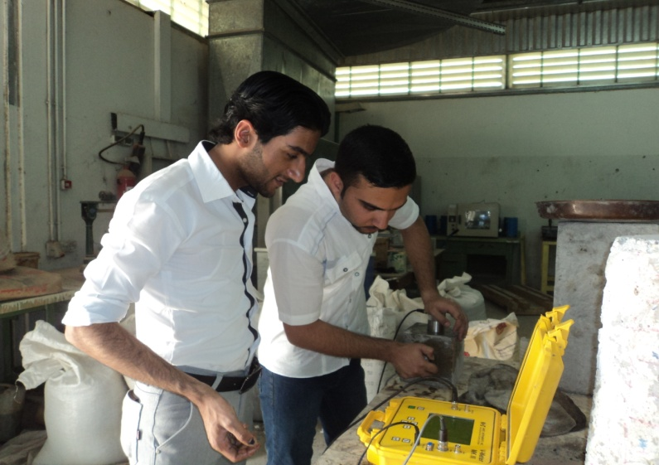

**3.6.2.2 Unit Weight Test**

The specimens left from curing tanks and their surfaces are wiped. Then, these specimens are weighted. The average value of weights for the two specimens is recorded, and the density for each mix at specified age is obtained.

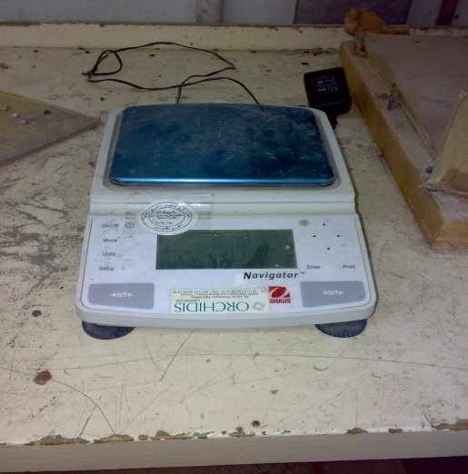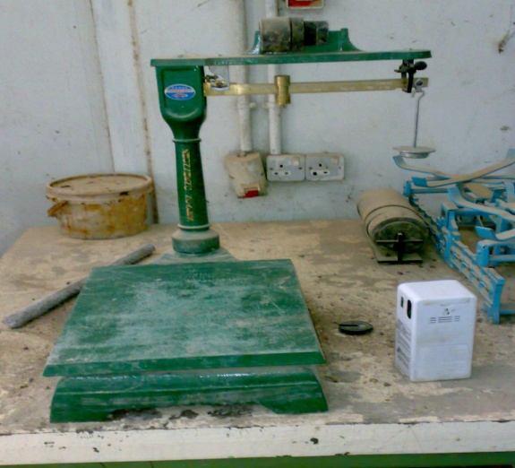

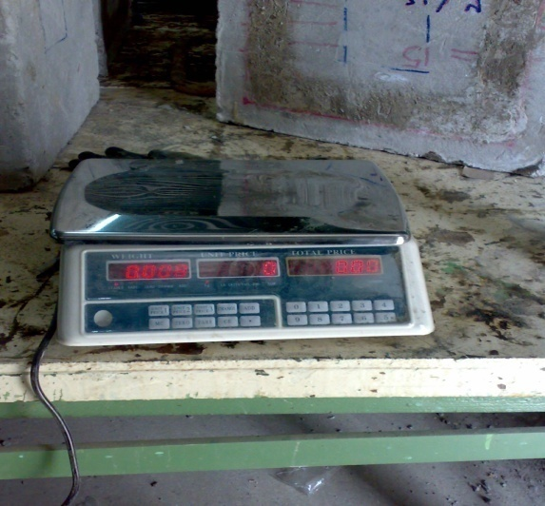

**Chapter Four**

**Results and Discussion**

**4.1 Fresh Concrete properties**

After constructing three dosage of superplasticizer,the fresh properties of each mix are evaluated and compared with the literature. The results of slump flow, L-box and V-funnel are discussed below. However, due to the importance of the superplasticizer effects in SCC, as illustrated in chapter two.

**4.1.1 Superplasticizer Dosages (SPD)**

The superplasticizer is added following the procedure explained in section 3.3.5. Figure (4.1) show the dosage of superplasticizer (SPD) as a percentage ratio (by cement weight) for each mix that satisfies a maximum spread (slumpflow diameter) under the following conditions[4]:

1. Slump flow diameter (D) should not be less than 500 mm.
2. The flow behavior should be without any indication of segregation.

**4.1.2 Slumpflow Tests**

Table (4.6) shows the results of slump flow tests. The values of (D) represent the maximum spread (slump flow final diameter), while the values of T50 represent the time required for the concrete flow to reach a circle with 50 cm diameter. D and T50 are plotted in a descending manner in Figs. (4.2) and (4.3) respectively. It is very clear from the results that same of the mixes satisfy the requirements of SCC illustrated in chapter 2-section 2.2.2.4. Thus, mixes (Tr2,Tr3,Tr4) have a good consistency and workability from the filling ability point of view, but Mixes (Tr1 and Tr5) have low consistency and low workability. However, these results show a wide range of variation. This variation illustrates the effects of the changes that are made in the mixes on the filling ability of SCC.

Table 4.1−Results of Slump flow Tests

|  |  |  |
| --- | --- | --- |
| Slump flow  ( mm) | dosage of sp | Mix |
|
|
| 470 | 0.5 | Tr1 |
| 631 | 1 | Tr2 |
| 674 | 1.5 | Tr3 |
| 680 | 2.5 | Tr4 |
| 814 | 3 | Tr5 |

Fig. 4.2 slump flow diameter D (mm)

Fig.(4.3) Time required to pass (500 mm dia.)circle (T50)

In fig.(4.3) above show the effect of dosage of the superplasticizer on the flow ability of fresh concrete ,fig.(4.2) and (4.3) illustrated that the filling ability increment with increase of dosage but not exceed the passable limitation because of cause segregation in fresh concrete ,and weakly the concrete. (Tr1) do not reaches to range diameter (500 -700)mm, and (Tr5) exceed the limitation and this mixes do not classify as a self-compact concrete (SCC).

The mixes (Tr1,Tr3,Tr4) became in the limitation range and this can be classified as self-compact concrete (SCC).

**4.1.3 L-box Tests**

With the L- box test, it is possible to measure the filling ability and the passing ability of the mixes. The L-box results are listed in Table (4.2). The values of (H2 / H1) represent the blocking ratio (BR). The values of T20 and T40 represent the times of the concrete flow to reach 20 and 40 cm respectively. The values of BR are illustrated in Fig. (4.4) in a descending manner, and the values of T20 and T40 are plotted in Fig. (4.5a ) ,(4.5b) and (4.5c) .

Table 4.2−Results of L-box Tests

|  |  |  |  |  |
| --- | --- | --- | --- | --- |
| T40(SEC) | T20(SEC) | L-box ratio  (H2/H1) | dosage of sp | Mix |
|
|
| 7.31 | 3.55 | 0.095 | 0.5 | Tr1 |
| 3.53 | 2.02 | 0.803 | 1 | Tr2 |
| 3.41 | 1.57 | 0.821 | 1.5 | Tr3 |
| 2.21 | 1.11 | 0.880 | 2.5 | Tr4 |
| 1.58 | 0.52 | 0.99 | 3 | Tr5 |
|  |  |  |  |  |

Fig (4. 4 ) Results of BR (H2/H1)

Fig (4.5a) Fig. 4.12−Results of T20cm

Fig.( 4.5b) Results of T40cm

Fig. (4.5c) Results of T20 & T40

The L-box results indicate good flow ability for mixes(Tr2, Tr3 , Tr4 and Tr5 ). Also, they show that the BR values for this mixes are greater than or equal to 0.80 (which is often considered in the literature as the critical lower limit). Except for mixes ( Tr2, Tr3 , Tr4 and Tr5 ) show excellent deformability, without blockage, through the closely spaced obstacles.

Two comparisons are made through Figs. (4.6) and (4.7) between the results of slumpflow tests (D and T50) and the results of L-box tests (BR and T40). The comparisons show that the trend of the results of these two tests is close. Thus, it can be said that what have been inferred from the behavior of these mixes in slumpflow tests (section 4.1.2) seem to be adequate to explain the behavior of these mixes in L-box test

Fig. (4.6)D and BR for all mix

Fig. (4.7)T50 & T40 Results for mixes

These two figures show that there are variations between the behavior of these mixes in slumpflow tests and their behavior in L-box tests. These variations are very clear at the results of this mixes.

Empirical relationships between the results of slump flow tests and those of L-box tests are illustrated in Fig. (4.8) where D is plotted with BR, and Fig. (4.9) where T50 is plotted with T40.

Fig. 4.8−D vs. BR

Fig. (4.9) T40 vs. T50

**4.1.4 V-funnel Tests**

Table (4.3) shows the results of V-funnel tests. The values of Tv represent the ability of the concrete to flow out of the funnel, while Tv5 values represent the same ability but after refilling the funnel and allowing concrete to discharge after 5 minutes from the refilling. The results are within the limits pointed out in the literature. No blocking or segregation behavior is observed for all mixes. Figure (4.10) shows the results of Tv and Tv5 in an ascending manner. The results clearly show the effects of the changes that are made in the mixes on the viscosity of the mixes.

Table (4.3) Results of V-funnel Tests

|  |  |  |  |
| --- | --- | --- | --- |
| V-funnel  Tv5 (sec) | V-funnel Tv (sec) | Dosage of  S.P | Mix |
|
|
| 38.7 | 9.58 | 0.5 | Tr1 |
| 9.1 | 7.51 | 1 | Tr2 |
| 8.66 | 6.6 | 1.5 | Tr3 |
| 8.41 | 6.23 | 2.5 | Tr4 |
| 3.32 | 5 | 3 | Tr5 |

Fig. (4.10) Tv & Tv5 (sec.)

SCC mixtures are often characterized by their funnel time Tv (which is often used as a degree of the apparent viscosity of mix) and their spread diameter D which stands for the filling ability [6]. Figure (4.11) gives an overview over the characteristic fresh concrete parameters of the tested mixes. The nature of the relationship between these two parameters is clearly defined by this figure. The highly degree of correlation between the results (R = 0.9774) demonstrates that mixes of this study are homogenous and SCC mixes.

From practical sight of view it will be convenient to know a reliable relationship between the flow times T50 and the funnel time Tv of a SCC mixture. Then, the V-funnel test can be skipped. The relationship between the flow times is plotted in Fig. (4.12). Based on the high degree of correlation coefficient (R = 0.9321), it can be assumed that this relationship is reliable.

Fig.(4.11) D vs. Tv

Fig. 4.12−T50 vs. Tv

**4.2 Hardened Concrete Properties**

As no segregation or bleeding is shown with the fresh state, SCC mixes should, theoretically, have improved the hardened properties.

**4.2.1 Destructive Tests**

**Compressive Strengths**

The compressive strength, as one of the most important properties of hardened concrete, is in general the characteristic material value for the classification of concrete in national and international codes. For this reason, it is of interest to investigate whether the changes in the mixture composition and positive dissimilarities in the microstructure, as mentioned before in chapter 3, affect the early and later compressive strengths.

In order to find the compressive strength of concrete ,cubes measuring 150 mm is used within this test. Tables (4.15) show the average results of the compressive strength tests at (7, 14, 28) days gained from cubes.

Table(4.4)Re sults of Compressive Strength (MPa) for 150mm cubes (fcu)

|  |  |  |  |
| --- | --- | --- | --- |
| mix | 7 days | 14 day | 28 day |
| Tr1 | 12.00 | 13.05 | 15.32 |
| Tr2 | 19.43 | 23.1 | 28.98 |
| Tr3 | 19.75 | 23.495 | 30.00 |
| Tr4 | 21.27 | 25.561 | 31.39 |
| Tr5 | 23.03 | 26.585 | 30.200 |

Figure (4.13) shows a comparison between the values of fcu for the mixes Developments of fcu for the same mixes with time are plotted in Fig. (4.14). These two figures clearly illustrate that the same addition of mineral admixtures as a replacement from the weight of cement, significantly affects the compressive strength of mixes in all ages.

Fig. (4.13) compressive strength for mixes

Fig.(4.14)development of compressive strength with age

Compared with the strengths of mix (Tr1 and Tr2) see Fig. (4.15) and Fig.(4.16).

Fig (4.15) Compressive strength for mix(Tr1 and Tr2)

Fig.(4.16)development fcu for mix (Tr1 and Tr2)

This behavior is expected due to the increment of the dosage in the mixes at the same content of cement and mineral admixture ,This behavior agrees with the literature in section 2.4.6.4.

**4.2.2 Non-Destructive Tests**

**4.2.2.1 Ultrasonic Pulse Velocity**

Table (4.30) shows the results of ultrasonic pulse velocity measurements gained from testing the 20 mixes with ages of (7,14 and 28 days. It clearly appears that the ultrasonic pulse velocity value increases with age. This is attributed mainly to the increment in the density of the specimen with age and the reduction in points of discontinuity.

Table (4.5) Ultrasonic Pulse Velocity Results

|  |  |  |  |
| --- | --- | --- | --- |
| mix | Ultrasonic Pulse Velocity Results (km/sec.) with Ages (direct) | | |
|  | 7 day | 14 day | 28 day |
| Tr1 | 4.1665 | 3.846 | 4.323 |
| Tr2 | 4.2023 | 4.3542 | 4.3681 |
| Tr3 | 4.243 | 4.2835 | 4.600 |
| Tr4 | 4.2518 | 4.485 | 4.760 |
| Tr5 | 4.0123 | 4.273 | 4.630 |

Figure (4.17) shows the results of plain SCC mixes, and makes a comparison between the results of mixes. The replacement of cement by different percentages of the mineral admixtures affects the results in all ages. These effects are similar and vary according to the type and fineness of the mineral admixture as well as the age of the specimen, but the dosage is differently .These effects are increment of velocity and refers to sympathy the concrete mixes.

Fig. (4.17)V results of plain SCC mixes

The relationship between ultrasonic pulse velocity and compressive strength the ultrasonic pulse velocity increases with the increase of compressive strengths. Fig (4.18) and Fig (4.19) show this relationship . degrees of correlation for these two figures are (R = 0.9984) and (R = 0.9928).

Fig. (4.18) fcu vs. V

Fig. (4.19) fc vs. V

**4.2.2.2 Concrete Density**

Densities of the 5 mixes are determined, listed in Table (4.6). From this table, it is clear that the densities of the studied mixes are in the range of (2317 – 2468). This range is greater than the range of the conventional concrete densities which is 2300 – 2400 [33].

Table (4.6) Densities (ρ) Values in (kg/m3)

|  |  |
| --- | --- |
| Mix | Density ρ (kg/m3) |
| Tr1 | 2317 |
| Tr2 | 2397 |
| Tr3 | 2416 |
| Tr4 | 2465 |
| Tr5 | 2468 |

**Chapter Five**

**Conclusions and**

**Suggestions for Further Researches**

**5.1 Conclusions**

Taking into account the findings from this study, the following conclusions can be drawn:

1-It has been verified that by using the slumpflow, L-box, U-box and V-funnel tests, SCC (produced by using locally available materials) achieves consistency and self-compactability under its own weight, without any external vibration or compaction. Also, SCC can be obtained in such a way, by adding suited superplasticizer and very fine mineral admixtures. These two materials provide sufficient balance between the yield and viscosity of the mix .

2- Mixes contain same fineness or same quantity of the mineral admixtures show increase in their SPD from( 0.5 -3) later each 100 kg cement compared to the reference mix. SPD of the studied mixes vary according to the type of the mineral admixture in each mix.

3-The workability of studied mixes(Tr2,Tr3and Tr4) is excellent, with slump flow diameter greater than or equal to (500 mm), blocking ratio greater than or equal to (0.80), and flow times range (6 to 12sec.) On the fresh properties.

4- From the statistical analysis and the empirical relationships made in this study, it can be concluded that the slumpflow test is enough to evaluate the SCC (with maximum size of coarse aggregate equal to 12.5mm).

5- Due to the excellent workability, consistency, and self-compactability, studied mixes show high compressive (28.98-30.2) MPa,

6-The addition of the mineral admixtures with same ratios as a replacement for the weight of cement, significantly affects the strengths of the mixes in all ages. These effects are not similar according to the type, dosage and fineness of the mineral admixture in each mix. The gained strengths are in range from medium to high, thus, it can be recommended that from the economical point of view it is more preferable to employ the replacement part of cement with suitable mineral admixture in producing SCC.

7- The ultrasonic pulse velocity is differentially affected according to the variables of the mineral admixtures (type, fineness and dosages).

8- Because of using the special superplasticizer, mineral admixtures , SCC mixes achieve densities between 2317 and 2468 kg/m3.This range is greater than the range of the conventional concrete densities which is (2300 – 2400)kg/m3.

**5.2 Suggestions for Future Researches:**

Because of the importance of this subject and its large practical applications, the followings are suggested:

* Further works are needed to investigate the influences of new locally types of mineral admixtures on the properties of SCC.
* The influences of the replacement of cement by other percentages of mineral admixture in order to get economical benefits with reasonable properties of SCC can be studied.
* The influences of the decrease of water content in order to access to high compressive strength.
* The influences of the maximum size, texture and the volumes in the mix of the coarse and fine aggregates on the properties of SCC can be investigated.
* More investigations are required to study the chemical and physical properties of the locally mineral admixtures.

1. These limits are gained from Okamura 1995 [19], Gibbs 1999 [20], Boral 2001 [21], Takada 1998 [22], Subramanian 2002 [23], Nagamoto 1997 [24] and Su 2001 [25].
2. European standard (cement–composition, specifications and conformity criteria - part 1: Common Cements) has been used instead of BS 12[21].
3. Ref. [4], [5], [8], [15], [17], [32], [35], [38], [46], [52], & [53].
4. The above conditions are assumed by the researcher