اسم الجامعة:ديالى
اسم الكلية:الهندسة
اسم القسم: الالكترونيك
المرحلة: الاولى
اسم المحاضر الثلاثي: وسام نجم الدين عبد
اللقب العلمي: مدرس
المؤهل العلمي: ماجستير
مكان العمل:

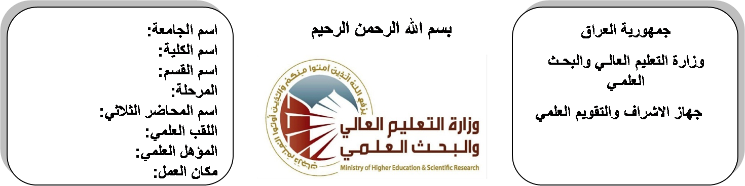

(( استمارة الخطة التدريسية السنوية ))

وسام نجم الدين عبد |  |  |  | اسم التدريسي:
wisam_alobaidee@yahoo.com |  |  |  | البريد الالكتروني:
Electrical Engineering Fundamentals |  |  |  | اسم المادة:
The aim of these subjects is to make the students ready to undestand and comprehend the scientific theories and their applications related to their field of the study. |  |  |  | أهداف المادة:
Electrical Technology by Theraja  Electrical Engineering by Boylested |  |  |  | الكتب المنهجية:
Fundemetal 0f Electrical Engineering by Hayt |  |  |  | المصادر الخارجية:
الامتحان النهائي | المختبرات | الفصل الثاني | الفصل الأول | تقديرات الفصل:
50% | 10% | 20% | 20%
 |  |  |  | معلومات إضافية:

جدول الدروس الأسبوعي – الفصل الدراسي الأول

الملاحظات | المادة العملية | المادة النظرية | التاريخ | الأسبوع
 |  | System of units | 28/9/2015 | 1
 |  | voltage and current | 5/10/2015 | 2
 |  | circuit element | 12/10/2015 | 3
 |  | Resistances in series and parallel | 19/10/2015 | 4
 |  | Resistances in series and parallel | 26/10/2015 | 5
 |  | Basic terminology | 2/11/2015 | 6
 |  | the loop current method | 9/11/2015 | 7
 |  | the node voltage method | 16/11/2015 | 8
 |  | superposition theorem | 23/11/2015 | 9
 |  | thevenin's theorem | 30/11/2015 | 10
 |  | Norton's theorem | 7/12/2015 | 11
 |  | reciprocity, and maximum power transfer. | 14/12/2015 | 12
 |  | RMS and average values | 21/12/2015 | 13
 |  | circuit elements in the pharos domain , power factors. | 28/12/2015 | 14
 |  | Ac current through various circuit elements | 4/1/2016 | 15
 |  | operations with complex numbers, phasor diagrams. | 11/1/2016 | 16
العطلة الربيعية |  |  | 15/1/2016 to  1/2/2016

توقيع الأستاذ: توقيع رئيس القسم توقيع العميد:

جدول الدروس الأسبوعي – الفصل الدراسي الثاني

الملاحظات | المادة العملية | المادة النظرية | التاريخ | الأسبوع
 |  | Active, reactive and apparent power | 15/2/2016 | 1
 |  | power, power in a complex form , the power triangle | 22/2/2016 | 2
 |  | Frequency response of various circuits | 1/3/2016 | 3
 |  | resonance in series and parallel circuits | 8/3/2016 | 4
 |  | quality factor, the half –power frequencies. | 15/3/2016 | 5
 |  | Loop and node voltage methods in ac circuits | 22/3/2016 | 6
 |  | circuit theorems in ac circuits. | 29/3/2016 | 7
 |  | Magnetic field | 5/4/2016 | 8
 |  | characteristics of lines of magnetic flux | 12/4/2016 | 9
 |  | magnetic field due to an electrical current | 19/4/2016 | 10
 |  | mmf, magnetic field strength | 26/4/2016 | 11
 |  | magnetic constants | 3/5/2016 | 12
 |  | reluctance | 10/5/2016 | 13
 |  | kirchoffs laws for magnetic circuits | 17/5/2016 | 14
 |  | series and parallel magnetic circuits | 24/5/2016 | 15
 |  | series and parallel magnetic circuits | 1/6/2016 | 16

توقيع الأستاذ: توقيع رئيس القسم توقيع العميد:

