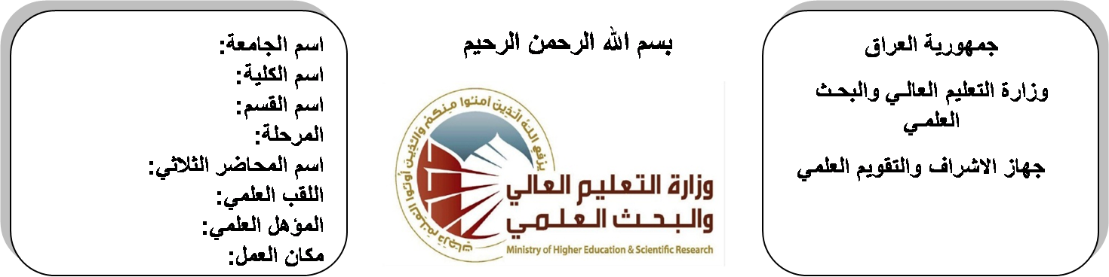
اسم الجامعة:ديالى
اسم الكلية:الهندسة
اسم القسم: الالكترونيك
المرحلة: الثانية
اسم المحاضر الثلاثي: روكان علي احمد
اللقب العلمي: مدرس
المؤهل العلمي: الدكتوراة
مكان العمل: كلية الهندسة

(( استمارة الخطة التدريسية السنوية ))

روكان علي احمد |  |  |  |  | اسم التدريسي:
Rokan_L4@yahoo.com. |  |  |  |  | البريد الالكتروني:
Analogue Electronics I |  |  |  |  | اسم المادة:
The aim of this subject is to make the students ready to undestand and comprehend the scientific theories and their applications related to their field of the study. |  |  |  |  | أهداف المادة:
Electronic circuits & devices part 1 by Boylested. |  |  |  |  | الكتب المنهجية:
1 ) Electronic Devices and Circuit by Bogart  2) Electronic Principles by Albert Malvino, David J Bates |  |  |  |  | المصادر الخارجية:
الامتحان النهائي | المختبرات | الفصل  الثاني | نصف السنة | الفصل الأول | تقديرات الفصل:
50% | 10% | 10% | 20% | 10%
 |  |  |  |  | معلومات إضافية:

جدول الدروس الأسبوعي – الفصل الدراسي الأول

الملاحظات | المادة العملية | المادة النظرية | التاريخ |  | الأسبوع
 |  | Bipolar Junction Transistors  (BJT) | 27/9/2015 |  | 1
 |  | Construction and operation | 4/10/2015 |  | 2
 |  | Configurations and  Characteristics | 11/10/2015 |  | 3
 |  | Operating regions and load–  lines | 18/10/2015 |  | 4
 |  | DC Biasing Circuits and  Stability | 24/10/2015 |  | 5
 |  | DC Biasing Circuits and  Stability | 1/11/2015 |  | 6
 |  | DC Biasing Circuits and  Stability | 8/11/2015 |  | 7
 |  | DC Biasing Circuits and  Stability | 15/11/2015 |  | 8
 |  | Power Dissipation, and  switching transistors | 22/11/2015 |  | 9
 |  | Power Dissipation, and  switching transistors | 29/11/2015 |  | 10
 |  | Transistor Equivalent  Circuits | 6/12/2015 |  | 11
 |  | Transistor Equivalent  Circuits | 12/12/2015 |  | 12
 |  | Voltage gain, current gain,  input and output  Impedance | 20/12/2015 |  | 13
 |  | Analysis of CE, CB and  CC configurations.. | 27/12/2015 |  | 14
 |  | Analysis of CE, CB and  CC configurations. | 3/1/2016 |  | 15
 |  | Analysis of CE, CB and  CC configurations. | 10/1/2016 |  | 16
العطلة الربيعية |  |  |  | 15/1/2016 to  1/2/2016

توقيع الأستاذ: توقيع رئيس القسم توقيع العميد:

جدول الدروس الأسبوعي – الفصل الدراسي الثاني

الملاحظات | المادة العملية | المادة النظرية | التاريخ | الأسبوع
 |  | Construction and  characteristics of JFET | 21/2/2016 | 1
 |  | MOSFET construction and  characteristics, CMOS | 28/2/2016 | 2
 |  | DC Biasing Circuits | 6/3/2016 | 3
 |  | DC Biasing Circuits | 13/3/2016 | 4
 |  | Amplifier JFET / MOSFET | 20/3/2016 | 5
 |  | Small Signal Model  Analysis | 27/3/2016 | 6
 |  | Analysis of CS, CG and  CD configurations | 3/4/2016 | 7
 |  | Analysis of CS, CG and  CD configurations | 10/4/2016 | 8
 |  | Analysis of CS, CG and  CD configurations | 17/4/2016 | 9
 |  | Analysis of CS, CG and  CD configurations | 24/4/2016 | 10
 |  | Types of multistage  amplifier | 1/5/2016 | 11
 |  | Cascade and cascode  amplifier's, Darlington  amplifier | 8/5/2016 | 12
 |  | Transformer-coupled  Amplifiers | 15/5/2016 | 13
 |  | single tuned amplifiers,  tapped and double-tuned  amplifiers | 22/5/2016 | 14
 |  | Description and operation  of silicon controlled  rectifier | 29/5/2016 | 15
 |  | DIAC, thyristor, GTO, and  TRIAC | 2/6/2016 | 16

توقيع الأستاذ: توقيع رئيس القسم توقيع العميد:

