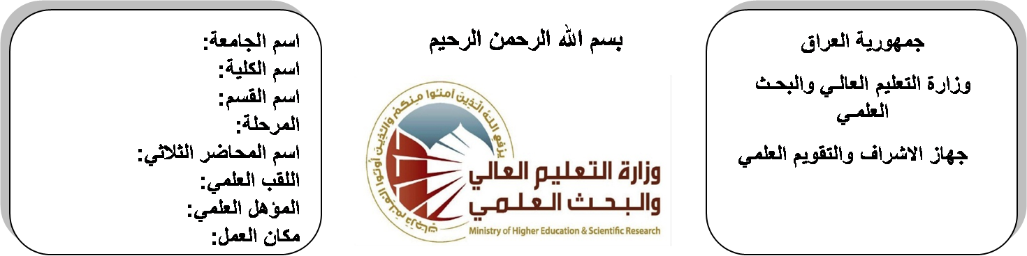
اسم الجامعة:ديالى
اسم الكلية:الهندسة
اسم القسم: الالكترونيك
المرحلة: الثانية
اسم المحاضر الثلاثي: عباس سلمان حميد
اللقب العلمي: مدرس
المؤهل العلمي: ماجستير
مكان العمل: كلية الهندسة

(( استمارة الخطة التدريسية السنوية ))

عباس سلمان حميد |  |  |  | اسم التدريسي:
abbasfuture@yahoo.com |  |  |  | البريد الالكتروني:
Computer Programming II |  |  |  | اسم المادة:
The aim of this subject is to make the students ready to undestand and comprehend the scientific theories and their applications related to their field of the study. |  |  |  | أهداف المادة:
C language by James M.ortega. |  |  |  | الكتب المنهجية:
How to program C language by prentice & hill. |  |  |  | المصادر الخارجية:
الامتحان النهائي | المختبرات | الفصل  الثاني | الفصل الأول | تقديرات الفصل:
50% | 10% | 20% | 20%
 |  |  |  | معلومات إضافية:

جدول الدروس الأسبوعي – الفصل الدراسي الأول

الملاحظات | المادة العملية | المادة النظرية | التاريخ |  | الأسبوع
 |  | A brief history importance of C++ | 27/9/2015 |  | 1
 |  | Simple program of C++ | 4/10/2015 |  | 2
 |  | Simple program of C++ | 11/10/2015 |  | 3
 |  | Identification, declaration | 18/10/2015 |  | 4
 |  | Identification, declaration | 24/10/2015 |  | 5
 |  | Data types, Expressions, Operators, Arithmetic | 1/11/2015 |  | 6
 |  | Data types, Expressions, Operators, Arithmetic | 8/11/2015 |  | 7
 |  | logical Assignment, Relation of Operator bitwise | 15/11/2015 |  | 8
 |  | ternary, I/O operation | 22/11/2015 |  | 9
 |  | cin>> statement, cout<<statement, main () function, semi column | 29/11/2015 |  | 10
 |  | Basic program control (for) statement, nesting loop, (while) statement | 6/12/2015 |  | 11
 |  | (Do, while) nesting loop, (if) statement, (if …..else) statement, switch( ) statement break | 12/12/2015 |  | 12
 |  | Arrays, 1-D arrays initialization, declaration storing | 20/12/2015 |  | 13
 |  | Multidimensional arrays initialization | 27/12/2015 |  | 14
 |  | Declaration application of 2D- arrays | 3/1/2016 |  | 15
 |  | Declaration application of 2D- arrays | 10/1/2016 |  | 16
العطلة الربيعية |  |  |  | 15/1/2016 to  1/2/2016

توقيع الأستاذ: توقيع رئيس القسم توقيع العميد:
جدول الدروس الأسبوعي – الفصل الدراسي الثاني

الملاحظات | المادة العملية | المادة النظرية | التاريخ | الأسبوع
 |  | character arrays, Arrays & pointers | 21/2/2016 | 1
 |  | Creating pointer | 28/2/2016 | 2
 |  | Declaration pointer | 6/3/2016 | 3
 |  | initialization pointer & variable types | 13/3/2016 | 4
 |  | Application on pointers | 20/3/2016 | 5
 |  | A brief history importance of MATLAB | 27/3/2016 | 6
 |  | Simple program of MATLAB | 3/4/2016 | 7
 |  | Variable, numbers, operations, functions | 10/4/2016 | 8
 |  | plots in matlab | 17/4/2016 | 9
 |  | plots of points, axes label, graph title | 24/4/2016 | 10
 |  | drawing multi point in the same graph | 1/5/2016 | 11
 |  | Basic program control (for) statement | 8/5/2016 | 12
 |  | nesting loop, (if) statement | 15/5/2016 | 13
 |  | (if …..else) statement | 22/5/2016 | 14
 |  | Arrays, 1-D arrays initialization | 29/5/2016 | 15
 |  | 2D- arrays, matrix operations in matlab | 2/6/2016 | 16

توقيع الأستاذ: توقيع رئيس القسم توقيع العميد:

