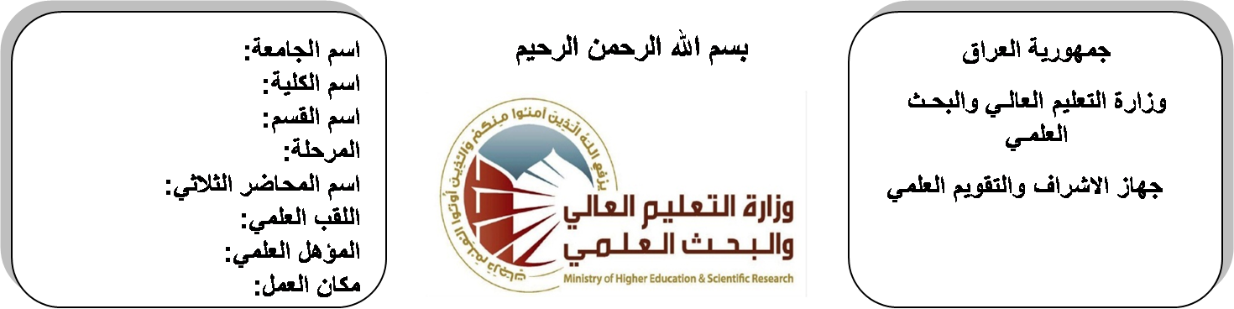
اسم الجامعة:ديالى
اسم الكلية:الهندسة
اسم القسم: الالكترونيك
المرحلة: الثانية
اسم المحاضر الثلاثي: ابراهيم سعدون
اللقب العلمي: مدرس مساعد
المؤهل العلمي: ماجستير
مكان العمل: كلية الهندسة

(( استمارة الخطة التدريسية السنوية ))

ابراهيم سعدون فتاح |  |  |  |  | اسم التدريسي:
IBRAHIM1969@YAHOO.COM |  |  |  |  | البريد الالكتروني:
Electrical Power & Machines |  |  |  |  | اسم المادة:
The aim of this subject is to make the students ready to undestand and comprehend the scientific theories and their applications related to their field of the study. |  |  |  |  | أهداف المادة:
Electrical Technology by B.L Theraja. |  |  |  |  | الكتب المنهجية:
 |  |  |  |  | المصادر الخارجية:
الامتحان النهائي | المختبرات | الفصل  الثاني | نصف السنة | الفصل الأول | تقديرات الفصل:
50% | 10% | 10% | 20% | 10%
 |  |  |  |  | معلومات إضافية:

جدول الدروس الأسبوعي – الفصل الدراسي الأول

الملاحظات | المادة العملية | المادة النظرية | التاريخ |  | الأسبوع
 |  | Construction of D-C machine | 30/9/2015 |  | 1
 |  | Direct current generator and motor principles | 7/10/2015 |  | 2
 |  | Principles of generator action, Types of D-G generators | 14/10/2015 |  | 3
 |  | Shunt D-Generator series D-C generators | 21/10/2015 |  | 4
 |  | Types of D-C motors | 28/10/2015 |  | 5
 |  | Shunt D-C motors, Series D-C motors | 4/11/2015 |  | 6
 |  | Compound D-C motors, Separately excited D-C motor, Shunt D-C motors | 11/11/2015 |  | 7
 |  | Compound D-C Motors | 18/11/2015 |  | 8
 |  | Construction of transformer | 25/11/2015 |  | 9
 |  | Fundamental principle of operation of ideal Tr | 2/12/2015 |  | 10
 |  | Approximate equivalent circuit  Voltage regulation | 9/12/2015 |  | 11
 |  | Transformer efficiency, Open circuit test, Short circuit test | 16/12/2015 |  | 12
 |  | Transformer efficiency, Open circuit test, Short circuit test | 23/12/2015 |  | 13
 |  | Transformer efficiency, Open circuit test, Short circuit test | 30/12/2015 |  | 14
 |  | Transformer efficiency, Open circuit test, Short circuit test | 6/1/2016 |  | 15
 |  | Transformer efficiency, Open circuit test, Short circuit test | 13/1/2016 |  | 16
العطلة الربيعية |  |  |  | 15/1/2016 to  1/2/2016

توقيع الأستاذ: توقيع رئيس القسم توقيع العميد:

جدول الدروس الأسبوعي – الفصل الدراسي الثاني

الملاحظات | المادة العملية | المادة النظرية | التاريخ | الأسبوع
 |  | . Electrical Power | 17/2/2016 | 1
 |  | Electrical Power | 24/2/2016 | 2
 |  | Power definition | 2/3/2016 | 3
 |  | Power in 1-cct | 9/3/2016 | 4
 |  | Power in 1-cct | 16/3/2016 | 5
 |  | Power in 3-cct | 23/3/2016 | 6
 |  | Power in 3-cct | 30/3/2016 | 7
 |  | Power plant over head transmission line | 6/4/2016 | 8
 |  | Power plant over head transmission line | 13/4/2016 | 9
 |  | Power plant over head transmission line | 20/4/2016 | 10
 |  | Conductor material | 27/4/2016 | 11
 |  | Conductor material | 4/5/2016 | 12
 |  | Conductor material | 11/5/2016 | 13
 |  | Material design sag tension relationship | 19/5/2016 | 14
 |  | Material design sag tension relationship | 26/5/2016 | 15
 |  | Material design sag tension relationship | 3/6/2016 | 16

توقيع الأستاذ: توقيع رئيس القسم توقيع العميد:

