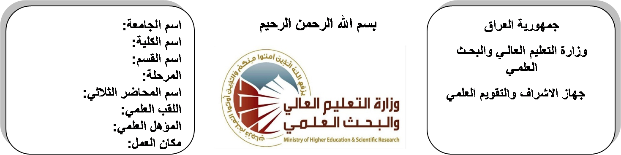
اسم الجامعة:ديالى
اسم الكلية:الهندسة
اسم القسم:الالكترونيك
المرحلة:الثالثة
اسم المحاضر الثلاثي:خالد عواد حمود
اللقب العلمي: مدرس
المؤهل العلمي: دكتوراة
مكان العمل: كلية الهندسة

(( استمارة الخطة التدريسية السنوية ))

د. خالد عواد |  |  |  | اسم التدريسي:
humoodkhalid@yah00.com |  |  |  | البريد الالكتروني:
Analogue Electronic II |  |  |  | اسم المادة:
The aim of this subject is to make the students ready to undestand and comprehend the scientific theories and their applications related to their field of the study. |  |  |  | أهداف المادة:
R.boylesta “electronic devices and cicuits theory” |  |  |  | الكتب المنهجية:
Electronic devices and cicuits theory by KUMAR IRBALB |  |  |  | المصادر الخارجية:
الامتحان النهائي | المختبرات | الفصل  الثاني | الفصل الأول | تقديرات الفصل:
50% | 10% | 20% | 20%
 |  |  |  | معلومات إضافية:

جدول الدروس الأسبوعي – الفصل الدراسي الأول

الملاحظات | المادة العملية | المادة النظرية | التاريخ |  | الأسبوع
 |  | Frequency response characteristics | 29/9/2015 |  | 1
 |  | Frequency small signal models of JFETs | 5/10/2015 |  | 2
 |  | Frequency response of various amplifier configutions. | 12/10/2015 |  | 3
 |  | Amplifer Frequncy Response | 19/10/2015 |  | 4
 |  | Frequency response concepts, transistor at high frequency | 26/10/2015 |  | 5
 |  | multistage at low &high frequency ,FET amplifiers at low &high frequency | 2/11/2015 |  | 6
 |  | Freed back Amplifier | 9/11/2015 |  | 7
 |  | Freedback concept, types, effects & topologies, feed back analysis, voltage-series | 16/11/2015 |  | 8
 |  | voltage–shunt, current-series, and current-shunt F.B stability & response of feedback amplifier | 23/11/2015 |  | 9
 |  | Operational Amplifier Design | 30/11/2015 |  | 10
 |  | Op-Amp characteristics and structure, difference amplifier | 7/12/2015 |  | 11
 |  | d.c level shifting stage | 14/12/2015 |  | 12
 |  | Operational Amplifier Applications | 21/12/2015 |  | 13
 |  | Inverting and non – inverting amplifiers, integrator, differentiator, adder , subtractor | 28/12/2015 |  | 14
 |  | comparator, precision diode, rectifier, precision clamps, sample and hold circuit, and peak detector | 4/1/2016 |  | 15
 |  | Active Filters | 11/1/2016 |  | 16
العطلة الربيعية |  |  |  | 15/1/2016 to  1/2/2016

توقيع الأستاذ: توقيع رئيس القسم توقيع العميد:

جدول الدروس الأسبوعي – الفصل الدراسي الثاني

الملاحظات | المادة العملية | المادة النظرية | التاريخ | الأسبوع
 |  | Filters concept, types, approximations, active RC design, biduad structure | 21/2/2016 | 1
 |  | Ladder design, and GIC. | 28/2/2016 | 2
 |  | Oscillator | 6/3/2016 | 3
 |  | Oscillator concept, RC oscillator | 13/3/2016 | 4
 |  | LC oscillator, crystal oscillators | 20/3/2016 | 5
 |  | Power Amplifier | 27/3/2016 | 6
 |  | Class A, class B, classAB and push-pull amplifiers | 3/4/2016 | 7
 |  | Class A, class B, classAB and push-pull amplifiers | 10/4/2016 | 8
 |  | Integrated Circuit Design | 17/4/2016 | 9
 |  | IC biasing techniques, current mirror, current repeaters, and wilder current sources | 24/4/2016 | 10
 |  | bipolar technology TTL,RTL , ECL, MOS, NMOS, PMOS, CMOS | 1/5/2016 | 11
 |  | Integrated Circuit Fabrication | 8/5/2016 | 12
 |  | Fabrication processes | 15/5/2016 | 13
 |  | IC components (resistors, capacitors) | 22/5/2016 | 14
 |  | transistor fabrication, Layout design rules, full custom | 29/5/2016 | 15
 |  | semi custom design , phase Locked loop | 2/6/2016 | 16

توقيع الأستاذ: توقيع رئيس القسم توقيع العميد:

