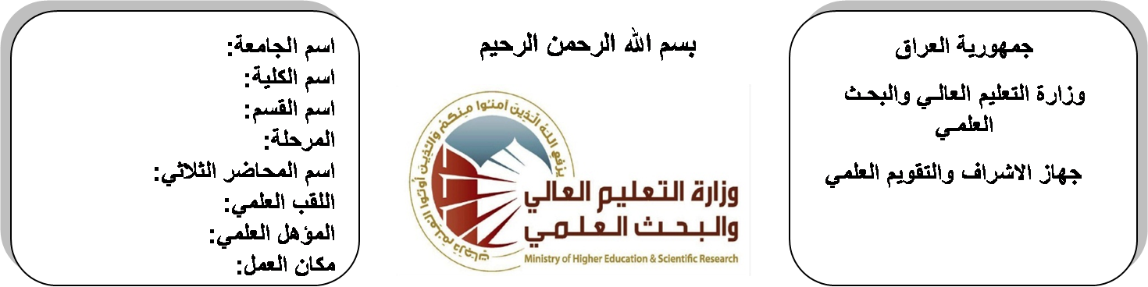
اسم الجامعة:ديالى
اسم الكلية:الهندسة
اسم القسم:الالكترونيك
المرحلة:الثالثة
اسم المحاضر الثلاثي:اياد قيس عبد الكريم
اللقب العلمي: مدرس مساعد
المؤهل العلمي:ماجستير
مكان العمل: كلية الهندسة

(( استمارة الخطة التدريسية السنوية ))

م.م اياد قيس عبد الكريم موسى |  |  |  | اسم التدريسي:
Aiyad_qais@yahoo.com |  |  |  | البريد الالكتروني:
Antenna & Propagation |  |  |  | اسم المادة:
The aim of this subject is to make the students ready to undestand and comprehend the scientific theories and their applications related to their field of the study. |  |  |  | أهداف المادة:
ANTENNA THEORY AND DESIGN BY STUTZM |  |  |  | الكتب المنهجية:
ANTENNA BY KRAUS |  |  |  | المصادر الخارجية:
الامتحان النهائي | المختبرات | الفصل  الثاني | الفصل الأول | تقديرات الفصل:
50% | 10% | 20% | 20%
 |  |  |  | معلومات إضافية:

جدول الدروس الأسبوعي – الفصل الدراسي الأول

الملاحظات | المادة العملية | المادة النظرية | التاريخ |  | الأسبوع
 |  | Isotrop & point radiator with reflector & parttern | 30/9/2015 |  | 1
 |  | The hertizian dipole& its pattern of electric field & power density Short antenna | 7/10/2015 |  | 2
 |  | Gain &short ant, Directivity & beam width | 14/10/2015 |  | 3
 |  | Antenna & its pattern of field &radiation resistance & polarization. | 21/10/2015 |  | 4
 |  | The loop antenna & Its field | 28/10/2015 |  | 5
 |  | Radiation, resistance & pattern receiving antenna & effective area of antenna Radar equations & path losses | 4/11/2015 |  | 6
 |  | Antenna above ground & monopole, Pattern | 11/11/2015 |  | 7
 |  | Folded antenna, Point radiator arrays &multi antenna arrays & their gain &patterns stacked antenna Yagi antenna Slot antenna | 18/11/2015 |  | 8
 |  | Microwave antenna | 25/11/2015 |  | 9
 |  | Microwave antenna | 2/12/2015 |  | 10
 |  | Horn &parabola | 9/12/2015 |  | 11
 |  | Horn &parabola | 16/12/2015 |  | 12
 |  | Helical antenna& helix& ionosphere & wave, Propagation &type of waves | 23/12/2015 |  | 13
 |  | Time varying field & Maxwell's equation, Faradays law | 30/12/2015 |  | 14
 |  | Amperes law, Gauss's law, Boundary condition on the field vectors | 6/1/2016 |  | 15
 |  | Amperes law, Gauss's law, Boundary condition on the field vectors | 13/1/2016 |  | 16
عطلة نصف السنة |  |  |  | 15/1/2016 to  1/2/2016

توقيع الأستاذ: توقيع رئيس القسم توقيع العميد:

جدول الدروس الأسبوعي – الفصل الدراسي الثاني

الملاحظات | المادة العملية | المادة النظرية | التاريخ | الأسبوع
 |  | Time-Instantaneous Pointing Theorem | 17/2/2016 | 1
 |  | Time-Instantaneous Pointing Theorem | 24/2/2016 | 2
 |  | Plane Wave Complex Pointing Vector | 2/3/2016 | 3
 |  | Plane Wave Complex Pointing Vector | 9/3/2016 | 4
 |  | Planes wave & their characteristic in free space | 16/3/2016 | 5
 |  | The wave equation | 23/3/2016 | 6
 |  | uniform plane wave | 30/3/2016 | 7
 |  | Propagation of plane wave in losses media | 6/4/2016 | 8
 |  | Polarization of uniform plane wave | 13/4/2016 | 9
 |  | Normal incident of uniform plane wave on plane boundaries | 20/4/2016 | 10
 |  | Guided waves | 27/4/2016 | 11
 |  | Wave between parallel planes | 4/5/2016 | 12
 |  | Wave between parallel planes | 11/5/2016 | 13
 |  | Transverse electric wave (TL-wave), Characteristic of TE&TM waves. | 19/5/2016 | 14
 |  | Transverse Electromagnetic Wave (TEM-waves) & Waves Guides | 26/5/2016 | 15
 |  | Transverse Electromagnetic Wave (TEM-waves) & Waves Guides | 3/6/2016 | 16

توقيع الأستاذ: توقيع رئيس القسم توقيع العميد:

