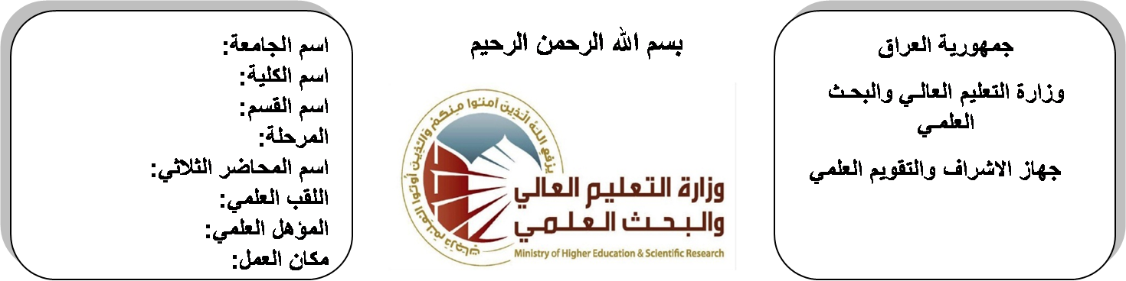
اسم الجامعة:ديالى
اسم الكلية:الهندسة
اسم القسم: الالكترونيك
المرحلة:الثالثة
اسم المحاضر: عصام صلاح حميد
اللقب العلمي: مدرس مساعد
المؤهل العلمي: ماجستير
مكان العمل: كلية الهندسة

(( استمارة الخطة التدريسية السنوية ))
عصام صلاح حميد |  |  |  | اسم التدريسي:
husamtakt@yahoo.com |  |  |  | البريد الالكتروني:
Digital Signal Processing (DSP) |  |  |  | اسم المادة:
The aim of this subject is to cover the novel techniques of digital signal and its processing that is involved in different applications including electronic and communication engineering. Besides, the topic of DSP covers the diverse signals such as that of human body and puts them under control by using mathematical algorithms in order to make the students ready to understand and comprehend the scientific theories and their applications related to their field of the study. |  |  |  | أهداف المادة:
- Digital Signal Processing: principles, algorithms, and applications, third edition, by John G. Proakis and Dimitris G. Manolakis.  - Digital Signal Processing, fundamentals and applications, 2008, by Li Tan. |  |  |  | الكتب المنهجية:
- Mathematics for Engineers and Applied Scientists, 2nd edition, by Stanley.  - Introductory Digital Signal Processing, 2nd edition by P. A. Lynn. |  |  |  | المصادر الخارجية:
الامتحان النهائي | المختبرات | الفصل الثاني | الفصل الأول | تقديرات الفصل:
60% | 00% | 20% | 20%
 |  |  |  | معلومات إضافية:

جدول الدروس الأسبوعي – الفصل الدراسي الأول

الملاحظات | المادة العملية | المادة النظرية | التاريخ |  | الأسبوع
 |  | Introduction to DSP | 29/9/2015 |  | 1
 |  | The concept of frequency in continues time and discrete time signals | 5/10/2015 |  | 2
 |  | Digital signals and systems | 12/10/2015 |  | 3
 |  | Discrete time Systems | 19/10/2015 |  | 4
 |  | Block diagram representation of discrete time systems | 26/10/2015 |  | 5
 |  | Discrete time systems as difference equation | 2/11/2015 |  | 6
 |  | Sampling theory amd Nyquist rate | 9/11/2015 |  | 7
 |  | Linear convolution and signal comparison | 16/11/2015 |  | 8
 |  | Circular convolution of discrete time sequence | 23/11/2015 |  | 9
 |  | Discrete Fourier Transform DFT | 30/11/2015 |  | 10
 |  | Inverse of Discrete Fourier Transform DFT | 7/12/2015 |  | 11
 |  | Application of Discrete Fourier Transform | 14/12/2015 |  | 12
 |  | Fast Fourier Transform FFT | 21/12/2015 |  | 13
 |  | The Inverse of Fast Fourier Transform FFT | 28/12/2015 |  | 14
 |  | Applications of Discrete Fourier Transform | 4/1/2016 |  | 15
 |  | Seminars | 11/1/2016 |  | 16
عطلة نصف السنة |  |  |  | 15/1/2016 to  1/2/2016

توقيع الأستاذ: توقيع رئيس القسم توقيع العميد:

جدول الدروس الأسبوعي – الفصل الدراسي الثاني

الملاحظات | المادة العملية | المادة النظرية | التاريخ | الأسبوع
 |  | Discrete time system analysis using Z-transform | 15/2/2016 | 1
 |  | Discrete time system analysis using Z-transform | 22/2/2016 | 2
 |  | Discrete time system analysis using  Z-transform | 1/3/2016 | 3
 |  | Inverse Z-transform | 8/3/2016 | 4
 |  | Digital Filters | 15/3/2016 | 5
 |  | Realization of digital filters | 22/3/2016 | 6
 |  | Analog Filter design | 29/3/2016 | 7
 |  | Butterworth filter design  (LPF, HPF, BPF, and BSF( | 5/4/2016 | 8
 |  | Chebyshev filter design  (LPF, HPF, BPF, and BSF( | 12/4/2016 | 9
 |  | FIR Digital Filter Design | 19/4/2016 | 10
 |  | IIR Digital Filter Design | 26/4/2016 | 11
 |  | Bilinear Transformation Design Method | 3/5/2016 | 12
 |  | Design of FIR filters using windows | 10/5/2016 | 13
 |  | Application of digital filters | 17/5/2016 | 14
 |  | Introduction to adaptive filtering  And its application | 24/5/2016 | 15
 |  | Seminars | 1/6/2016 | 16

توقيع الأستاذ: توقيع رئيس القسم توقيع العميد:

