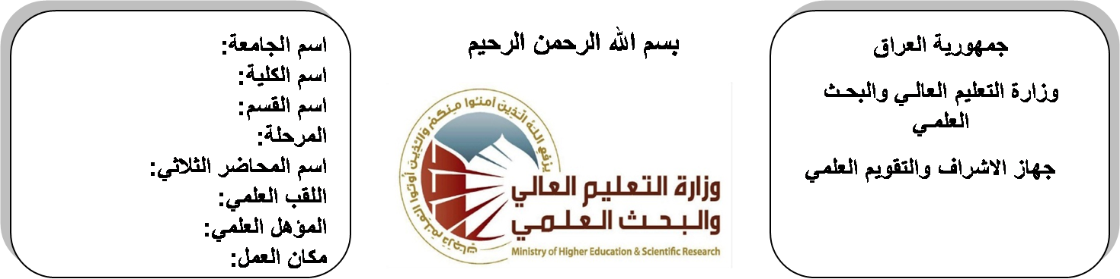
اسم الجامعة:ديالى
اسم الكلية:الهندسة
اسم القسم: الالكترونيك
المرحلة: الثالثة
اسم المحاضر الثلاثي:حنان بديع
اللقب العلمي: مدرس مساعد
المؤهل العلمي: ماستر
مكان العمل: كلية الهندسة

(( استمارة الخطة التدريسية السنوية ))

حنان بديع احمد |  |  |  | اسم التدريسي:
Hanan1980@yahoo.com |  |  |  | البريد الالكتروني:
Engineering & Numerical Analysis |  |  |  | اسم المادة:
The aim of this subject is to make the students ready to undestand and comprehend the scientific theories and their applications related to their field of the study. |  |  |  | أهداف المادة:
Advanced Mathematics by Wiley. |  |  |  | الكتب المنهجية:
Calculus by James Stewart ,Barbara Frank. |  |  |  | المصادر الخارجية:
الامتحان النهائي | المختبرات | الفصل  الثاني | الفصل الأول | تقديرات الفصل:
60% | 0% | 20% | 20%
 |  |  |  | معلومات إضافية:

جدول الدروس الأسبوعي – الفصل الدراسي الأول

الملاحظات | المادة العملية | المادة النظرية | التاريخ |  | الأسبوع
 |  | Fourier transform | 29/9/2015 |  | 1
 |  | Properties , convolution theorm | 5/10/2015 |  | 2
 |  | power spectral density and correlation | 12/10/2015 |  | 3
 |  | signals and linear system ,applications. | 19/10/2015 |  | 4
 |  | The Z- transform | 26/10/2015 |  | 5
 |  | Region of convergence, properties of Z-transform | 2/11/2015 |  | 6
 |  | Z-transform pairs, the inverse of Z-transform | 9/11/2015 |  | 7
 |  | analysis and discrete- time systems, applications | 16/11/2015 |  | 8
 |  | Numerical Analysis | 23/11/2015 |  | 9
 |  | Solution of non-linear eguations (Iteration ,bisection and Newton – Raphson). | 30/11/2015 |  | 10
 |  | Finite differences | 7/12/2015 |  | 11
 |  | Numerical differentiation and Integration | 14/12/2015 |  | 12
 |  | Numerical Solution of 1st order ordinary differential equations | 21/12/2015 |  | 13
 |  | Matrix anaylsis | 28/12/2015 |  | 14
 |  | Review of matrix theory | 4/1/2016 |  | 15
 |  | linear transformation | 11/1/2016 |  | 16
العطلة الربيعية |  |  |  | 15/1/2016 to  1/2/2016

توقيع الأستاذ: توقيع رئيس القسم توقيع العميد:

جدول الدروس الأسبوعي – الفصل الدراسي الثاني

الملاحظات | المادة العملية | المادة النظرية | التاريخ | الأسبوع
 |  | egin values & egin vectors | 15/2/2016 | 1
 |  | laplace transform of matrices, application of matrices to electric cct. | 22/2/2016 | 2
 |  | Definition, frequency distribution (relative & commulative, mean, standard deviation). | 1/3/2016 | 3
 |  | Definition, frequency distribution (relative & commulative, mean, standard deviation). | 8/3/2016 | 4
 |  | Definition, mutually exclusive & conditional probability | 15/3/2016 | 5
 |  | permutations & combinations, probability distribution, normal & Poisson distributions | 22/3/2016 | 6
 |  | Function of complex variable , complex differentiation | 29/3/2016 | 7
 |  | analytic function & its properties, integration in the complex plane | 5/4/2016 | 8
 |  | Cauchy's theorem , Cauchy's integral, taylor's theorem, Laurent series, the residue theorem. | 12/4/2016 | 9
 |  | Legendre's equation, Legendre's polynomials | 19/4/2016 | 10
 |  | Bessel function of the first and second order kinds, Bessel function properties. | 26/4/2016 | 11
 |  | Partial differential equation | 3/5/2016 | 12
 |  | Wave equation | 10/5/2016 | 13
 |  | laplace's equation | 17/5/2016 | 14
 |  | solution of boundary condition problems | 24/5/2016 | 15
 |  | solution by separation of variables | 1/6/2016 | 16

توقيع الأستاذ: توقيع رئيس القسم توقيع العميد:

