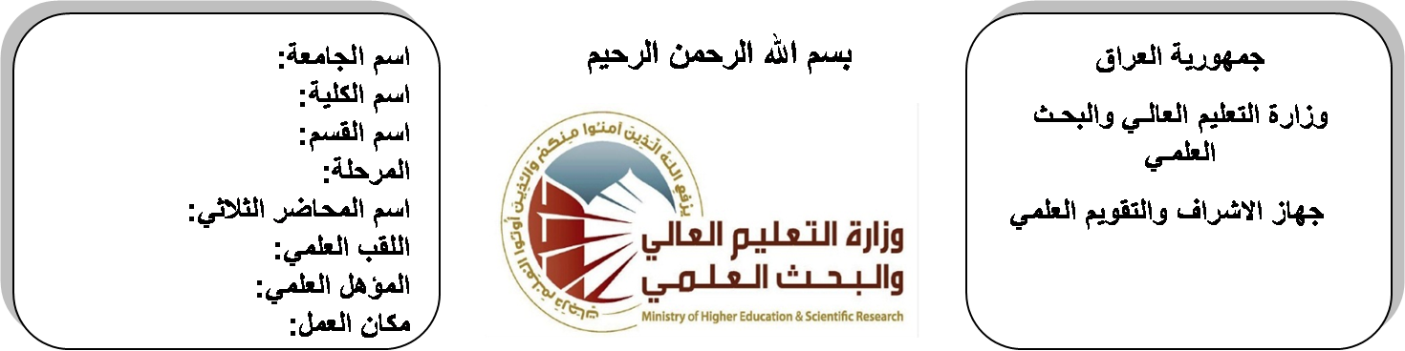
اسم الجامعة:ديالى
اسم الكلية:الهندسة
اسم القسم:الالكترونيك
المرحلة:الثالثة
اسم المحاضر الثلاثي:محمد سلمان صالح
اللقب العلمي: مدرس
المؤهل العلمي:دكتوراة
مكان العمل: كلية الهندسة

(( استمارة الخطة التدريسية السنوية ))

د. محمد سلمان |  |  |  | اسم التدريسي:
MSELMAN-09@YAHOO.COM |  |  |  | البريد الالكتروني:
Microprocessor |  |  |  | اسم المادة:
The aim of this subject is to make the students ready to undestand and comprehend the scientific theories and their applications related to their field of the study. |  |  |  | أهداف المادة:
Microprocessor architecture,programming and applications with 8085/8080A by Ramesh Gaonkar |  |  |  | الكتب المنهجية:
 |  |  |  | المصادر الخارجية:
الامتحان النهائي | المختبرات | الفصل  الثاني | الفصل الأول | تقديرات الفصل:
50% | 10% | 20% | 20%
 |  |  |  | معلومات إضافية:

جدول الدروس الأسبوعي – الفصل الدراسي الأول

الملاحظات | المادة العملية | المادة النظرية | التاريخ |  | الأسبوع
 |  | Definitions, computing logic , microprocessor development construction , fields of application. | 30/9/2015 |  | 1
 |  | Definitions, computing logic , microprocessor development construction , fields of application. | 7/10/2015 |  | 2
 |  | Numbers system, methods of numbering | 14/10/2015 |  | 3
 |  | Numbers system, methods of numbering | 21/10/2015 |  | 4
 |  | additional conversion methods between the number system, | 28/10/2015 |  | 5
 |  | additional conversion methods between the number system, | 4/11/2015 |  | 6
 |  | arithmetic operations | 11/11/2015 |  | 7
 |  | Compute logic | 18/11/2015 |  | 8
 |  | coding state | 25/11/2015 |  | 9
 |  | Boolean algebra | 2/12/2015 |  | 10
 |  | karnauff map method | 9/12/2015 |  | 11
 |  | sequentional logic circuits | 16/12/2015 |  | 12
 |  | Optimum using for sequention circuit in Microprocessor structure | 23/12/2015 |  | 13
 |  | Optimum using for sequention circuit in Microprocessor structure | 30/12/2015 |  | 14
 |  | Optimum using for sequention circuit in Microprocessor structure | 6/1/2016 |  | 15
 |  | Optimum using for sequention circuit in Microprocessor structure | 13/1/2016 |  | 16
عطلة نصف السنة |  |  |  | 15/1/2016 to  1/2/2016

توقيع الأستاذ: توقيع رئيس القسم توقيع العميد:

جدول الدروس الأسبوعي – الفصل الدراسي الثاني

الملاحظات | المادة العملية | المادة النظرية | التاريخ | الأسبوع
 |  | Techniques, bipolar, schotcky bipolar | 17/2/2016 | 1
 |  | integrated injection logic (I²L), | 24/2/2016 | 2
 |  | tabled comparation | 2/3/2016 | 3
 |  | tabled comparation | 9/3/2016 | 4
 |  | Memory, type of semiconductor memory | 16/3/2016 | 5
 |  | Memory, type of semiconductor memory | 23/3/2016 | 6
 |  | Memory, type of semiconductor memory | 30/3/2016 | 7
 |  | data save methods arrangement | 6/4/2016 | 8
 |  | data save methods arrangement | 13/4/2016 | 9
 |  | Architecture | 20/4/2016 | 10
 |  | data and instructions representation | 27/4/2016 | 11
 |  | data and instructions representation | 4/5/2016 | 12
 |  | adders buses | 11/5/2016 | 13
 |  | data and instruction | 19/5/2016 | 14
 |  | timing, instructions groups, architecture of bipolar wafers | 26/5/2016 | 15
 |  | Software, accumulating languge, algorithms | 3/6/2016 | 16

توقيع الأستاذ: توقيع رئيس القسم توقيع العميد:

