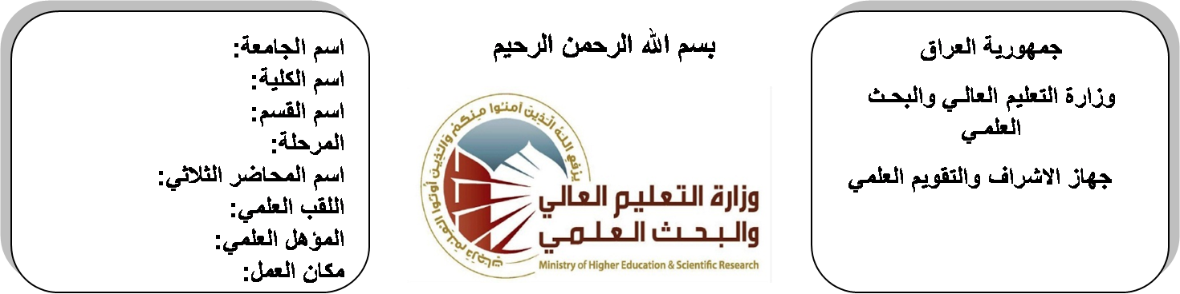 **(( استمارة الخطة التدريسية السنوية ))**

**اسم الجامعة:ديالى**

**اسم الكلية: الهندسة**

**اسم القسم: الالكترونيك**

**المرحلة: الرابعة**

**اسم المحاضر الثلاثي: احمد محمد**

**اللقب العلمي: مدرس مساعد**

**المؤهل العلمي: الماجستير**

**مكان العمل: قسم الاتصالات**

|  |  |  |  |  |
| --- | --- | --- | --- | --- |
| **احمد محمد** | | | | **اسم التدريسي:** |
| **AHMED_ZYDI@YAHOO.COM** | | | | **البريد الالكتروني:** |
| Communication Systems | | | | **اسم المادة:** |
| **The aim of this subject is to make the students ready to undestand and comprehend the scientific theories and their applications related to their field of the study.** | | | | **أهداف المادة:** |
| Anologe & Digital communications by HWEI, **HSU.** | | | | **الكتب المنهجية:** |
| **Communication systemsby Ferrel G.Stremler.** | | | | **المصادر الخارجية:** |
| **الامتحان النهائي** | **المختبرات** | **الفصل**  **الثاني** | **الفصل الأول** | **تقديرات الفصل:** |
| 50% | 10% | 20% | 20% |
|  | | | | **معلومات إضافية:** |

**جدول الدروس الأسبوعي – الفصل الدراسي الأول**

|  |  |  |  |  |  |
| --- | --- | --- | --- | --- | --- |
| **الملاحظات** | **المادة العملية** | **المادة النظرية** | **التاريخ** | | **الأسبوع** |
|  |  | **Information Theory** | **30/9/2015** | | 1 |
|  |  | Self information | **7/10/2015** | | 2 |
|  |  | sourse entropy and sourse entropy rate | **14/10/2015** | | 3 |
|  |  | mutual information | **21/10/2015** | | 4 |
|  |  | channel model BSC and nonsymmetric discrete channels | **28/10/2015** | | 5 |
|  |  | Optimum threshold setting | **4/11/2015** | | 6 |
|  |  | Capacity of continuous channel(Shannon eq). | **11/11/2015** | | 7 |
|  |  | Coding of Discrete Sources | **18/11/2015** | | 8 |
|  |  | Efficiency and redundancy of a code | **25/11/2015** | | 9 |
|  |  | fixed length codes | **2/12/2015** | | 10 |
|  |  | variable length codes | **9/12/2015** | | 11 |
|  |  | fano code, huffiman code | **16/12/2015** | | 12 |
|  |  | Shannon code. Nonbinary source coding | **23/12/2015** | | 13 |
|  |  | Source extention for higher coding efficiency. | **30/12/2015** | | 14 |
|  |  | **Channel Coding** | **6/1/2016** | | 15 |
|  |  | Even and odd parity error detecting codes | **13/1/2016** | | 16 |
| عطلة نصف السنة | | | | 15/1/2016 to  1/2/2016 | |

**توقيع الأستاذ: توقيع رئيس القسم توقيع العميد:**

**جدول الدروس الأسبوعي – الفصل الدراسي الثاني**

|  |  |  |  |  |
| --- | --- | --- | --- | --- |
| **الملاحظات** | **المادة العملية** | **المادة النظرية** | **التاريخ** | **الأسبوع** |
|  |  | prob of undetected errors. Error correcting codes | **17/2/2016** | 1 |
|  |  | linear block codes (generator and parity check matrices),hamming distance | **24/2/2016** | 2 |
|  |  | hamming weight bound, and error correction capabilities | **2/3/2016** | 3 |
|  |  | Decoding of linear block codes (syndromes). | **9/3/2016** | 4 |
|  |  | Cyclic codes: generator polynomial, nonsystematic code (multiplication) | **16/3/2016** | 5 |
|  |  | systematic cyclic code (division), and realization logic circuit for encoding logic and decoding of systematic cyclic codes | **23/3/2016** | 6 |
|  |  | Convolution codes,encoding logic (generation),tree diagram state diagram and trellis diagram of convolutional cod | **30/3/2016** | 7 |
|  |  | Block diagram of a general (DSP) system.  Basic concepts: linear, time variant, stable and casual discrete systems. Input/output relation in Z-domains | **6/4/2016** | 8 |
|  |  | Discrete convolution techniques: tabular method-transform method, matrix method, add overlap method. | **13/4/2016** | 9 |
|  |  | Deconvolution methods: iterative method and Z-transform method. Frequency response of discrete system | **20/4/2016** | 10 |
|  |  | Discrete Fourier transform (DFT),Fast Fourier transform (FFT) decimation in time. | **27/4/2016** | 11 |
|  |  | Review of analogue filters design (Butterworth and chebyshev filter) | **4/5/2016** | 12 |
|  |  | Classification and realization of discrete systems (FIR and IIR system ) | **11/5/2016** | 13 |
|  |  | IIR filter design using analogue filters and the bilinear transformation, filter transformation for IIR(LPF/LPF,LPF/HPF,LPF/BPF,LPF/BSF) | **19/5/2016** | 14 |
|  |  | FIR filter design using windows: Rectangular, Bartlett, hanning, hamming and Blackman windows | **26/5/2016** | 15 |
|  |  | LPF, HPF, BPF, and BPF, and FIR filter. | **3/6/2016** | 16 |

**توقيع الأستاذ: توقيع رئيس القسم توقيع العميد:**