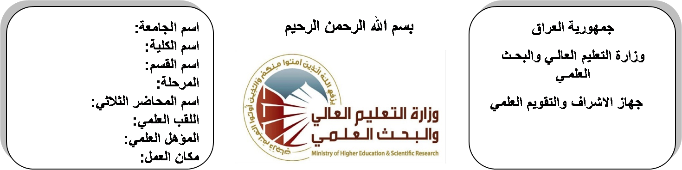
اسم الجامعة:ديالى
اسم الكلية:الهندسة
اسم القسم: الالكترونيك
المرحلة:الرابعة
اسم المحاضر الثلاثي: ارشد عبد الحميد
اللقب العلمي: مدرس
المؤهل العلمي: دكتوراة
مكان العمل: كلية الهندسة

(( استمارة الخطة التدريسية السنوية ))

ارشد عبد الحميد محمد |  |  |  | اسم التدريسي:
Arshad.ahd@gmail.com |  |  |  | البريد الالكتروني:
Control Engineering |  |  |  | اسم المادة:
The aim of this subject is to make the students ready to undestand and comprehend the scientific theories and their applications related to their field of the study. |  |  |  | أهداف المادة:
Modern control system by “OGATA” |  |  |  | الكتب المنهجية:
Advanced control system by’ROLAND S.BURNS” |  |  |  | المصادر الخارجية:
الامتحان النهائي | المختبرات | الفصل  الثاني | الفصل الأول | تقديرات الفصل:
50% | 10% | 20% | 20%
 |  |  |  | معلومات إضافية:

جدول الدروس الأسبوعي – الفصل الدراسي الأول

الملاحظات | المادة العملية | المادة النظرية | التاريخ |  | الأسبوع
 |  | Basic Definition | 29/9/2015 |  | 1
 |  | Transfer functions of electrical system | 5/10/2015 |  | 2
 |  | mechanical system & servo system | 12/10/2015 |  | 3
 |  | Block Diagram Algebra | 19/10/2015 |  | 4
 |  | Signal flow graph & mason's rule | 26/10/2015 |  | 5
 |  | Time Domain Response | 2/11/2015 |  | 6
 |  | Typical test signals & types of the systems | 9/11/2015 |  | 7
 |  | The steady-state error due to step, ramp & parabolic inputs. | 16/11/2015 |  | 8
 |  | Transient Response of Second Order Systems. | 23/11/2015 |  | 9
 |  | Transient Response of Second Order Systems. | 30/11/2015 |  | 10
 |  | Stability of control system, Routh criterion, Root locus | 7/12/2015 |  | 11
 |  | Stability of control system, Routh criterion, Root locus | 14/12/2015 |  | 12
 |  | Stability of control system, Routh criterion, Root locus | 21/12/2015 |  | 13
 |  | Stability of control system, Routh criterion, Root locus | 28/12/2015 |  | 14
 |  | Frequency Response | 4/1/2016 |  | 15
 |  | Introduction to Nyquist plot | 11/1/2016 |  | 16
عطلة نصف السنة |  |  |  | 15/1/2016 to  1/2/2016

توقيع الأستاذ: توقيع رئيس القسم توقيع العميد:

جدول الدروس الأسبوعي – الفصل الدراسي الثاني

الملاحظات | المادة العملية | المادة النظرية | التاريخ | الأسبوع
 |  | Nyquist plot | 15/2/2016 | 1
 |  | Phase margin | 22/2/2016 | 2
 |  | Gain margin | 1/3/2016 | 3
 |  | Introduction to Bode plot | 8/3/2016 | 4
 |  | Lead Compensation | 15/3/2016 | 5
 |  | Lag Compensation | 22/3/2016 | 6
 |  | Lead-Lag Compensation | 29/3/2016 | 7
 |  | Three-term Controller (PID) | 5/4/2016 | 8
 |  | Three-term Controller (PID) | 12/4/2016 | 9
 |  | Three-term Controller (PID) | 19/4/2016 | 10
 |  | State equation for dynamic system (electrical system) | 26/4/2016 | 11
 |  | Solving state equations | 3/5/2016 | 12
 |  | Analogue Computer Simulation | 10/5/2016 | 13
 |  | Analogue Computer Simulation | 17/5/2016 | 14
 |  | Analogue Computer Simulation | 24/5/2016 | 15
 |  | Nonlinear Control System | 1/6/2016 | 16

توقيع الأستاذ: توقيع رئيس القسم توقيع العميد:

