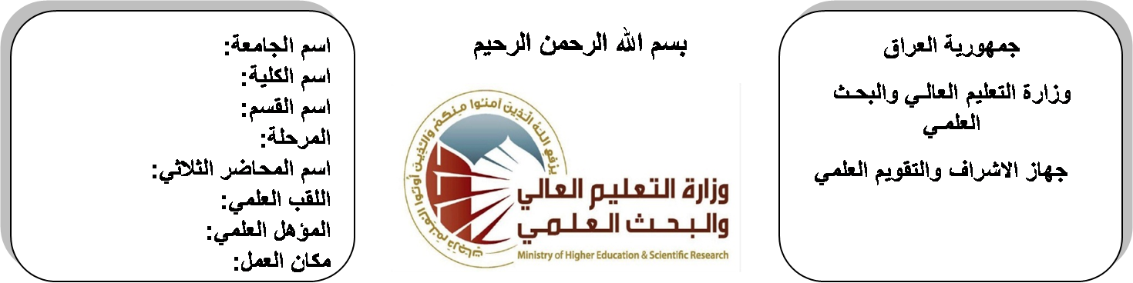 (( استمارة الخطة التدريسية السنوية ))
اسم الجامعة:ديالى
اسم الكلية:الهندسة
اسم القسم: الالكترونيك
المرحلة:الرابعة
اسم المحاضر الثلاثي: قحطان خلف
اللقب العلمي: مدرس
المؤهل العلمي: دكتوراة
مكان العمل: كلية الهندسة

قحطان خلف عمران |  |  |  | اسم التدريسي:
Khatan khalafo@yahoo.com |  |  |  | البريد الالكتروني:
Digital System Design |  |  |  | اسم المادة:
The aim of this subject is to make the students ready to undestand and comprehend the scientific theories and their applications related to their field of the study. |  |  |  | أهداف المادة:
DIGITAL DESIGN BY MORISANO M |  |  |  | الكتب المنهجية:
DIGITAL DESIGN BY FLOD |  |  |  | المصادر الخارجية:
الامتحان النهائي | المختبرات | الفصل  الثاني | الفصل الأول | تقديرات الفصل:
60% | 00% | 20% | 20%
 |  |  |  | معلومات إضافية:

جدول الدروس الأسبوعي – الفصل الدراسي الأول

الملاحظات | المادة العملية | المادة النظرية | التاريخ |  | الأسبوع
 |  | Simplification of Boolean Function using K-map and Tabulation | 29/9/2015 |  | 1
 |  | Simplification of Boolean Function using K-map and Tabulation | 5/10/2015 |  | 2
 |  | Simplification of Boolean Function using K-map and Tabulation | 12/10/2015 |  | 3
 |  | Digital Circuit Design using Logic Circuits (LSI, SSI, MSI) | 19/10/2015 |  | 4
 |  | Digital Circuit Design using Logic Circuits (LSI, SSI, MSI) | 26/10/2015 |  | 5
 |  | Digital Circuit Design using Logic Circuits (LSI, SSI, MSI) | 2/11/2015 |  | 6
 |  | Design using Programmable Logic Circuits (ROM, PLA, PAL) | 9/11/2015 |  | 7
 |  | Design using Programmable Logic Circuits (ROM, PLA, PAL) | 16/11/2015 |  | 8
 |  | Design using Programmable Logic Circuits (ROM, PLA, PAL) | 23/11/2015 |  | 9
 |  | Synchronized Sequential Circuits (Analysis and Design) | 30/11/2015 |  | 10
 |  | Synchronized Sequential Circuits (Analysis and Design) | 7/12/2015 |  | 11
 |  | Synchronized Sequential Circuits (Analysis and Design) | 14/12/2015 |  | 12
 |  | ASM Diagrams | 21/12/2015 |  | 13
 |  | ASM Diagrams | 28/12/2015 |  | 14
 |  | ASM Diagrams | 4/1/2016 |  | 15
 |  | ASM Diagrams | 11/1/2016 |  | 16
عطلة نصف السنة |  |  |  | 15/1/2016 to  1/2/2016

توقيع الأستاذ: توقيع رئيس القسم توقيع العميد:

جدول الدروس الأسبوعي – الفصل الدراسي الثاني

الملاحظات | المادة العملية | المادة النظرية | التاريخ | الأسبوع
 |  | Analysis and Design of Sequential Circuits using ASM Diagrams | 15/2/2016 | 1
 |  | Analysis and Design of Sequential Circuits using ASM Diagrams | 22/2/2016 | 2
 |  | Analysis and Design of Sequential Circuits using ASM Diagrams | 1/3/2016 | 3
 |  | Asynchronous Circuits (Analysis) | 8/3/2016 | 4
 |  | Asynchronous Circuits (Analysis) | 15/3/2016 | 5
 |  | Asynchronous Circuits (Analysis) | 22/3/2016 | 6
 |  | Luminescent pulse phenomenon in logic circuits (Static and Dynamic | 29/3/2016 | 7
 |  | Luminescent pulse phenomenon in logic circuits (Static and Dynamic | 5/4/2016 | 8
 |  | Luminescent pulse phenomenon in logic circuits (Static and Dynamic | 12/4/2016 | 9
 |  | Microprocessors-Component and Architecture | 19/4/2016 | 10
 |  | Microprocessors-Component and Architecture | 26/4/2016 | 11
 |  | Microprocessors-Component and Architecture | 3/5/2016 | 12
 |  | Microprocessors Hardwer, 4-, 8-, 16- and 32-bit Microprocessors | 10/5/2016 | 13
 |  | Microprocessors Hardwer, 4-, 8-, 16- and 32-bit Microprocessors | 17/5/2016 | 14
 |  | Single Chip Microcomputer 8085, 8088, MPU details. | 24/5/2016 | 15
 |  | Single Chip Microcomputer 8085, 8088, MPU details. | 1/6/2016 | 16

توقيع الأستاذ: توقيع رئيس القسم توقيع العميد:

