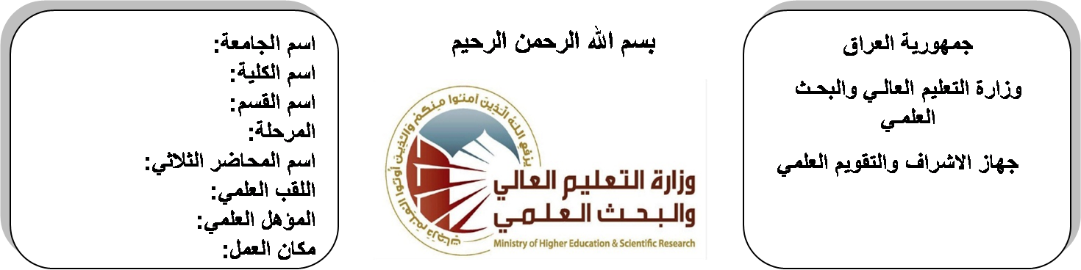 (( استمارة الخطة ((استمارة الخطة التدريسية السنوية ))
اسم الجامعة:ديالى
اسم الكلية:الهندسة
اسم القسم: الالكترونيك
المرحلة:الرابعة
اسم المحاضر الثلاثي: حنان بديع
اللقب العلمي: مدرس مساعد
المؤهل العلمي: ماجستير
مكان العمل: كلية الهندسة

حنان بديع احمد |  |  |  | اسم التدريسي:
Hanan1980@yahoo.com |  |  |  | البريد الالكتروني:
Microwave |  |  |  | اسم المادة:
The aim of this subject is to make the students ready to undestand and comprehend the scientific theories and their applications related to their field of the study. |  |  |  | أهداف المادة:
Microwave engineering by R.GOWRI |  |  |  | الكتب المنهجية:
Electromagnetics with applications by KRAUS/FLEISH |  |  |  | المصادر الخارجية:
الامتحان النهائي | المختبرات | الفصل  الثاني | الفصل الأول | تقديرات الفصل:
60% | 0% | 20% | 20%
 |  |  |  | معلومات إضافية:

جدول الدروس الأسبوعي – الفصل الدراسي الأول

الملاحظات | المادة العملية | المادة النظرية | التاريخ |  | الأسبوع
 |  | Electromagnetic Theory: Review | 21/2/2016 |  | 1
 |  | Electromagnetic Theory: Review | 28/2/2016 |  | 2
 |  | Transmission Lines in Microwaves | 6/3/2016 |  | 3
 |  | Transmission Lines in Microwaves | 13/3/2016 |  | 4
 |  | Microwave Network Analysis Using S-Parameters | 20/3/2016 |  | 5
 |  | Microwave Network Analysis Using S-Parameters | 27/3/2016 |  | 6
 |  | Passive Components in Microwave | 3/4/2016 |  | 7
 |  | Passive Components in Microwave | 10/4/2016 |  | 8
 |  | Microwave Filters | 17/4/2016 |  | 9
 |  | Microwave Filters | 24/4/2016 |  | 10
 |  | Design & Analysis of Ferromagnetic Components in Microwave. | 1/5/2016 |  | 11
 |  | Design & Analysis of Ferromagnetic Components in Microwave. | 8/5/2016 |  | 12
 |  | Active Microwave Circuits | 15/5/2016 |  | 13
 |  | Active Microwave Circuits | 22/5/2016 |  | 14
 |  | Microwave Tubes | 29/5/2016 |  | 15
 |  | Microwave Tubes | 2/6/2016 |  | 16
عطلة نصف السنة |  |  |  | 15/1/2016 to  1/2/2016

توقيع الأستاذ: توقيع رئيس القسم توقيع العميد:

جدول الدروس الأسبوعي – الفصل الدراسي الثاني

الملاحظات | المادة العملية | المادة النظرية | التاريخ | الأسبوع
 |  | Diode & Transistors in Microwaves | 21/2/2016 | 1
 |  | Diode & Transistors in Microwaves | 28/2/2016 | 2
 |  | Microwave Amplifier Design | 6/3/2016 | 3
 |  | Microwave Amplifier Design | 13/3/2016 | 4
 |  | Microwave Oscillator Design | 20/3/2016 | 5
 |  | Microwave Oscillator Design | 27/3/2016 | 6
 |  | Microwave Integrated Circuits | 3/4/2016 | 7
 |  | Microwave Integrated Circuits | 10/4/2016 | 8
 |  | Microwave Integrated Circuits | 17/4/2016 | 9
 |  | Applcation of Microwave in Communication Systems | 24/4/2016 | 10
 |  | Applcation of Microwave in Communication Systems | 1/5/2016 | 11
 |  | Applcation of Microwave in Communication Systems | 8/5/2016 | 12
 |  | Applcation of Microwave in Communication Systems | 15/5/2016 | 13
 |  | Radar System | 22/5/2016 | 14
 |  | Radar System | 29/5/2016 | 15
 |  | Radar System | 2/6/2016 | 16

توقيع الأستاذ: توقيع رئيس القسم توقيع العميد:

