Curriculum Vitae _ Marwa Subhi Ibrahim

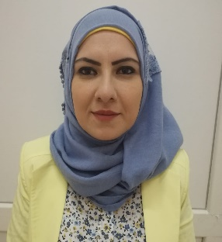
Personal Information _ .
Birth Date & Place: February, 12, 1985 – Iraq
Nationality: Iraqi
Email: marwa.s@uodiyala.edu.iq , marwa.s@uodiyala.edu.iq
Website: www.uodiyala.edu.iq
Postal address: Department of Computer Engineering, College of Engineering, Diyala University, Baquba City, Diyala Governorate, ZIP 32001, Iraq.
Professional Strength and Skills .
- I have experts in labs of computer engineering such as C programming lab, C++, visual basic lab, 8085 labs, 8086 labs, logic lab and digital electronic lab.
. Educational Qualifications .
- Ms. C. Computer Science 2023 Aliraqia university – College of engineering -Iraq.
- B.Sc. Computer Engineering 2006-2007 College of Engineering – Diyala University-Iraq. (English Curriculum).
Memberships and Academic positions .

- Member of Computer Engineering Staff since 2008.

Training and Courses .
- English Language Certificate - College of engineering – Diyala University – Iraq - 2016.
- Computer Programming Certificate in Diyala University – Iraq – 2016.
Languages .
- English: Written and spoken (Very good)
- Arabic: Mother tongue.
Employment History (Academic & Technical) .
Diyala University – College of Engineering (2008 – till now)
Location: Diyala – Iraq
Position: Faculty member Department of Computer Engineering
Description: Teaching in laboratory of Logic, Digital Electronic, and in Laboratory of Programs Technical (C, C++, visual basic,8085, 8086 and prolog).
Published Research Papers .
- Efficient hardware implementation for light weight Loong algorithm using FPGA, Indonesian Journal of Electrical Engineering and Computer Scienc
- The Performance of Various Lightweight Block Ciphers FPGA Architectures: A Review, Al-Iraqia Journal for Scientific Engineering Research

For more information visit the following links of Social and Scientific media

Google Scholar https://scholar.google.com/citations?user=eyyoCYcAAAAJ&hl=ar&authuser=5
Publons https://www.webofscience.com/wos/author/record/GQH-4814-2022

