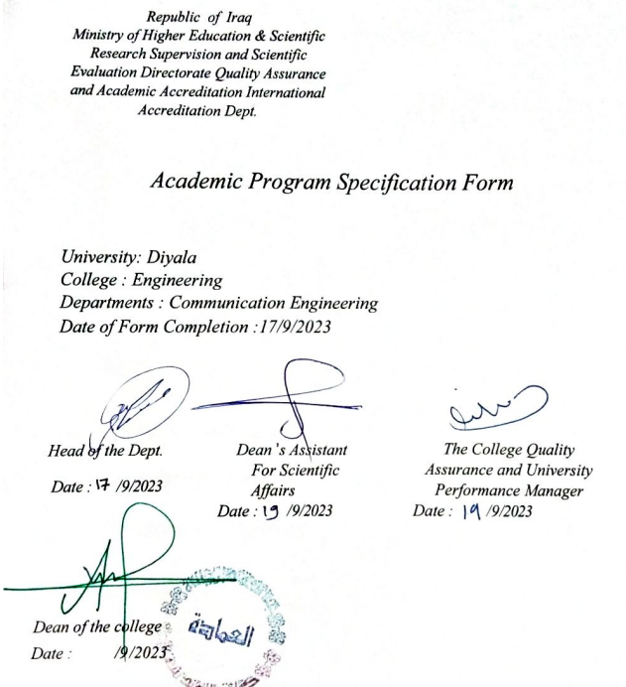

TEMPLATE FOR PROGRAMME SPECIFICATION

HIGHER EDUCATION PERFORMANCE REVIEW: PROGRAMME REVIEW
PROGRAMME SPECIFICATION
This Program Specification provides a concise summary of the main features of the program and the learning outcomes that a typical student might reasonably be expected to achieve and demonstrate if he/she takes full advantage of the learning opportunities that are provided. It is supported by a specification for each course that contributes to the program.

1. Teaching Institution | University of Diyala
2. University Department/Centre | College of Engineering
3. Dept. Title | Dept. of Communication Engineering
4. Title of Final Award | B.Sc. Communication Engineering
5. Modes of Attendance offered | Semesters
6. Accreditation | There is no accreditation program
7. Other external influences | Nothing
8. Date of production/revision of this specification | 17/9/2023
9. Aims of the Program
✓ Build the student scientifically and prepare him to work in the field of communication engineering
✓ Build and prepare the student psychologically to play his role as a reliable engineer in this field.
✓ Build students capable of computing with other engineers for job opportunities and obtaining the required seats to complete postgraduate studies.
✓ Ability to submit to external tests by local, regional or international bodies for the purpose of completing studies or appointment.
✓ Urging the student to be creative and think about specialization projects and keep up with the development taking place in this field.
✓ Providing students with scientific, practical and personal skills that enable them to solve practical problems and deal with them using scientific concepts
10. Learning Outcomes, Teaching, Learning and Assessment Methods
- Cognitive goals
A1. - Understanding and teaching the student the principles of how electromagnetic waves work and how to deal with its field.
A2- Enabling students to obtain knowledge and understanding in working on electromagnetic waves.
A3- The student understands the methods of forming electromagnetic waves and their interconnection.
A4- Enabling students to obtain knowledge and understanding of designing everything related to electromagnetic fields.
A5- Enabling students to obtain knowledge and understanding of diagnosing faults and maintaining various electromagnetic fields devices.
A6- The student understands the foundations of solving programming problems, computer networks, and communications which related with electromagnetic fields

- The skills goals special to the programme .
B1 - Explanation of computer principles topics by specialists in the subject, with an emphasis on the use of mathematics as a basis for understanding and learning.
B2 - Providing them with skills to solve practical problems related to various computer systems and computer programs for addressing and solving technical problems in various fields of electromagnetic waves
Teaching and Learning Methods
✓ Providing students with the basics and additional topics related to previous educational outcomes and skills to solve practical problems.
✓ Solving a group of practical examples by the academic staff.
✓ Students participate during the lecture in solving some practical problems.
✓ The department’s scientific laboratories are monitored by the academic staff.
Assessment methods
✓ Daily exams with practical and scientific questions.
✓ Participation marks for difficult competition questions among students.
✓ Assigning grades to homework assignments and reports assigned to them.
✓ Semester exams for the curriculum, in addition to the mid-year exam and final exam.
- Affective and value goals
C1- Enabling students to think and analyze topics related to the engineering framework, such as various logical circuits.
C2- Enabling students to think and analyze topics related to computer systems related to the engineering framework.
C3- Enabling students to think and analyze topics related to solving practical problems.
Teaching and Learning Methods
✓ Providing students with the basics, additional topics, and field experiences related to the outcomes of thinking and analysis.
✓ Forming discussion circles during or outside lectures to discuss scientific engineering topics that require thinking and analysis.
✓ Asking students a set of thinking questions during lectures, such as (what, how, when, why) for specific topics.
✓ Giving students homework and periodic reports.
Assessment methods
✓ Daily exams with practical and scientific questions.
✓ Participation marks for difficult competition questions among students.
✓ Assigning grades to homework assignments and reports assigned to them.
✓ Semester exams for the curriculum in addition to the final exam.
11. Program structure
Credit rating |  | Level/Year | Course or Module  Code | Course or Module Title
Theory | Practical
2 | - | First | U101 | Democracy & human Rights
- | 3 | First | U102 | Workshop skills
1 | 3 | First | U103 | Computer skills
2 | - | First | U 104 | English Language
- | 3 | First | U105 | Engineering Drawing
4 | - | First | E101 | Mathematics -I
4 | - | First | E102 | Mathematics -II
4 | - | First | E106 | Electronic Physics
1 | 3 | First | E108 | C++ Programming
4 | 2 | First | COE101 | Digital Techniques
6 | 2 | First | COE102 | Electrical Engineering I
6 | 2 | First | COE103 | Electrical Engineering II
4 | - | Second | E201 | Applied Mathematics –I
4 | - | Second | E202 | Applied Mathematics –II
2 | 2 | Second | COE201 | Electronic Circuits I
3 | 2 | Second | COE202 | Signals and Systems
2 | - | Second | COE203 | Communication Transmission Lines
4 | - | Second | COE204 | Probability and Random Processes
3 | 2 | Second | COE205 | Electric Circuits I
2 | - | Second | COE206 | Electromagnetic Fields I
1 | 2 | Second | COE207 | MATLAB Programming
3 | - | Second | COE208 | Electromagnetic Fields II
3 | 2 | Second | COE209 | Analog Communication Systems
3 | 2 | Second | COE210 | Electric Circuits II
2 | 2 | Second | COE211 | Electronic Circuits II
1 | 2 | Second | COE212 | Neural Network Engineering
2 | 2 | Second | COE213 | Numerical Methods
2 | - | Second | COE214 | Automatic Control Theory
2 | - | Third | E301 | Engineering Economy
2 | - | Third | COE301 | Engineering Analysis
3 | 2 | Third | COE302 | Digital Communication I
3 | 2 | Third | COE303 | Antenna Theory and Design
3 | 2 | Third | COE304 | Digital Signal Processing
2 | 2 | Third | COE305 | Microcontroller and DSP Systems
3 | 2 | Third | COE306 | Communication Electronics -I
2 | - | Third | COE307 | Optical Communication Systems
3 | - | Third | COE308 | Detection and Estimation Theory
3 | 2 | Third | COE309 | Digital Communication II
2 | 2 | Third | COE310 | Image Processing
3 | - | Third | COE311 | Information Theory
2 | 2 | Third | COE312 | Radar Systems
2 | 2 | Third | COE313 | Computer Networks
2 | - | Third | COE314 | Waves Propagation
2 | 2 | Third | COE315 | Communication Electronics -II
1 | - | Fourth | E401 | Engineering Profession Ethics
- | 8 | Fourth | E402 | Graduation Project
3 | 2 | Fourth | COE401 | Microwave Engineering-I
3 | - | Fourth | COE402 | Modern Communication Systems
2 | - | Fourth | COE403 | Cellular Mobile Networks
2 | - | Fourth | COE404 | Cryptography for Communication Systems
2 | - | Fourth | COE405 | Satellite Communication Systems
3 | 2 | Fourth | COE406 | Microwave Engineering-II
2 | - | Fourth | COE407 | Global Positioning Systems
2 | - | Fourth | COE408 | Multimedia Communication
2 | - | Fourth | COE409 | Telecom Switching Systems
2 | - | Fourth | COE410 | Television and Broadcasting Systems

13. Personal Development Planning
It is planned to develop the students’ personalities by holding discussion circles with them and asking them for periodic reports and seminars throughout the four stages and on various topics to develop their personal development.
14. Admission criteria .
Central admission from the Ministry of Higher Education and Scientific Research
15. Key sources of information about the programme
✓ College website.
✓ The department’s website and email.

Curriculum Skills Map
please tick in the relevant boxes where individual Programme Learning Outcomes are being assessed
 |  |  |  | Programme Learning Outcomes
Year / Level | Course Code | Course Title | Core (C)  Title or Option (O) | Knowledge and understanding |  |  |  | Subject-specific skills |  |  |  | Thinking Skills |  |  |  | General and Transferable Skills (or) Other skills relevant to employability and personal development
 |  |  |  | A1 | A2 | A3 | A4 | B1 | B2 | B3 | B4 | C1 | C2 | C3 | C4 | D1 | D2 | D3 | D4
second | COE208 | Electromagnatic fields II | C | √ | √ | √ | √ | √ | √ | √ | √ | √ | √ | √ | √ | √ | √ | √ | √

11. Infrastructure
1. Books Required reading: |  | - Engineering Electromagnetic MC-Graw Hill; 5th Edition; 1992;7th Reprint 1995. By Willaim H. Hayt.\  . Electromagnetics By Joseph Edminister (Schaum’s Outline Series) : Joseph Edminister, Vishnu Priye Mc Graw Hill Education
2. Main references (sources) |  | • Lectures presented by the subject teacher  • Books available in the college library
A- Recommended books and references (scientific journals, reports…). |  | All reputable scientific journals and periodicals related to electromagnetic fields its components and applications
B-Electronic references, Internet sites… |  | • All websites that explain the electromagnetic fields
 | 12. The development of the curriculum plan
 | Modifying scientific vocabulary according to modern mathematical systems and using it in a way that suits the university student’s level of understanding
 | Modifying scientific vocabulary according to modern mathematical systems and using it in a way that suits the university student’s level of understanding

