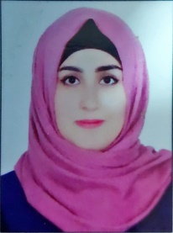
Haneen Sobhi Aziz Al-azawi
Ass. Lec. in
Department of Electronic Engineering,
College of Engineering, University of Diyala,
Baqubah, Diyala Province, Iraq
haneen_s@.uodiyala.edu.iq
haneensobhi76@gmail.com
Personal  Information | - Nationality: Iraqi  - Date and Place of Birth: 03/ 07 / 1993, Diyala-Iraq  - Address: Baqubah, Diyala, Iraq
Education | - M.Sc. Degree in Electronic and communication Engineering, Al-Nahrain University, Collage of Engineering (2020)  - B.Sc. Degree in Electronic Engineering, Diyala University, Collage of Engineering (2015)
Languages | - English and Arabic
Work Experiences | - Assistant Lecturer at Bilad Alrafidain University College/ Department of Electric Power Techniques Engineering (Mathematics II), (Electric Circuits Analysis), (Programing Language (Matlab)), (Electrical Engineering Fundamentals), (electromagnetic field), and (Digital Signal processing (DSP)). (12\ 2020- 4\2023)
Publications
Journal :
- Haneen S. Aziz and Dhirgham K. Naji, “Printed 5G MIMO antenna arrays in smartphone handset for LTE bands 42/43/46 applications,” Progress In Electromagnetics Research M, Vol. 90, 167–184, 2020
- Haneen S. Aziz and Dhirgham K. Naji, “Compact dualband MIMO antenna system for LTE smartphone applications,” Progress In Electromagnetics Research C, Vol. 102, 13–30, 2020

Publications:

More information about my scientific activity can be found via links below

Research Gate | Haneen SOBHI | Research Assistant | collage of engineering | Research profile (researchgate.net)

