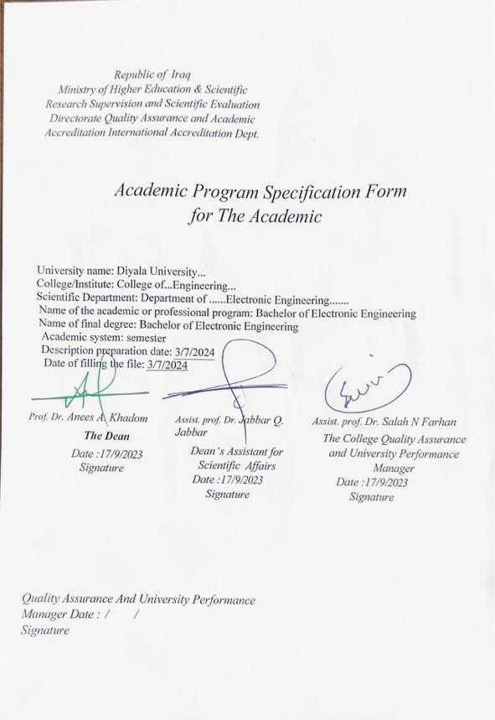

TEMPLATE FOR PROGRAMME SPECIFICATION

- vision
The basic vision of the Department of Electronic Engineering is to make the department one of the leading engineering departments in the field of contemporary scientific and technological development. Therefore, the department strives to develop modern scientific curricula in the field of electronic engineering, in addition to completing all requirements for the department’s laboratories. And improving the teaching staff, to provide society with engineering cadres capable of contributing to technological growth.

- mission
The department offers a high level of knowledge in the field of electronic engineering and its various applications by integrating theoretical knowledge with practical experience. The department strives to advance the process of scientific, engineering and technological research, and to encourage research creativity. The department also provides valuable information to students in their field of specialization, which makes their thinking and ability to solve various technological and scientific problems and meet the needs of society, whether at the public or private sector level, serve our dear country.

- Aims of the Program
- Train specialized engineers in the field of electronic engineering, with a focus on professional ethics, and prepare them to be distinguished scientifically and practically.
- The department supports scientific research to advance knowledge and technology in the field of electronic engineering and its applications.
- The department provides a comprehensive training program to equip graduate students with the basic skills needed to be fully prepared to work in community institutions.
- Collaborating with all scientific and industrial entities to enhance the engineering education process at the college and elevate its global ranking.

- Programmatic accreditation
N/A

- Other external Supports
N/A

- Program Structure
Notes | Percentage Notes | of Courses Study | Number of Courses Study | Program Structure
متطلبات المؤسسة | 3.9 | 6 | 5 | Institution requirements
متطلبات الكلية | 18.7 | 29 | 9 | College requirements
متطلبات القسم | 77.4 | 120 | 49 | Requirements of Section
There is a summer course | يوجد |  |  | Summer Training

- Program Structure |  |  |  | 12. Awards and Credits
Level/Year | Course or Module  Code | Course or Module Title | Credit rating
1st Year-1st Semester | E 101 | Mathematics 1 | 6 | Bachelor Degree Requires ( 155) credits
1st Year-1st Semester | EE 101 | Electrical Engineering Fundamentals 1 | 8
1st Year-1st Semester | EE 107 | Electronic Physics | 6
1st Year-1st Semester | EE 106 | Engineering Drawing | 4
1st Year-1st Semester | U 103 | Computer Skills | 4
1st Year-1st Semester | U 104 | English Language | 2
1st Year-2nd Semester | E 102 | Mathematics 2 | 6
1st Year-2nd Semester | EE 102 | Electrical Engineering Fundamentals 2 | 8
1st Year-2nd Semester | EE 103 | Digital techniques | 7
1st Year-2nd Semester | EE 105 | C++ Programming | 4
1st Year-2nd Semester | EE 104 | Workshops skills | 3
1st Year-2nd Semester | U 101 | Human Rights and Democracy | 2
2nd Year-1st Semester | E201 | Advance Mathematics –I | 3
2nd Year-1st Semester | EE 201 | Electronics I | 2
2nd Year-1st Semester | EE 203 | Electric Circuits Analysis I | 2
2nd Year-1st Semester | EE 205 | Advanced Programming | 1
2nd Year-1st Semester | EE 208 | Electro-Magnetics I | 2
2nd Year-1st Semester | EE 210 | Digital Electronic I | 2
2nd Year-1st Semester | EE 206 | Machines (DC) | 2
2nd Year-2nd Semester | E202 | Advance Mathematics- II | 3
2nd Year-2nd Semester | EE 202 | Electronics II | 3
2nd Year-2nd Semester | EE 204 | Electric Circuits Analysis II | 2
2nd Year-2nd Semester | EE 212 | Measurement &Instruments | 2
2nd Year-2nd Semester | EE 209 | Electro-Magnetics II | 2
2nd Year-2nd Semester | EE 211 | Digital Electronic II | 3
2nd Year-2nd Semester | EE 207 | Power and AC Machines | 4
2nd Year-2nd Semester | EE 213 | University Culture Activity | -
3rd Year-1st Semester | EE 301 | Digital Signal Processing I | 2
3rd Year-1st Semester | EE 309 | Advanced Electronics I | 3
3rd Year-1st Semester | EE 303 | Communication Systems I | 3
3rd Year-1st Semester | EE 305 | Microprocessor and Microcontroller: Hardware | 3
3rd Year-1st Semester | EE 307 | Engineering Analysis I | 2
3rd Year-1st Semester | EE 311 | Antenna | 3
3rd Year-2nd Semester | EE 312 | Engineering Administration | 2
3rd Year-2nd Semester | EE 302 | Digital Signal Processing II | 3
3rd Year-2nd Semester | EE 310 | Advanced Electronics II | 3
3rd Year-2nd Semester | EE 304 | Communication Systems II | 3
3rd Year-2nd Semester | EE 306 | Microprocessor-Based System: Programming | 2
3rd Year-2nd Semester | EE 308 | Engineering Analysis II | 2
3rd Year-2nd Semester | EE 313 | Optoelectronics | 2
Fourth Year-1st Semester | EE 401 | Microelectronic I | 2
Fourth Year-1st Semester | EE 403 | Power Electronics I | 3
Fourth Year-1st Semester | EE405 | Control System I | 3
Fourth Year-1st Semester | EE407 | Digital System Design | 3
Fourth Year-1st Semester | EE 409 | Information Theory | 3
Fourth Year-1st Semester | EE411 | Hardware Description Language (HDL ) Programming | 3
Fourth Year-2nd Semester | EE 413 | Introduction to AI | 2
Fourth Year-2nd Semester | E402 | Eng. Graduation Project I | 2
Fourth Year-2nd Semester | EE402 | Microelectronic II | 2
Fourth Year-2nd Semester | EE404 | Power Electronics II | 3
Fourth Year-2nd Semester | EE406 | Control System II | 3
Fourth Year-2nd Semester | EE408 | Advanced Digital System Design | 3
Fourth Year-2nd Semester | EE410 | Microwave | 2
Fourth Year-2nd Semester | E401 | Engineering Profession Ethics | 2
Fourth Year-2nd Semester | EE412 | Digital Image Processing | 2
Fourth Year-2nd Semester | E403 | Eng. Graduation Project II | 2

- Learning Outcomes, Teaching, Learning and Assessment Methods
- Cognitive goals
A1- The ability to have knowledge in the fields of mathematics and specialized sciences Engineering expertise in the application of electronic engineering.
A2 Preparing the student to continue self-learning and acquire technology And new skills in the field of electronic engineering.
A3- Enabling students to obtain knowledge and understanding of designing and implementing various electronic systems.
A4- The student will understand the foundations of creating, programming, and simulating electronic circuits in hardware languages and various engineering programs.
A5- Enabling the student to visualize project management and solve the problems he encounters in the factory.
B. The skills goals special to the program.
B1 - The ability to select and perform the required examinations and collect their locations. Review and analyze the results of the relevant tests.
B2 The ability to design and supervise the implementation of relevant systems In electronic engineering.
B3 The ability to derive and approach engineering problems in a Recognize and determine the appropriate method to address the emerging engineering problems. This.
B4 - Provides them with skills to solve practical problems related to various electronic systems and computer programs for those systems.
C. Affective and value goals
C1- Questioning: Searching for a new information and raising questions.
C 2 Inference and deduction: thinking about what is beyond the known available to fill the gaps in it
C 3 Comparison: Noticing the proportions and differences between things
C 4- Classification: Placing things into groups according to common characteristics.
- Teaching and Learning Methods
- Providing students with the basics, additional topics, and field experiences related to the outcomes of thinking and analysis.
- Forming discussion circles during or outside lectures to discuss scientific engineering topics that require thinking and analysis.
- Asking students, a set of thinking questions during lectures, such as (what, how, when, why) for specific topics.
- Giving students homework and periodic reports.
- Assessment methods
- Daily exams with practical and scientific questions.
- Participation marks for difficult competition questions among students.
- Assigning grades to homework assignments and reports assigned to them.
- Semester exams for the curriculum in addition to the final exam.

- Academic staff
Number of teaching staff |  | Specialization | Scientific degree
1 | Electronic and communication |  | Prof
5 | Electronic |  | Asst. Prof
1 | Control |  | Asst. Prof
5 | Electronic and communication |  | Lect.
3 | Electronic |  | Lect.
1 | communication |  | Lect.
1 | Power |  | Lect.
5 | Electronic and communication |  | Asst. LECT

- Personal Development Planning
It is planned to develop the students’ personalities by holding discussion circles with them and asking them for periodic reports and seminars throughout the four stages and on various topics to develop their personal development.
- Admission criteria .
According to the rules and regulations of Ministry of Higher Education and Scientific Research.
- Key sources of information about the program
- College website.
- The department’s website and contact the department by email.

Curriculum Skills Map
please tick in the relevant boxes where individual Programme Learning Outcomes are being assessed
 |  |  |  | Programme Learning Outcomes
Year / Level | Course Code | Course Title | Core (C)  Title or Option (O) | Knowledge and understanding |  |  |  |  | Subject-specific skills |  |  |  | Thinking Skills
 |  |  |  | A1 | A2 | A3 | A4 | A5 | B1 | B2 | B3 | B4 | C1 | C2 | C3 | C4
2nd Year-1st Semester | EE 203 | Electric Circuits Analysis I | C | √ |  | √ |  | √ | √ |  | √ |  | √ |  | √ | √

TEMPLATE FOR COURSE SPECIFICATION

HIGHER EDUCATION PERFORMANCE REVIEW: PROGRAMME REVIEW

COURSE SPECIFICATION

This Course Specification provides a concise summary of the main features of the course and the learning outcomes that a typical student might reasonably be expected to achieve and demonstrate if he/she takes full advantage of the learning opportunities that are provided. It should be cross-referenced with the programme specification.

 | 1. Course title | Electric Circuits Analysis I
 | 2. Course code | EE 203
 | 3. Semester/Year | 1st Semester – 2nd Year
 | 4. Date of production/revision of this specification | April 2024
 | 5. Modes of Attendance offered | Class Lectures
 | 6. Number of Credit Hours (Total) / Number of Units (Total) | 30 hours
 | 7. Course administrator's name (mention all, if more than one name) | Haneen S. Aziz  Haneen_s@uodiyala.edu.iq
 | 8. Aims of the Course
 | The subject of electrical circuit analysis aims to teach the student to identify the analysis of simple and complex electrical circuits (single-phase and three-phase) Study circuits with two outlets and identify the terminology of these circuits as well as the relationship between the different types of circuits with two outlets and the study of magnetically connected circuits Study of linear, ideal and subjective transformers Study of the frequency response of circuits and study of the transition function.
A- Cognitive goals.
A1- During the first semester, the student learns the concept of multiphase electrical circuits and the sequence of voltages in them.
A2- The student learns electrical circuits with two outlets and learn about their terminology, methods of analysis, the relationship between them and other types and ways to connect these circuits.
A3- The student learns magnetically connected circuits and methods of analyzing them and calculating energy in them.
A4- The student learns the difference between the types of transformers and their equivalent circuits.
A5- The student learns the frequency response of electrical circuits and the transition function.
B. The skills goals special to the course.
B1 – Learn the concept of multiphase circuits.
B2- Learn circuits with two ports and methods of analysis and linking them.
B3- Learning magnetic circuits and methods of analyzing them.
B4- Learn the frequency response of electrical circuits.
C. Affective and value goals
C1- Urging the student to make a profit from statistics.
C2- Urging the student to think about the importance of dealing with digital data.
C3- Urging the student to think and understand transformatively in an alternative way to digital.
C4- Urging the student to think and understand the old method of compressing the discovered information and correcting it for that Logarithms using MATLAB describe these operations.
C5- Urging the student to think about choosing leading and contributing digital communications departments .
9- Teaching and Learning Methods
- Providing students with the basics, additional topics, and field experiences related to the outcomes of thinking and analysis.
- Forming discussion circles during or outside lectures to discuss scientific engineering topics that require thinking and analysis.
- Asking students, a set of thinking questions during lectures, such as (what, how, when, why) for specific topics.

10- course strategy
Week | Hours | Unit/Module or Topic Title | Teaching Method | Assessment Method
Week 1 | 3 | Three – Phase Networks, phase sequences | Lectures Notes  PDF  power point  Video | Daily exams + monthly exams
Week 2 | 3 | analysis of YY, YD, DY, DD connected circuits for balanced and unbalanced systems | Lectures Notes  PDF  power point  Video | Daily exams + monthly exams
Week 4 | 3 | power calculations and measurements in three phase circuit | Lectures Notes  PDF  power point  Video | Daily exams + monthly exams
Week 5 | 3 | Two – Port Networks, (Definitions and terminologies) | Lectures Notes  PDF  power point  Video | Daily exams + monthly exams
Week 6 | 3 | analysis of two port parameters sets (z, y, h, g, ABCD, and abcd) | Lectures Notes  PDF  power point  Video | Daily exams + monthly exams
Week 7 | 3 | analysis of two port parameters sets (z, y, h, g, ABCD, and abcd) | Lectures Notes  PDF  power point  Video | Daily exams + monthly exams
Week 8 | 3 | relationships between parameters, | Lectures Notes  PDF  power point  Video | Daily exams + monthly exams
Week 9 | 3 | interconnection of networks | Lectures Notes  PDF  power point  Video | Daily exams + monthly exams
Week 10 | 3 | Magnetically Coupled Circuits | Lectures Notes  PDF  power point  Video | Daily exams + monthly exams
Week 1 1 | 3 | analysis of magnetically coupled circuits | Lectures Notes  PDF  power point  Video | Daily exams + monthly exams
Week 1 2 | 3 | energy in magnetically coupled circuits | Lectures Notes  PDF  power point  Video | Daily exams + monthly exams
Week 13 | 3 | linear transformers, ideal transformer, ideal auto-transformer, | Lectures Notes  PDF  power point  Video | Daily exams + monthly exams
Week 14 | 3 | conductively coupled equivalent circuits | Lectures Notes  PDF  power point  Video | Daily exams + monthly exams
Week 15 | 3 | Frequency Response | Lectures Notes  PDF  power point  Video | Daily exams + monthly exams

11. Infrastructure
1. Books Required reading: | - "Fundamentals of Electric Circuits", Charles K. Alexander, Matthew N. O. Sadiku, 5th ed.  - " ENGINEERING CIRCUIT ANALYSIS ", William H. Hayt, Jack E. Kemmerly, Steven M. Durbin-8th edition, 2012
2. Main references (sources) | • Lectures presented by the Lecturer  • Books available in the college library
A- Recommended books and references (scientific journals, reports…).
B-Electronic references, Internet sites… | Any other materials available on the web.

