السيرة الذاتية: (م.د. عمر اسماعيل محمد )

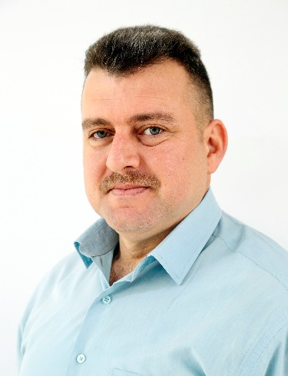
أولا: المعلومات الشخصية:

اللقب العلمي: مدرس دكتور

محل وتاريخ الولادة: بعقوبة 21/10/1978

الجنسية: العراقية

الحالة الزوجية: متزوج

رقم الهاتف: 07810104848

البريد الالكتروني: omar.ismael@uodiyala.edu.iq

عنوان العمل: جامعة ديالى – كلية الهندسة – قسم هندسة العمارة

ثانياً: المؤهلات العلمية:

دكتوراه هندسة انشائية 2022 – جامعة الجنوب الغربي الحكومية – جمهورية روسيا الاتحادية

ماجستير هندسة بناء 2014 - جامعة بيلغورود التكنلوجية الحكومية – جمهورية روسيا الاتحادية

بكالوريوس هندسة مدنية 2006 – الجامعة المستنصرية – كلية الهندسة – قسم الهندسة المدنية .

ثالثاً: اللغات المتقنة:

اللغة العربية (اللغة الام).

اللغة الروسية.

اللغة الانكليزية.

رابعاً : البحوث المنشورة:

PUBLICATIONS ON THE THEME OF THE THESIS Publications in publications indexed by Scopus, Web of Science

1. Alhashimi Omar Ismael, AL-Hasnawi Yasser Sami Ghareb. Effect Bonding
Strength Steel Reinforcement with Epoxy Coating on the Character Destruction of
Autoclaved Aerated Concrete Beams in Bending /Materials Science Forum Submitted.2019. Vol. 974. pp 665-671.
2. Alhashimi Omar Ismael Mohammed. Experimental Studies of Strength
Inclined Sections Bent Elements from Autoclaved Aerated Concrete// IOP Conf. Series:Materials Science and Engineering. 2021. Vol. 1079. № 022062.
3. AL-Hasnawi Yasser Sami Ghareb1, Omar Ismael Alhashimi, Andrey V.
Shevchenko, Nowruzi Mohammad Shoja. Experimental Investigation on Flexural
Behavior of Cold Formed Beams with Lightweight Concrete // Research journal of
applied Materials Science Forum. 2020. Vol. 992. pp. 149-155.
4. AL-Hasnawi Yasser Sami Ghareb1, Shevchenko A.V., Alhashimi Omar Ismael, Light Steel Thin-Walled Structures Composite Beam of Cellular Concrete // Research journal of applied Materials Science Forum. 2020. Vol. 974. pp. 596-600.

Publications in publications included in the list of VAK
5. Kolchunov V.I., O.I. Al-Hashimi, Protchenko M.V. Stiffness of reinforced concrete structures in bending with transverse and longitudinal forces //
Construction and reconstruction. - 2021. - No. 6. - P. 5-19.
6. Al-Hashimi, O.I., Al-Khasnavi Ya.S. Effective materials for reinforced elements made of autoclaved cellular concrete // Innovations and investments. - 2019. - No. 6. - p. 241-245.
7- Donchenko Oleg 1 Al'-Hashimi Omar Ismael 2. PRESENT STATE OF THE RESISTANCE THEORY AND METHODS OF CALCULATION MASONRY OF AERATED STONES WHILE COMPRESSION// Journal: BULLETIN OF BELGOROD STATE TECHNOLOGICAL UNIVERSITY NAMED AFTER. V. G. SHUKHOV Volume 3 № 8 , 2018 .

خامساً: المؤتمرات العلمية:

1-International scientific and practical conference “Construction and architecture: theory and practice of innovative development” (CATPID 2019) October 1-5, Kislovodsk. The results of the conference were published in the journals Materials and Technologies in Construction and Architecture II. in indexed in Web of Science.
2- International scientific and practical conference “Science and Innovation in Construction”, “Science and Innovation in Construction” (To the 165th anniversary of the birth of V.G. Shukhov) (Belgorod, 2018).
3 - International multi-conference on industrial engineering and modern technologies (FarEastCon2019) October 1-4, 2019 Far Eastern Federal University (FEFU), Vladivostok (Asia-Pacific region), Russia.
4- International multidisciplinary conference on industrial engineering and modern technologies “FarEastCon” (Vladivostok, Russky Island, October 6-9, 2020). The results of the conference were published in (indexing of articles in Scopus and/or WoS databases).

سادسا: المزيد من المعلومات عن النشاط العلمي يمكن ايجادها على روابط التواصل العلمي:

Author ID: | https://www.scopus.com/feedback/author/reviewAuthorProfile.uri?authorIds=57215534117
Research Gate
Orchid
Google Scholar
LinkedIn
Web of Science

