Ministry of Higher Education and Scientific Research Scientific Supervision and Scientific Evaluation Apparatus Directorate of Quality Assurance and Academic Accreditation Accreditation Department

Academic Program and Course Description Guide

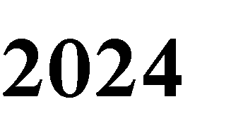

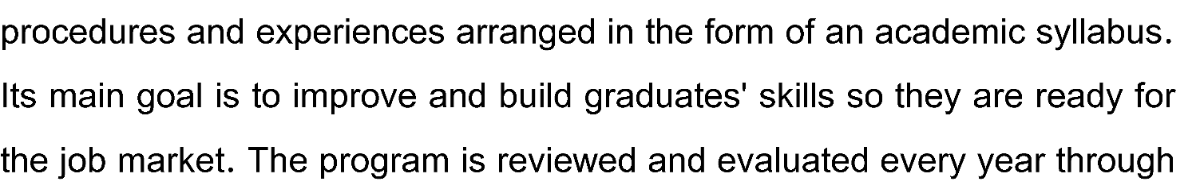
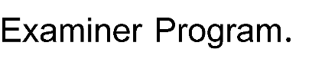
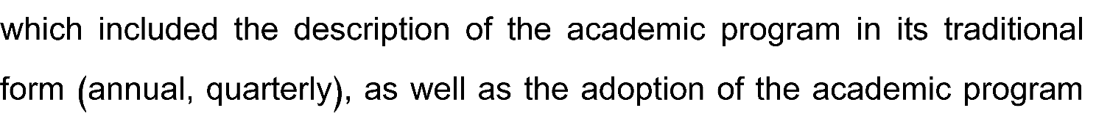
Introduction:

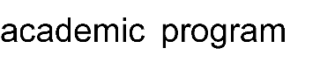
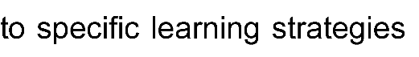
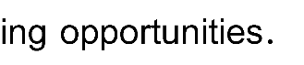
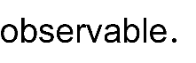
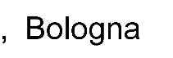
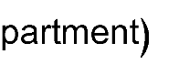
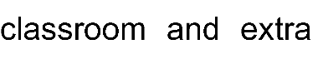
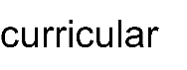
Concepts and terminology:

University Name: Diyala
Faculty/Institute: Engineering
Scientific Department: Computer
Academic or Professional Program Name: BSc in Computer Engineering
Final Certificate Name: BSc in Computer Engineering
Academic System: Courses
Description Preparation Date: 24/4/2024
File Completion Date: 24/4/2024

Signature:
Head of Department Name:
Assist. prof. Dr. Ali N. Albu-Rghaif
Date: 24/4/2024
Signature:
Scientific Associate Name:
Assist. prof. Dr. Jabbar Q. Jabbar
Date:

The file is checked by: Assist. prof. Dr. Salah N Farhan
Department of Quality Assurance and University Performance
Director of the Quality Assurance and University Performance Department: Date:
Signature:

Approval of the Dean
Prof. Dr. Anees A. Khadom

The computer engineering department is a "distinct" model for the production and development of engineering and technological knowledge to prepare qualified engineering cadres capable of supporting and developing the society in the fields of computing, information technology and software.

Develop the engineering cadres by providing them with modern technological knowledge in various branches of computer engineering sciences to enable them to carry out the various engineering projects efficiently and professionally with high accuracy and perfection as required by the labor market and to continue scientific and academic progress through keeping abreast of the accelerating global developments.

  - Developing specialized engineering programs that conform to international quality standards in the field of computers and software, through which they can provide engineering cadres able to prove their worth in the field of work.
  - Developing the abilities and skills of the teaching staff and the staff to improve the educational and research reality in the department.
  - Serving the local and international community through the development of applied and academic research to solve various problems in the industrial and engineering fields.
  - To provide an advanced learning and research environment suitable for the students of the department of students and cadres of engineering, engineering and teaching to produce high quality educational and engineering leaders.

Not at the moment

No

University Requirements | 5 | 6 | 4.24%
College Requirements | 9 | 20 | 14.20%
Department Requirements | 46 | 115 | 81.56%
Summer Training |  |  |  | Graduation Requirements
Other

 |  |  | Theoretical | Practical
2nd Year-1st Semester | E 201 | Applied Mathematics I | 3 | -
2nd Year-1st Semester | CPE 201 | Computer Architecture I | 2 | -
2nd Year-1st Semester | CPE 203 | Electronics | 2 | 2
2nd Year-1st Semester | CPE 205 | Digital Logic Circuits II | 3 | 2
2nd Year-1st Semester | CPE 207 | Data Structures and Algorithms | 2 | 2
2nd Year-1st Semester | CPE 209 | Operating Systems I | 2 | -
2nd Year-1st Semester | CPE 211 | Fundamentals of Communications | 3 | -
2nd Year-2nd Semester | E 202 | Applied Mathematics II | 3 | -
2nd Year-2nd Semester | CPE 202 | Computer Architecture II | 2 | -
2nd Year-2nd Semester | CPE 204 | VLSI Circuit and Design | 2 | 2
2nd Year-2nd Semester | CPE 206 | Microprocessor Programming | 2 | 2
2nd Year-2nd Semester | CPE 208 | Database Systems | 2 | 3
2nd Year-2nd Semester | CPE 210 | Software Engineering | 2 | 2
2nd Year-2nd Semester | CPE 212 | Object Oriented Programming using Java | 2 | 2
3rd Year-1st Semester | CPE 301 | Engineering Analysis | 3 | -
3rd Year-1st Semester | CPE 303 | Digital Signal Processing I | 2 | 2
3rd Year-1st Semester | CPE 305 | Digital System Design I | 2 | 2
3rd Year-1st Semester | CPE 307 | Digital Communications | 2 | 2
3rd Year-1st Semester | CPE 309 | Control Theory | 2 | 2
3rd Year-1st Semester | CPE 311 | Operating Systems II | 2 | 2
3rd Year-1st Semester | CPE 313 | Internet Web Site Design | 2 | 2
3rd Year-2nd Semester | CPE 302 | Numerical Analysis | 3 | -
3rd Year-2nd Semester | CPE 304 | Digital Signal Processing II | 2 | 2
3rd Year-2nd Semester | CPE 306 | Digital System Design II | 2 | 2
3rd Year-2nd Semester | CPE 308 | Computer Networks I | 3 | -
3rd Year-2nd Semester | CPE 310 | Computer Control | 2 | 2
3rd Year-2nd Semester | CPE 312 | Computer Interfacing | 2 | 2
3rd Year-2nd Semester | CPE 314 | Digital Image Processing | 2 | 2
Fourth Year-1st Semester | E 402 | Graduation Project | - | 4
Fourth Year-1st Semester | E 401 | Engineering Profession Ethics | 2 | -
Fourth Year-1st Semester | CPE 401 | Computer Vision | 2 | -
Fourth Year-1st Semester | CPE 403 | Cryptography and Network Security I | 3 | 2
Fourth Year-1st Semester | CPE 405 | GNSS Applications | 2 | 2
Fourth Year-1st Semester | CPE 407 | Computer Networks II | 2 | 2
Fourth Year-2nd Semester | E 402 | Graduation Project | - | 4
Fourth Year-2nd Semester | E 404 | Engineering Economy | 2 | -
Fourth Year-2nd Semester |  | Soft Computing | 2 | -
Fourth Year-2nd Semester |  | Cryptography and Network Security II | 3 | 2

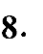
- Teaching the student, the principles of how computers work and how to deal with computer algorithms.
- Enabling students to obtain knowledge and understanding in working on and designing electronic computers.
- Teaching the student, the methods of forming computer parts and their interconnection.
- Enabling students to obtain knowledge and understanding of designing everything related to computer microprocessors.
- Enabling students to obtain knowledge and understanding of diagnosing faults and maintaining various computer devices.
- Teaching the student the foundations of solving programming problems, computer networks, and communications.
- Explanation of computer principles topics by specialists in the subject, with an emphasis on the use of mathematics as a basis for understanding and learning.
- Providing them with skills to solve practical problems related to various computer systems and computer programs for addressing and solving technical problems in various fields of computerized work.
- Enabling students to think and analyze topics related to the engineering framework, such as various logical circuits.
- Enabling students to think and analyze topics related to computer systems related to the engineering framework.
- Enabling students to think and analyze topics related to solving practical problems.

- Providing students with the basics and additional topics related to previous educational outcomes and skills to solve practical problems.
- Solving a group of practical examples by the academic staff.
- Students participate during the lecture in solving some practical problems.
- The department’s scientific laboratories are monitored by the academic staff.

- Daily exams with practical and scientific questions.
- Participation marks for difficult competition questions among students.
- Assigning grades to homework assignments and reports assigned to them.
- Monthly exams for the curriculum in addition to the final exam.

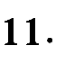
Prof. | Electric Eng. | Electronic Eng. |  |  | 1
Asst. Prof. | Computer Eng. | Machine Learning |  |  | 1
Asst. Prof. | Computer Eng. | A.I. |  |  | 1
Asst. Prof. | Computer Eng. | Comp. Architecture |  |  | 1
Asst. Prof. | Electric & Electronic Eng. | Control |  |  | 1
Asst. Prof. | Computer Science | Simulation |  |  | 1
Asst. Prof. | Computer Science | Comp. Vision |  |  | 1
Asst. Prof. | Computer Science | A.I. |  |  | 1
Asst. Prof. | Computer Science | Data Compression |  |  | 1
Asst. Prof. | Computer Eng. | Wireless Net. |  |  | 1
LECT. | Computer Eng. | Comp. Net. |  |  | 2
LECT. | Electric Eng. | Control & Comp. |  |  | 1
LECT. | Computer Science | Complex modeling |  |  | 1
LECT. | Computer Science | Software |  |  | 1
LECT. | Computer Eng. | I.T. |  |  | 3
LECT. | Computer Eng. | Information Secuirty |  |  | 1
LECT. | Computer Eng. | Comp. Vision |  |  | 1
LECT. | Computer Eng. | Science & Eng. Comp. |  |  | 1
LECT. | Computer Eng. | Software |  |  | 1
LECT. | Electric Eng. | Electrical Power |  |  | 1
LECT. | Electric Eng. | Electronic & Communication |  |  | 1
LECT. | Computer Science | I.T. |  |  | 2
LECT. | Computer Eng. | Computer Eng. |  |  | 2
Asst. LECT. | Computer Eng. | Nano Electronic |  |  | 1
Asst. LECT. | Computer Eng. | Comp. Net. |  |  | 1
Asst. LECT. | Electronic Eng. | mechatronics |  |  | 1
Asst. LECT. | Electric Eng. | Electronic & Communication |  |  | 1
Asst. LECT. | Arabic Language | Arabic Language |  |  | 1

Faculty members are instructed to hold regular meetings and review questionnaires received from students with the Scientific Committee.
The teaching staff undergoes development through training, workshops, and seminars. Progress is evaluated by subject performance.

12. Acceptance Criterion
According to the rules and regulations of Ministry of Higher Education and Scientific Research.

13. The Most Important Sources of Information about the Program
- College website.
- The department’s website and contact the department by email.

14. Program Development Plan
- The courses are updated annually to keep up with developments in computer science
- the laboratories are also updated under academic curricula.
- Additionally, postgraduate programs are now being offered.

Program Skills Outline
 |  |  |  | Required program Learning outcomes
Year/Level | Course Code | Course Name | Core or optional | Knowledge |  |  |  | Skills |  |  |  | Ethics
 |  |  |  | A1 | A2 | A3 | A4 | B1 | B2 | B3 | B4 | C1 | C2 | C3 | C4
2nd Year-1st Semester | CPE 203 | Electronics | Core | √ | √ | √ | √ | √ | √ | √ | √ | √ | √ | √ | √

- Please tick the boxes corresponding to the individual program learning outcomes under evaluation.

13

Course Description Form

Course Name:
Electronics
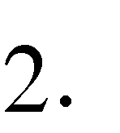Course Code:
CPE 203
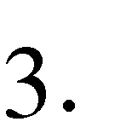Semester / Year: 1st Semester –
1st Semester – 2nd Year
Description Preparation Date:
24/4/2024
5. Available Attendance Forms:
Class Lectures
6. Number of Credit Hours (Total) / Number of Units (Total)
45 hours / 3 Units
7. Course administrator's name (mention all, if more than one name)
Name: Prof. Dr. Saad Mohammed Saleh
Email: saad.alazawi@uodiyala.edu.iq
8. Course Objectives
- During the academic year, the student learns the basics of analogue electronics.
- The student learns the types of Bipolar Junctions Transistors (BJT), their components and operation
- The student learns to analyze biasing circuits of the BJT
- The student learns the biasing circuits, the components and the operation of the MOSFET.
- The student learns how to analyze Amplifier circuits of MOSFET transistors
- The student learns the principles of operational amplifier applications.
9. Teaching and Learning Strategies
  - The lecturer prepares lectures on the subject in paper and electronic form and presents them to the students.
  - The lecturer delivers lectures in detail.
  - The lecturer requests periodic reports and homework assignments on the basic topics of the subject.

10. Course Structure
Week | Hours | Required Learning Outcomes | Unit or Subject Name | Learning Method | Evaluation Method
Week 1 to Week 2 | 6 | Student learns the construction and the operation of the BJT | Bipolar Junction Transistors (BJT) | Lectures Notes  PDF  power point  Video | Daily exams + monthly exams
Week 3 to Week 4 | 6 | Student learns the analysis of the BJT Biasing circuits and DC Load Line | BJT Biasing and DC Load Line | Lectures Notes  PDF  power point  Video | Daily exams + monthly exams
Week 5 to Week 7 | 9 | Student learns the construction, operation and biasing of the MOSFET | Enhancement Type MOSFET Operation, P-Channel and CMOS | Lectures Notes  PDF  power point  Video | Daily exams + monthly exams
Week 8 to Week 11 | 12 | Student learns the analysis of the operation and biasing of the MOSFET | MOSFET Amplifier | Lectures Notes  PDF  power point  Video | Daily exams + monthly exams
Week 12 to Week 15 | 9 | Student learns the Operational Amplifier Applications | Operational Amplifiers (OP Amp) | Lectures Notes  PDF  power point  Video | Daily exams + monthly exams

11. Course Evaluation
Distributing the score out of 100 according to the tasks assigned to the student such as daily preparation, daily oral, monthly, or written exam, report … etc.
12. Learning and Teaching Resources
Books Required reading: | - Sedra and Smith, Microelectronic Circuits, Oxford University Press, Sixth Edition, 2010.
Main references (sources) | - Lectures presented by the Lecturer  - Books available in the college library
Recommended books and references (scientific journals, reports…). | - Neamen, Microelectronics - Circuit Analysis and Design, McGraw-Hill, 2010.  - Behzad Razavi, Fundamentals of Microelectronics, John Wiley & Sons, Preview Edition, 2006  - Jimmie J. Cathey, Ph.D, Theory and Problems of Electronic Devices and Circuits, 2nd Edition, 2002.  - Robert L. Boylestad and Louis Nashelsky, Electronic Devices and Circuit Theory, 7th or 10th or 11th Edition.
Electronic references, Internet sites… | - All related information in the Web.  - Lecturer YouTube Channel:

