

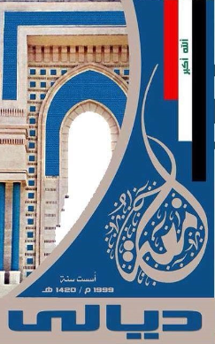

Ministry of Higher Education and Scientific Research Scientific Supervision and Scientific Evaluation Apparatus Directorate of Quality Assurance and Academic Accreditation Accreditation Department

University of Diyala

College of engineering

Department of Electrical Power and Machines Engineering



**Academic Program and Course Description Guide**

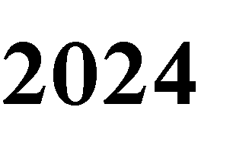

**Introduction:**

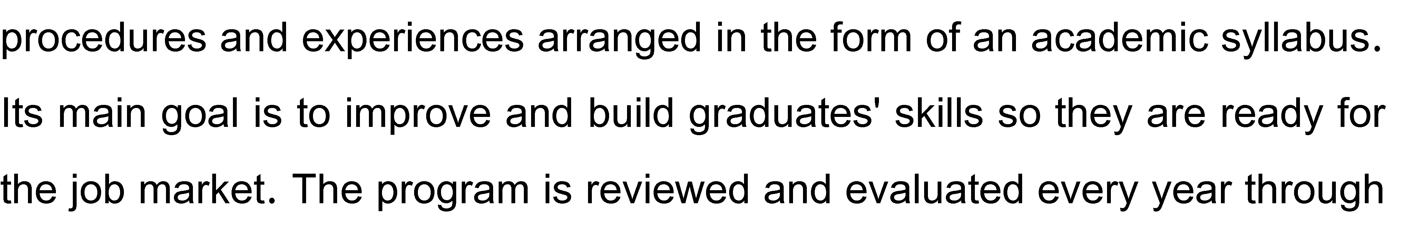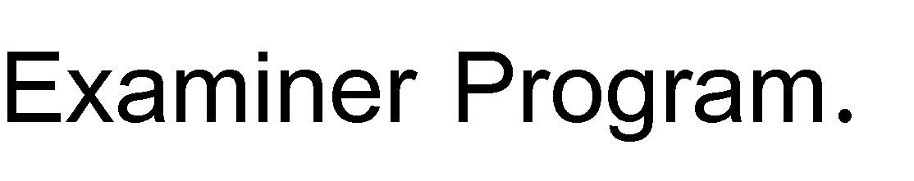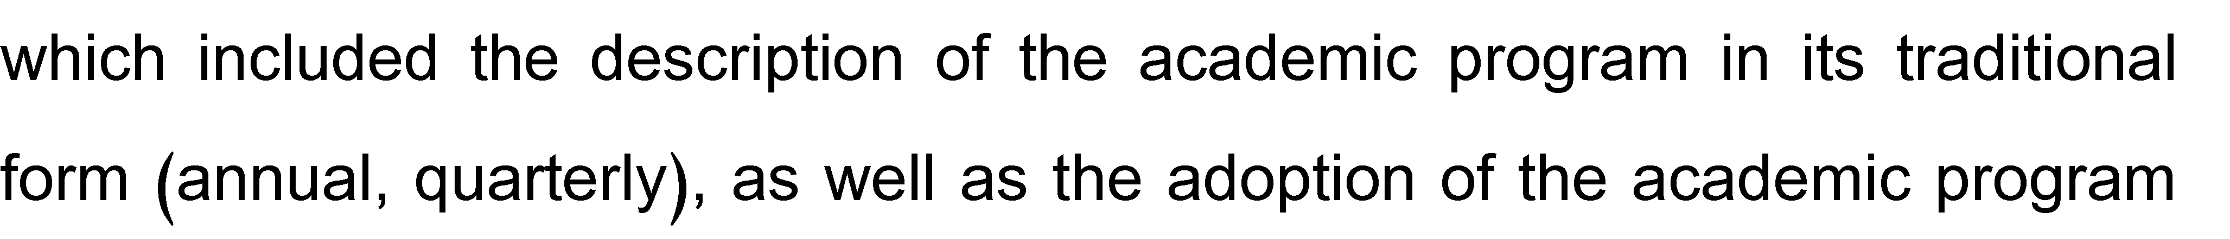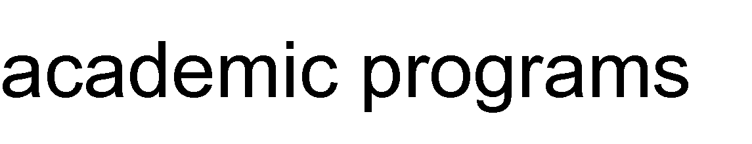

**Concepts and terminology:**

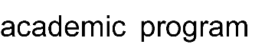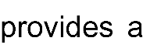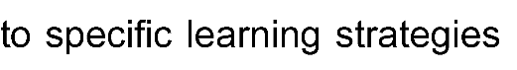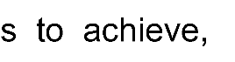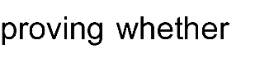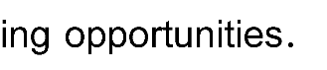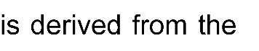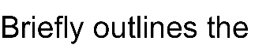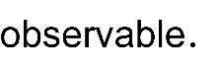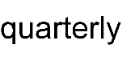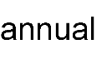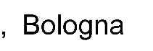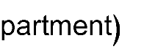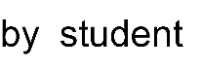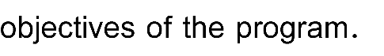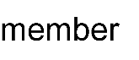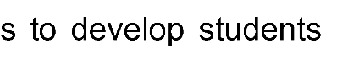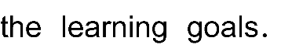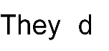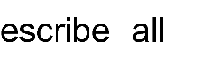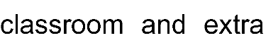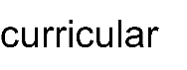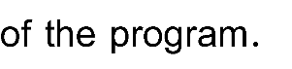

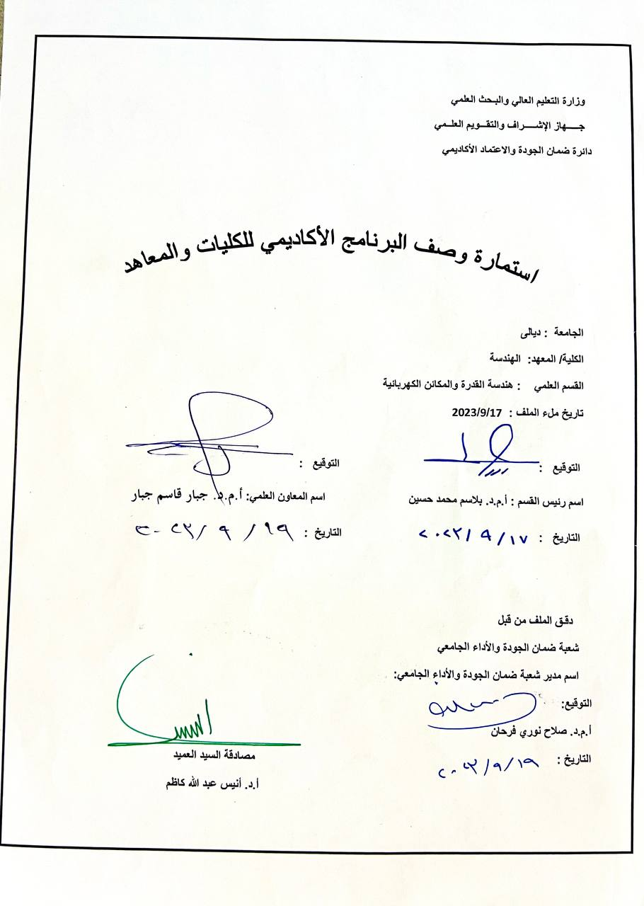

|  |
| --- |
| 1. **Program Vision** |
| The department has a clear vision of the current and future needs of society in general and the electrical energy sector in particular, and the scientific and qualitative specifications required for graduates and scientific plans to meet these needs. |

|  |
| --- |
| 1. Program Mission |
| * Graduating competent engineers qualified to perform the engineering tasks assigned to them, capable of innovation and creative solutions, responding to the requirements of the labor market, and able to compete with their counterparts from other universities while adhering to professional ethics. * Contributing to research and studies related to the scientific and engineering technology renaissance. * Opening to companies and directorates of the Ministry of Electricity and the Ministry of Industry to integrate the theoretical side and the applied technical side. |

|  |
| --- |
| 1. Program objectives |
| The overall objectives assigned to the Department of Electrical Power Engineering stem from the growing importance of the electricity sector, as electrical energy is considered the cornerstone in building the elements of cultural and economic advancement with the services it provides that meet human material and service requirements. Therefore, the department aims to achieve the following:   1. Numbers of engineers capable of effectively contributing to the operation and management of electrical networks in the following areas:  * Generating electrical energy in thermal, steam, gas and hydroelectric plants. * Transmitting electrical energy through high-voltage towers from generating stations to consumers in cities and villages. * Working in various types of distribution networks, which include a huge number of distribution and power transformers. * Design and implement protection and control systems for each part of the electrical network and maintain them from faults. * Design, implementation, and supervision of electrical and lighting installations for commercial and industrial buildings, hospitals and others.  1. Supporting the development of the department’s staff, including teachers and engineers, in addition to their students, in the following areas:  * Keeping pace with developments in the use of modern software in operating and controlling the electrical power system, training the department’s staff and students on its various applications, and supporting its spread and application in the national electrical network. * Keeping up with the trend in renewable energy applications and its sources, such as solar energy, wind energy, and the exploitation of waste as biofuels and underground energy, through theoretical and practical research by teaching staff and introducing it into the department’s curricula and graduation projects for the fourth stage. This trend is currently part of the plans of several Iraqi ministries. |

|  |
| --- |
| 1. Program Accreditation |
| Quality standards issued by the College and University Council |

|  |
| --- |
| 1. Other external influences |
|  |

|  |  |  |  |  |
| --- | --- | --- | --- | --- |
| 1. Program structure | | | | |
| Reviews | percentage | Credits Hours | Number of courses | Program structure |
|  |  | ***6*** | ***4*** | University Req. |
|  |  | ***26*** | ***14*** | College Req. |
|  |  | ***112*** | ***46*** | Department Req. |
|  |  |  |  | Summer Training |
|  |  | ***10*** | ***12*** | Others |

|  |  |  |  |  |  |  |  |  |
| --- | --- | --- | --- | --- | --- | --- | --- | --- |
| 1. **Program description** | | | | | | | | |
| **Credit hours** | | | | **Course Code** | **Course Name** | | | **Year/level** |
| **practical** | | | **theoretical** |
|  | | | ***1*** | ***U101*** | ***Human Rights& Democracy*** | | | **University Req.** |
| **2** | | | ***1*** | ***U102*** | ***Computer Science*** | | |
|  | | | ***2*** | ***U103*** | ***English Language*** | | |
|  | | | ***1*** | ***U104*** | ***Arabic Language*** | | |
|  | | | ***3*** | ***E101*** | ***Mathematics I*** | | | **College Req.** |
|  | | | ***3*** | ***E102*** | ***Mathematics II*** | | |
|  | | | ***2*** | ***E103*** | ***Physics*** | | |
| **3** | | |  | ***E104*** | ***Engineering Drawing I*** | | |
| **3** | | |  | ***E105*** | ***Engineering Drawing II*** | | |
| **3** | | |  | ***E106*** | ***Workshop Skills I*** | | |
| **3** | | |  | ***E107*** | ***Workshop Skills II*** | | |
| **2** | | | ***1*** | ***E108*** | ***Programming*** | | |
|  | | | ***3*** | ***E201*** | ***Applied Mathematics I*** | | |
|  | | | ***3*** | ***E202*** | ***Applied Mathematics II*** | | |
|  | | | ***2*** | ***E401*** | ***Engineering Profession Ethics*** | | |
| **2** | | |  | ***E402*** | ***Eng. Graduation Project I*** | | |
| **2** | | |  | ***E403*** | ***Eng. Graduation Project II*** | | |
|  | | | ***2*** | ***E404*** | ***Engineering Economy*** | | |
| **2** | | ***2*** | | ***EP101*** | ***Digital Techniques I*** | | | **Department Req.** |
| **2** | | ***2*** | | ***EP102*** | ***Digital Techniques II*** | | |
| **3** | | ***3*** | | ***EP103*** | ***Electrical Engineering Fundamentals I*** | | |
| **3** | | ***3*** | | ***EP104*** | ***Electrical Engineering Fundamentals II*** | | |
|  | | ***2*** | | ***EP105*** | ***Engineering Mechanics I***  ***(Statics)*** | | |
|  | | ***2*** | | ***EP106*** | ***Engineering Mechanics II***  ***(Dynamics)*** | | |
|  | | ***2*** | | ***EP107*** | ***Physical Electronics*** | | |
| **1** | |  | | ***EP108*** | ***Entertainment & Culture Activity*** | | |
| **2** | | ***2*** | | ***EP201*** | ***Electronics I*** | | |
| **2** | | ***2*** | | ***EP202*** | ***Electronics II*** | | |
|  | | ***2*** | | ***EP203*** | ***Electric Circuits Analysis I*** | | |
|  | | ***2*** | | ***EP204*** | ***Electric Circuits Analysis II*** | | |
| **2** | | ***1*** | | ***EP205*** | ***Advanced Programming*** | | |
| **2** | | ***2*** | | ***EP206*** | ***Machines I (DC)*** | | |
| **2** | | ***2*** | | ***EP207*** | ***Machines (Transformer) II*** | | |
|  | | ***2*** | | ***EP208*** | ***Electro-Magnetics I*** | | |
|  | | ***2*** | | ***EP209*** | ***Electro-Magnetics II*** | | |
|  | | ***2*** | | ***EP210*** | ***Thermodynamics*** | | |
|  | | ***2*** | | ***EP211*** | ***Power Plants*** | | |
| **2** | | ***1*** | | ***EP212*** | ***Software Eng. Application*** | | |
| **1** | | **1** | | ***EP213*** | ***Entertainment & Culture Activity*** | | |
| ***2*** | | ***2*** | | ***EP301*** | ***Electric Power Engineering I*** | | |
| ***2*** | | ***2*** | | ***EP302*** | ***Electric Power Engineering II*** | | |
|  | |  | | ***EP303*** | ***Measurement & Instruments*** | | |
|  | |  | | ***EP304*** | ***Electronic Systems and Signals*** | | |
|  | |  | | ***EP305*** | ***Communication Systems*** | | |
| ***2*** | | ***2*** | | ***EP306*** | ***High Voltage Engineering*** | | |
| ***2*** | | ***2*** | | ***EP307*** | ***AC-Machines I (Synchronous)*** | | |
| ***2*** | | ***2*** | | ***EP308*** | ***AC-Machines II (Induction)*** | | |
| ***2*** | | ***2*** | | ***EP309*** | ***Power Electronics I*** | | |
| ***2*** | | ***2*** | | ***EP310*** | ***Power Electronics II*** | | |
| ***2*** | | ***2*** | | ***EP311*** | ***Control Theory I*** | | |
| ***2*** | | ***2*** | | ***EP312*** | ***Control Theory II*** | | |
|  | |  | | ***EP313*** | ***Electric Power Generation*** | | |
|  | |  | | ***EP314*** | ***Microcontroller*** | | |
|  | |  | | ***EP315*** | ***Engineering Analysis*** | | |
|  | |  | | ***EP316*** | ***Engineering Numerical Methods*** | | |
| ***1*** | | ***1*** | | ***EP317*** | ***Entertainment & Culture Activity*** | | |
| ***2*** | | ***2*** | | ***EP401*** | ***Power System Analysis 1*** | | |
| ***2*** | | ***2*** | | ***EP402*** | ***Power System Analysis II*** | | |
| ***2*** | | ***2*** | | ***EP403*** | ***Power System Protection*** | | |
|  | |  | | ***EP404*** | ***Electric Power Distribution*** | | |
|  | |  | | ***EP405*** | ***Electrical Design & sustainability*** | | |
| ***2*** | | ***2*** | | ***EP406*** | ***Special Machines*** | | |
| ***2*** | | ***2*** | | ***EP407*** | ***Electrical Drives*** | | |
|  | |  | | ***EP408*** | ***Administration &Leadership skills*** | | |
|  |  | | |  |  | | | **Summer Training** |
|  | ***2*** | | | ***EP409*** | ***Renewable Energy Utilization*** | | | **Others** |
|  | ***2*** | | | ***EP410*** | ***Smart Grid*** | | |
|  | ***2*** | | | ***EP411*** | ***Digital Signal Processing (DSP)*** | | |
|  | ***2*** | | | ***EP412*** | ***Electric Heating*** | | |
|  | ***2*** | | | ***EP413*** | ***Industrial Application of AC Motors*** | | |
|  | ***2*** | | | ***EP414*** | ***Distribution System Automation*** | | |
|  | ***2*** | | | ***EP415*** | ***Information Theory*** | | |
|  | ***2*** | | | ***EP416*** | ***Lighting Engineering*** | | |
|  | ***2*** | | | ***EP417*** | ***Grounding*** | | |
|  | ***2*** | | | ***EP418*** | ***Power System Operation & Control*** | | |
|  | ***2*** | | | ***EP419*** | ***Artificial Intelligence*** | | |
|  | ***2*** | | | ***EP420*** | ***Servomechanism*** | | |
| 1. **Expected learning outcomes of the program** | | | | | | | | |
| **Knowledge** | | | | | | | | |
| Learning outcomes Statement 1 | | | | | | | Learning outcomes 1 | |
| **Skills** | | | | | | | | |
| Learning outcomes Statement 2 | | | | | | | Learning outcomes 2 | |
| Learning outcomes Statement 3 | | | | | | | Learning outcomes 3 | |
| **Ethics** | | | | | | | | |
| Learning outcomes Statement 4 | | | | | | Learning outcomes 4 | | |
| Learning outcomes Statement 5 | | | | | | Learning outcomes 5 | | |

|  |
| --- |
| 1. **Teaching and learning strategies** |
| * Developing skills included in curricula and graduation projects. * Focus on home and classroom tasks that must be accomplished using programming language skills, the English language, computer skills and its various applications. * Assigning students to seminars and seminars that are presented within the classroom using available technologies. |

|  |
| --- |
| 1. **Evaluation methods** |
| * Conducting research, working papers, and postgraduate research for the completed stage * Oral, monthly and daily tests * Discussions and seminars |

|  |  |  |  |  |  |
| --- | --- | --- | --- | --- | --- |
| 1. **Faculty** | | | | | |
| **Faculty Members** | | | | | |
| **Numbers of teaching staff** | | **Special requirements/skills (if applicable)** | **Specialization** | | **Academic Rank** |
| **Lecturer** | **Staff** | **Special** | **General** |
|  | **🗸** |  | Electrical Power | Electrical Engineering | Professor |
|  | **🗸** |  | Electrical Power | Electrical Power and Machinery Engineering | Professor |
|  | **🗸** |  | Energy | Electrical Engineering | Assistant Professor |
|  | **🗸** |  | Electrical Power | Electrical Engineering | Assistant Professor |
|  | **🗸** |  | Electrical Power Systems | Electrical Engineering | Assistant Professor |
|  | **🗸** |  | Control | Electrical And Electronic Engineering | Assistant Professor |
|  | **🗸** |  | Electrical Power | Electrical And Electronic Engineering | Assistant Professor |
|  | **🗸** |  | Electrical Power | Electrical Power and Machinery Engineering | Assistant Professor |
|  | **🗸** |  | Electrical Power | Electrical Engineering | Assistant Professor |
|  | **🗸** |  | Electrical Capacity | Electrical Engineering | Assistant Professor |
|  | **🗸** |  | Plasma | Physics | Assistant Professor |
|  | **🗸** |  | Electrical Power | Electrical Engineering | Lecturer |
|  | **🗸** |  | Renewable Energies | Electrical Power and Machinery Engineering | Lecturer |
|  | **🗸** |  | Electrical Power | Electrical Engineering | Lecturer |
|  | **🗸** |  | Power And Electrical Machines | Electrical Power and Machinery Engineering | Lecturer |
|  | **🗸** |  | Power And Electrical Machines | Electrical Power and Machinery Engineering | Lecturer |
|  | **🗸** |  | Power And Electrical Machines | Electrical Power and Machinery Engineering | Lecturer |
|  | **🗸** |  | Electrical Power | Electrical Engineering | Lecturer |
|  | **🗸** |  | Electrical Power | Electrical Engineering | Lecturer |
|  | **🗸** |  | Power And Electrical Machines | Electrical Power and Machinery Engineering | Assistant Lecturer |
|  | **🗸** |  | Electrical Power | Electrical Engineering | Assistant Lecturer |
|  | **🗸** |  | Renewable Energy | Electrical Engineering | Assistant Lecturer |
|  | **🗸** |  | Electrical Power | Electrical Engineering | Assistant Lecturer |
|  | **🗸** |  | Electrical Power | Electrical Engineering | Assistant Lecturer |
|  | **🗸** |  | Electrical And Electronic Engineering | Electrical Engineering | Assistant Lecturer |
|  | **🗸** |  | Electronics And Communications | Electrical Engineering | Assistant Lecturer |
| **Professional development** | | | | | |
| **Monitoring new faculty members** | | | | | |
|  | | | | | |
| **Professional development of faculty members** | | | | | |
|  | | | | | |

|  |
| --- |
| 1. **Acceptance Criterion** |
| In accordance with the instructions of the Ministry of Higher Education and Scientific Research, students are accepted into the college according to their grades in the sixth year of preparatory school (baccalaureate). The criteria for distributing students to the department were as follows:  • The student’s desire.  • Total number of students in middle school.  • The department’s absorptive capacity.  • The privilege that a student obtains because his father or mother works as a teacher in the Ministry of Higher Education. |

|  |
| --- |
| 1. **The most important sources of information about the program** |
| • References and textbooks.  • Sources (printed or electronic books, scientific magazines and periodicals, and websites in the specialty).  • International and Iraqi standards, policies and laws. |

|  |
| --- |
| 1. **Program development plan** |
|  |

|  |  |  |  |  |  |  |  |  |  |  |  |  |  |  |  |
| --- | --- | --- | --- | --- | --- | --- | --- | --- | --- | --- | --- | --- | --- | --- | --- |
|  | | | | | | | | | | | | | | | |
|  | | | | **Required program Learning outcomes** | | | | | | | | | | | |
| **Year/Level** | **Course Code** | **Course Name** |  |  | | | |  | | | |  | | | |
| **A1** | **A2** | **A3** | **A4** | **B1** | **B2** | **B3** | **B4** | **C1** | **C2** | **C3** | **C4** |
| First Year | **U101** | **Human Rights& Democracy** | Basic | **✓** |  |  |  |  |  |  | **✓** | **✓** | **✓** | **✓** | **✓** |
| **U102** | **Computer Science** | Basic | **✓** |  |  | **✓** |  |  |  |  | **✓** | **✓** | **✓** | **✓** |
| **U103** | **English Language** | Basic | **✓** |  |  |  |  |  |  | **✓** | **✓** |  | **✓** | **✓** |
| **U104** | **Arabic Language** | Basic | **✓** |  |  |  |  |  |  | **✓** | **✓** |  | **✓** | **✓** |
| **E101** | **Mathematics I** | Basic | **✓** |  |  |  | **✓** |  |  |  | **✓** |  |  |  |
| **E102** | **Mathematics II** | Basic | **✓** |  |  |  | **✓** |  |  |  | **✓** |  |  |  |
| **E104** | **Engineering Drawing** | Basic | **✓** | **✓** |  | **✓** | **✓** |  | **✓** |  | **✓** | **✓** | **✓** | **✓** |
| **E107** | **Workshop Skills** | Basic | **✓** | **✓** |  |  | **✓** |  |  |  | **✓** |  | **✓** | **✓** |
| **EP101** | **Programming** | Basic | **✓** | **✓** |  |  | **✓** | **✓** | **✓** |  | **✓** |  | **✓** | **✓** |
| **EP102** | **Digital Techniques I** | Basic | **✓** | **✓** |  |  | **✓** |  |  |  | **✓** |  | **✓** | **✓** |
| **EP104** | **Electrical Engineering Fundamentals I** | Basic | **✓** | **✓** |  | **✓** | **✓** | **✓** | **✓** |  | **✓** | **✓** | **✓** | **✓** |
| **EP105** | **Electrical Engineering Fundamentals II** | Basic | **✓** | **✓** | **✓** | **✓** |  |  |  |  | **✓** | **✓** |  | **✓** |
| **EP106** | **Engineering Mechanics I**  **(Statics)** | Basic | **✓** | **✓** | **✓** | **✓** |  |  |  |  | **✓** | **✓** |  | **✓** |
| **E 202** | **Applied Mathematics I** | Basic | **✓** | **✓** | **✓** |  | **✓** | **✓** | **✓** | **✓** | **✓** | **✓** |  | **✓** |
| **EP201** | **Applied Mathematics II** | Basic | **✓** | **✓** | **✓** |  | **✓** | **✓** | **✓** | **✓** | **✓** | **✓** |  | **✓** |
| Second Year | **EP202** | **Electronics I** | Basic | **✓** | **✓** |  | **✓** |  |  |  |  | **✓** | **✓** |  | **✓** |
| **EP203** | **Electronics II** | Basic | **✓** | **✓** |  | **✓** |  |  |  |  | **✓** | **✓** |  | **✓** |
| **EP204** | **Electric Circuits Analysis I** | Basic | **✓** | **✓** | **✓** | **✓** |  |  |  |  | **✓** | **✓** |  | **✓** |
| **EP205** | **Electric Circuits Analysis II** | Basic | **✓** |  |  |  | **✓** |  |  |  | **✓** |  |  | **✓** |
| **EP206** | **Advanced Programming** | Basic | **✓** |  |  |  | **✓** |  |  |  | **✓** |  |  | **✓** |
| **EP207** | **Software Eng. Application** | Basic | **✓** | **✓** |  | **✓** |  |  |  |  | **✓** | **✓** |  | **✓** |
| **EP208** | **Machines I (DC)** | Basic | **✓** | **✓** |  | **✓** |  |  |  |  | **✓** | **✓** |  | **✓** |
| **EP209** | **Machines (Transformer) II** | Basic | **✓** | **✓** | **✓** |  | **✓** | **✓** |  |  | **✓** |  |  | **✓** |
| **EP210** | **Electro-Magnetics I** | Basic | **✓** | **✓** | **✓** |  | **✓** | **✓** |  |  | **✓** |  |  | **✓** |
| **EP211** | **Electro-Magnetics II** | Basic | **✓** | **✓** |  |  |  |  |  | **✓** |  |  |  |  |
| **EP212** | **Thermodynamics** | Basic | **✓** | **✓** |  |  |  |  |  | **✓** |  |  |  |  |
| **EP301** | **Power Plants** | Basic |  |  | **✓** |  |  |  |  | **✓** | **✓** |  |  | **✓** |
| Third Year | **EP302** | **Electric Power Engineering I** | Basic |  |  | **✓** |  |  |  |  | **✓** | **✓** |  |  | **✓** |
| **EP303** | **Electric Power Engineering II** | Basic | **✓** | **✓** | **✓** |  | **✓** | **✓** | **✓** | **✓** | **✓** | **✓** |  | **✓** |
| **EP304** | **Measurement & Instruments** | Basic | **✓** | **✓** | **✓** |  | **✓** | **✓** | **✓** | **✓** | **✓** | **✓** |  | **✓** |
| **EP305** | **Electronic Systems and Signals** | Basic | **✓** | **✓** |  | **✓** |  |  |  |  | **✓** | **✓** |  | **✓** |
| **EP306** | **Communication Systems** | Basic | **✓** | **✓** | **✓** | **✓** |  |  |  |  | **✓** | **✓** |  | **✓** |
| **EP307** | **High Voltage Engineering** | Basic |  | **✓** | **✓** |  | **✓** |  | **✓** |  |  | **✓** | **✓** |  |
| **EP308** | **AC-Machines I (Synchronous)** | Basic |  | **✓** | **✓** |  | **✓** |  | **✓** |  |  | **✓** | **✓** |  |
| **EP309** | **AC-Machines II (Induction)** | Basic |  | **✓** | **✓** |  | **✓** |  |  |  | **✓** |  |  |  |
| **EP310** | **Power Electronics I** | Basic | **✓** |  |  | **✓** |  |  |  |  | **✓** |  |  | **✓** |
| **EP311** | **Power Electronics II** | Basic |  | **✓** | **✓** |  |  |  | **✓** | **✓** | **✓** | **✓** | **✓** | **✓** |
| **EP312** | **Control Theory I** | Basic | **✓** |  |  |  |  |  |  |  | **✓** |  |  | **✓** |
| **EP313** | **Control Theory II** | Basic |  | **✓** | **✓** |  |  |  | **✓** | **✓** | **✓** | **✓** | **✓** | **✓** |
| **EP314** | **Electric Power Generation** | Basic |  | **✓** | **✓** |  |  |  | **✓** | **✓** | **✓** | **✓** | **✓** | **✓** |
| **EP315** | **Microcontroller** | Basic | **✓** |  |  |  |  |  |  |  | **✓** |  |  | **✓** |
| **EP316** | **Engineering Analysis** | Basic | **✓** |  |  |  |  |  |  |  | **✓** |  |  | **✓** |
| Fourth Year | **E401** | **Engineering Numerical Methods** | Basic |  | **✓** | **✓** | **✓** |  |  | **✓** | **✓** | **✓** | **✓** | **✓** | **✓** |
| **E404** | **Engineering Profession Ethics** | Basic |  | **✓** | **✓** | **✓** |  |  | **✓** | **✓** | **✓** | **✓** | **✓** | **✓** |
| **EP401** | **Eng. Graduation Project I** | Basic |  | **✓** | **✓** |  | **✓** |  | **✓** |  |  | **✓** | **✓** |  |
| **EP403** | **Engineering Economy** | Basic | **✓** |  |  |  |  |  |  | **✓** |  |  |  |  |
| **EP404** | **Power System Analysis 1** | Basic | **✓** |  |  | **✓** |  |  |  |  | **✓** |  |  | **✓** |
| **EP405** | **Power System Analysis II** | Basic | **✓** |  |  | **✓** |  |  |  |  | **✓** |  |  | **✓** |
| **EP406** | **Power System Protection** | Basic |  | **✓** | **✓** |  | **✓** |  |  | **✓** | **✓** | **✓** |  | **✓** |
| **EP407** | **Electric Power Distribution** | Basic |  |  |  |  |  |  |  |  |  | **✓** | **✓** | **✓** |
| **EP408** | **Electrical Design & sustainability** | Basic | **✓** | **✓** | **✓** |  | **✓** | **✓** | **✓** | **✓** | **✓** |  |  | **✓** |
| **EP409** | **Special Machines** | Optional | **✓** | **✓** | **✓** |  | **✓** | **✓** | **✓** |  | **✓** |  |  | **✓** |
| **EP411** | **Electrical Drives** | Optional |  | **✓** | **✓** |  | **✓** |  |  | **✓** | **✓** | **✓** |  | **✓** |
| **EP413** | **Administration &Leadership skills** | Optional | **✓** | **✓** | **✓** |  | **✓** | **✓** | **✓** | **✓** | **✓** |  |  | **✓** |
| **EP417** | **Utilization of Renewable Energy** | Optional | **✓** | **✓** | **✓** |  | **✓** | **✓** | **✓** |  | **✓** |  |  | **✓** |
| **EP418** | **Digital Signal Processing (DSP)** | Optional |  | **✓** | **✓** |  | **✓** |  |  | **✓** | **✓** | **✓** |  | **✓** |

**8**

**Course Description Form**

|  |  |  |  |  |  |  |  |  |  |  |  |  |
| --- | --- | --- | --- | --- | --- | --- | --- | --- | --- | --- | --- | --- |
| Course Name: | | | | | | | | | | | | |
|  | | | | | | | | | | | | |
| Course Code: | | | | | | | | | | | | |
|  | | | | | | | | | | | | |
| Semester / Year: | | | | | | | | | | | | |
|  | | | | | | | | | | | | |
| Description Preparation Date: | | | | | | | | | | | | |
|  | | | | | | | | | | | | |
| 5. Available Attendance Forms: | | | | | | | | | | | | |
|  | | | | | | | | | | | | |
| 6. Number of Credit Hours (Total) / Number of Units (Total) | | | | | | | | | | | | |
|  | | | | | | | | | | | | |
| 7. Course administrator's name (mention all, if more than one name) | | | | | | | | | | | | |
| Name: Email: | | | | | | | | | | | | |
|  | | | | | | | | | | | | |
|  | | | | | | | | •  •  • | | | | |
|  | | | | | | | | | | | | |
|  | | |  | | | | | | | | | |
|  | | | | | | | | | | | | |
|  |  |  | |  |  |  |  | |  |  |  |  |
|  | | |  | | |  | | |
|  |  | | |  | | |  | |  |  | | |

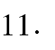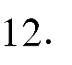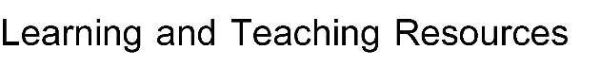

Distributing the score out of 100 according to the tasks assigned to the student such as daily preparation, daily oral, monthly, or written exams, reports etc

**Course description form**

|  |  |  |  |  |  |  |  |  |
| --- | --- | --- | --- | --- | --- | --- | --- | --- |
| 1. **Course Name** | | | | | | | | |
| Electromagnetics II | | | | | | | | |
| 1. **Course Code** | | | | | | | | |
| EP209 | | | | | | | | |
| 1. **Semester/Year** | | | | | | | | |
| 2n’d Semester/Second Year | | | | | | | | |
| 1. **The date this description was prepared** | | | | | | | | |
| 1/9/2023 | | | | | | | | |
| 1. **Available forms of attendance** | | | | | | | | |
| Face-to-Face theoretical lectures | | | | | | | | |
| 1. **Number of study hours (total) / number of units (total)** | | | | | | | | |
| 30/6 | | | | | | | | |
| 1. **Name of the course administrator** | | | | | | | | |
| Name: Ass. Lect. Yasir Ghazi Rashid Email:[yasserghazee_enge@uodiyala.edu.iq](mailto:yasserghazee_enge@uodiyala.edu.iq) | | | | | | | | |
| 1. **Course objectives** | | | | | | | | |
| The objective of the subject of electromagnetic theory in the second course is to introduce the student to the concept of voltage and the potential difference on a charge or system of charges and the potential field, as well as the relationship between voltage and the electric field and ways to extract them mathematically, in addition to getting to know the concepts of the electric duo and electric flux and knowing their laws and ways to extract them. In this course, the student also learns about the types of materials such as conductors, insulators, and semiconductors, as well as the types of currents and their densities that pass through the three types of materials. The student also learns about the concept of electrical polarization. The student also learns about the concept of insulators and their direct relationship to the electrical capacity and energy stored in them, the operation of capacitors and methods of connecting them. Finally, the concept of magnetic flux and how it arises is learned, and the laws of Biot-Svart &amp; We then discuss the magnetic field, how to measure it on a strip of electric current, and magnetic flux density and its relationship to the magnetic field. The student also learns how to extract these concepts mathematically. | | | | | | **Objectives of the study subject** | | |
| 1. **Teaching and learning strategies** | | | | | | | | |
| * Weekly lectures included providing students with the basics and topics related to the pre-skills education outcomes to solve practical problems through presentation, lecture, or conducting experiments. * Solve a group of practical and applied examples by faculty members. * Through discussion, students participate in solving some practical problems. * Practical laboratories in the department are monitored by faculty members in the department. * Asking the student to visit the library and the international information network (the Internet) to obtain additional knowledge of the academic subjects. * Presenting a seminar to the student in front of his fellow students to enhance his self-confidence. | | | | | **The Strategy** | | | |
| 1. **Course structure** | | | | | | | | |
| **Interpolation and solving differential equations.** | **Learning method** | **Required learning outcomes** | | **Name of the unit or topic** | | | **Hours** | **Week** |
| Daily, oral, monthly, written examinations and reports | Whiteboard and Data show | Learn about the properties of materials. Convection and conduction currents; Conductor properties and boundary conditions; The way of the magicians; Semiconductors. Nature of insulating materials. | | **Electric Fields in Material Space:**  *Properties of Materials; Convection and Conduction Currents; Conductor properties and boundary conditions; The method of mages; Semiconductors; The nature of dielectric materials; Boundary conditions for perfect dielectric materials.* | | | 4 | 1&2 |
| Daily, oral, monthly, written examinations and reports | Whiteboard and Data show | Definition of capacity; Capacity of some useful configurations; Two-wire line capacity. Poisson and Laplace equations - Poisson and Laplace equations; Singularity theory; Solve Laplace's equation in a given situation. | | **Capacitance:**  *Capacitance; Capacitance of some useful configuration; Capacitance of a two-wire line; Poisson's and Laplace's equations-Poisson's and Laplace equations; Uniqueness theorem; Solution of Laplace’s equation in certain situation; Solution of Poisson's equation in certain situation; Product solution of Laplace’s equation.* | | | 6 | 3&4&5 |
| Daily, oral, monthly, written examinations and reports | Whiteboard and Data show | Introduction to static magnetic fields: Magnetic field constant. Peyote-Savart Law; Curl Stoke's Theory | | **Magnetostatic Fields:**  *The steady of magnetic field; Biot- savart law; the curl; Stocke's theorem* | | | 4 | 6&7 |
| Daily, oral, monthly, written examinations and reports | Whiteboard and Data show | Understand and apply Ampere's circle law; Application of Ampere's law. Magnetic flux and magnetic flux density. | | **Magnetostatic Fields:**  *Ampere's circuit law; Application of ampere's law; Magnetic flux and magnetic flux density; The scalar and vector magnetic potential; Derivation of steady magnetic field laws.* | | | 6 | 8&9&10 |
| Daily, oral, monthly, written examinations and reports | Whiteboard and Data show | Calculating magnetic forces. Materials and the induced force on a moving charge; The force on the differential current element. The force between the differential current elements. | | **Magnetostatic Fields:**  *Magnetic forces; Materials and inductance-force on a moving charge; Force on a differential current element; Force between differential current elements.* | | | 4 | 11&12 |
| Daily, oral, monthly, written examinations and reports | Whiteboard and Data show | Understanding force and torque in a closed circuit; The nature of magnetic materials; Magnetism and permeability. Magnetic boundary conditions | | **Magnetostatic Fields:**  *Force and torque on a closed circuit; The nature of magnetic materials; Magnetization and permeability; Magnetic boundary conditions, The magnetic circuit, Potential energy and forces on magnetic materials; Inductance and mutual inductance; Time varying fields.* | | | 4 | 13&14 |
| Daily, oral, monthly, written examinations and reports | Whiteboard and Data show | Learn about Max Well's equations | | **Maxwell’s Equations:**  *Maxwell's equations-faraday's law; displacement current; Maxwell’s equations in point form; Maxwell’s equations integral form; the retarded potentials.* | | | 2 | 15 |
| 1. **Course Evaluation** | | | | | | | | |
| Distribution of the grade out of 100 according to the tasks assigned to the student, such as daily preparation, daily, oral, monthly, written exams, reports, etc.   |  |  | | --- | --- | | 10% (10) | **Quizzes** | | 10% (10) | **Assignments** | | 10% (10) | **Projects** | | 10% (10) | **Report** | | 40% (40) | **Annual quest** | | 60% (60) | **Final Exam** | | 100% (100 Marks) | **Total assessment** | | | | | | | | | |
| 1. **Learning and teaching resources** | | | | | | | | |
| Matthew, N. O. "Sadiku Elements of Electromagnetics." (2018). | | | Required textbooks (methodology, if any) | | | | | |
| Electromagnetics By Joseph Edminister (Schaum’s Outline Series) : Joseph Edminister, Vishnu Priye Mc Graw Hill Education | | | Main references (sources) | | | | | |
| All scientific magazines and periodicals related to electromagnetic fields | | | Recommended supporting books and references (scientific journals, reports....) | | | | | |
| https://www.coursera.org/browse/physical-science-and-engineering/electrical-engineering | | | Electronic references, Internet sites | | | | | |