 | Curriculum Vitae | 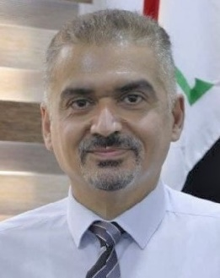
Name | Khattab Saleem Abdul- Razzaq
Birth | July, 25, 1974, Baghdad-Iraq
Nationality | Iraqi
Address | Baghdad
Tel | (+964) 07711614714
e-mail | dr.khattabsaleem@yahoo.com

- B. Sc. in Civil Engineering / College of Engineering / University of Baghdad – Baghdad - Iraq, 1996.
- M. Sc. in Structural Engineering / Civil Engineering / College of Engineering / University of Baghdad – Baghdad - Iraq, 1999.
- Ph. D. in Structural Engineering / Civil Engineering / College of Engineering / Moscow State University of Civil Engineering – Moscow –Russia, 2005.
- Instructor at University of Diyala since 2005-till now
- Assistance Professor at University of Diyala, 2012
- Full professor at University of Diyala, 2018
- Editor in Chief of Diyala Journal of Engineering Sciences 2016-till now:
https://djes.info/index.php/djes

- Head of Department of Civil Engineering
- Chair of Engineering Scientific Promotion Committee
- Member of Central Scientific Promotion Committee
- Chair of Research Auditing Committee
- Member of the expert committee of the Iraqi Ministry of Higher Education
- Director of the Planning and Follow-up Division
- Member of the Iraqi Universities Evaluation Committee
- Teaching Methods Trainer

- Google scholar:
https://scholar.google.com/citations?user=wT4Sr2cAAAAJ&hl=en

- Scopus:
https://www.scopus.com/authid/detail.uri?authorId=57200261080

- Patents
- New reinforcement details in reinforced concrete corbels
- Suggesting a new reinforcement technique in reinforced concrete continuous deep beams
- Innovate technique in using steel plates in strengthening openings in reinforced concrete t-beams
- Proposing a new reinforcement details in reinforced concrete pile caps

